GCSE English Language Paper 2 Year 10

Name Teacher

…………………………………………………………………………………………………………………………………….

Contents

Page 1 Approaching Q1-Q5
Page 7 November 2018 Exam Paper (Cycling)
Page 16 June 2018 Exam Paper (Surfing)
Page 25 June 2019 Exam Paper (Boats)
Page 34 June 2020 Exam Paper (Climbing)

Approaching Q1-Q5

Question 1

4 marks --- 5 minutes --- T/F Statements

You are given eight statements on the opening of Source A. You need to identify the four statements that are true. Pay close attention to detail because it’s surprisingly easy to make a mistake.

Before you answer

- Read the allocated extract
- Read the statements

When you answer

- Tick the correct boxes
- Double-check your answers

Advice from the Chief Examiner

- Don’t scribble in the boxes
- Don’t tick more than four boxes

- Don’t rush through this task
- Make sure you understand what each statement says

Question 2

8 marks --- 12 minutes --- Infer Similarities or Differences

To infer something means that you form an evidence-based judgement on a specific area. This task requires you to make inferences on either similarities or differences between the sources.

Before you write a response

- Be clear on the focus of the task (i.e. similarities or differences)
- Read both sources carefully with key word/s in mind
- Identify two or three short quotations in each source to explore
- Add light annotations

When you write a response

- Use the key word/s of the question in each of your points
- Use the quotations you’ve identified as the basis for your response
- Write at least two full paragraphs

Use and adapt these sentence stems

- In Source A, we learn that... This is shown through...
- Contrastingly / similarly, we learn in Source B that... This is significant because …

Advice from the Chief Examiner

- Don’t simply retell what happens in each source
- Don’t analyse language

- Read the sources carefully and with the key word/s in mind (don’t rush!)
- Give yourself permission to re-read sections that are unclear
- Make like-for-like comparisons
- Use supporting evidence from the sources
- Remember that you are rewarded for the quality and depth of your inferences

Question 3

12 marks --- 15 minutes --- Language

Analysing language means that you need to focus on words, phrases and techniques and explore the effects they have on you as a reader.

Before you write a response

- Return to Source A and read the extract
- Identify two or three short quotations to explore
- Add light annotations

When you write a response

- Use the key word/s of the question in each of your points
- Use appropriate terminology: word, phrase, image, simile, metaphor, personification, contrast
- Use the quotations you’ve identified as the basis for your response
- Write at least three full paragraphs

Use and adapt these sentence stems

- The writer uses the word / phrase / image to show…
- This has the effect of… / This is significant because… / We learn from this…

Key Words

- Connotation Associations beyond a literal meaning (a snake has connotations of deceit)
- Imagery Descriptive language that appeals to the senses
- Metaphor A direct comparison (e.g. the world is a stage)
- Simile A comparison using ‘like’ or ‘as’ (e.g. as cold as ice)
- Personification Giving human qualities, feelings or actions to non-human things
- Tone The overall attitude or mood
- Juxtaposition Placing contrasting elements side by side to highlight their differences

Advice from the Chief Examiner

- Don’t write about language from outside the stated lines
- There is no requirement to cover all the bullet points (e.g. the one on sentence forms)
- Avoid generic comments (e.g. ‘it creates a picture in my head’)
- Avoid feature spotting without exploring the effect on the reader

- Zoom-in on single words and explore why they’ve been used
- Ask yourself: why this word and not another?
- Don’t write unnecessarily at length (i.e. don’t waffle)
- You are rewarded for depth of analysis (i.e. say more about less)
- Focus on the effects of the writer’s choice of specific words and phrases
- Remember that explaining effects matters more than using terminology

Question 4

16 marks --- 18 minutes --- Comparison

Think of the question as a combination of Q2 and Q3 in the sense that you have to compare the sources with a specific focus in mind and comment on the methods used by both writers.

Before you write a response

- Be clear on the focus of the task (i.e. similarities or differences)
- Skim-read the sources if you need to or think it will help
- Identify two or three short quotations in each source to explore
- Add light annotations

When you write a response

- Use the key word/s of the question in each of your points
- Use the quotations you’ve identified as the basis for your response
- Use appropriate terminology: word, phrase, image, simile, metaphor, personification, contrast
- Write at least three full paragraphs

Use and adapt these sentence stems

- In Source A, one of the writer’s main thoughts / perspectives is...
- The writer uses the word / phrase / image to show... This has the effect of...
- In contrast / similarly, the writer of Source B feels... This is demonstrated through...
- The writer uses the word / phrase / image to show... This has the effect of...
- A further difference / similarity between the writers’ thoughts / perspectives is…

Advice from the Chief Examiner

- Some answers are too short (remember this task is worth 16 marks)
- Respond directly to the focus of the task rather than repeating content from Q2
- A lack of comment on writers’ methods (i.e. language) will likely restrict marks to Level 2
- Avoid making generalised or unsupported comments

- Build on skills from Q2 and Q3
- Make sure your points are firmly rooted in the sources
- Track how attitudes and perspectives shift

- When you look at the past papers, note that the second bullet-point on Q4 will be ‘comment on’ rather than ‘compare’ in the exam
Question 5

40 marks --- 45 minutes --- Transactional Writing

This part of the exam tests your ability to communicate clearly and to write with accuracy. It’s important that you craft your writing rather than rushing to get the task done.

Before you write a response

- Read the statement carefully
- Create a brief plan

When you write a response

- Aim for precision in your vocabulary choices
- Vary the structure of your sentences
- Use paragraphs and ensure they are coherently linked
- Write at least two full pages
- Ensure that your writing is legible

Advice from the Chief Examiner

- Avoid using facts and statistics that are obviously false
- Avoid using anecdotes that are clearly fictitious

- It’s usually better to adopt a specific stance on the statement
- Sequence your points coherently
- Use rhetorical devices naturally and with care
- Remember that clarity always trumps complexity
- Varying the structure of your sentences is very important
- Proof-reading at the end is also very important

Exam Paper 1

November 2018

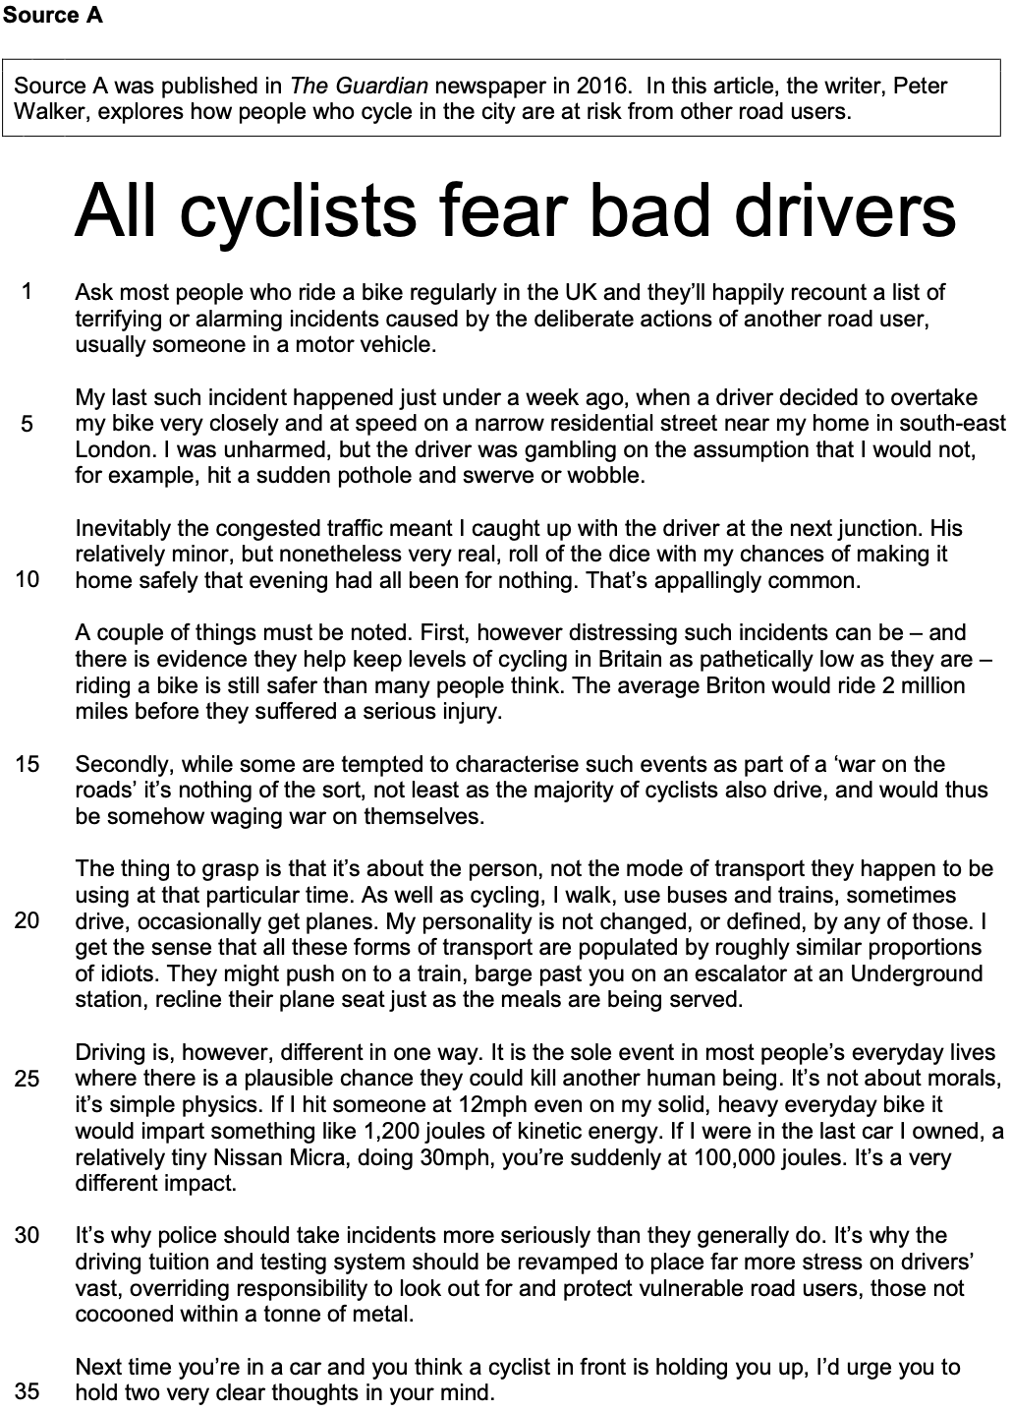

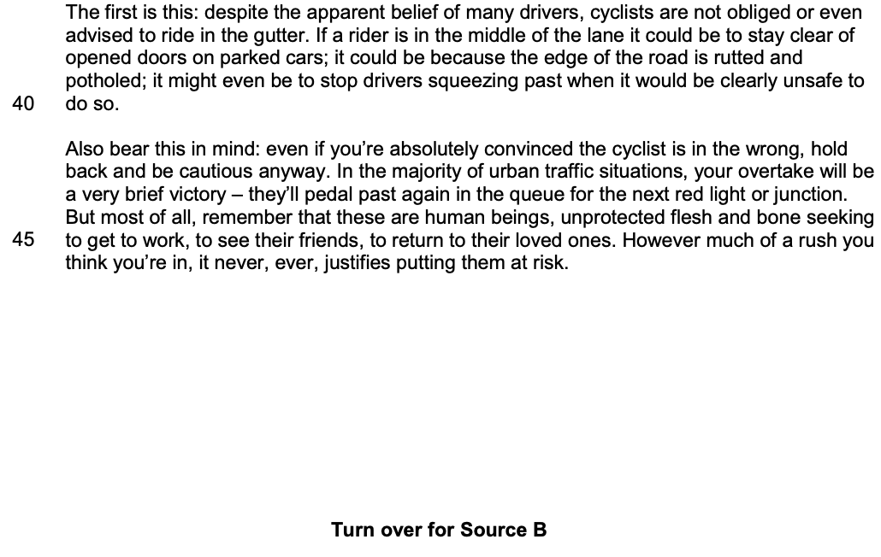

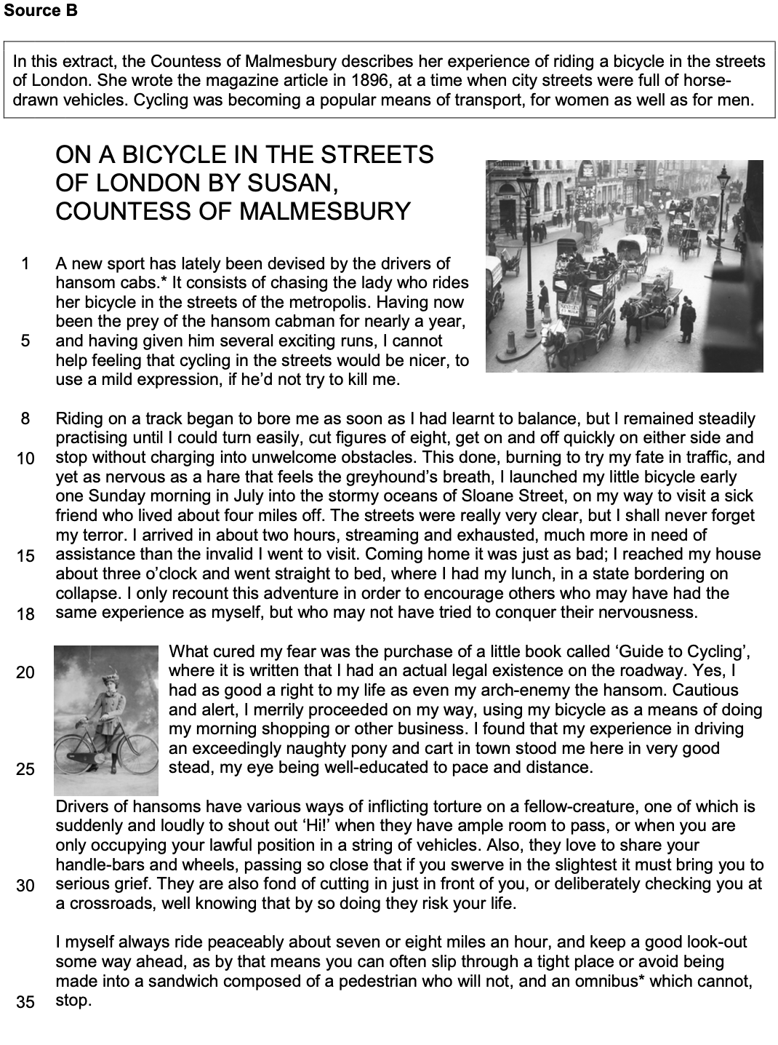

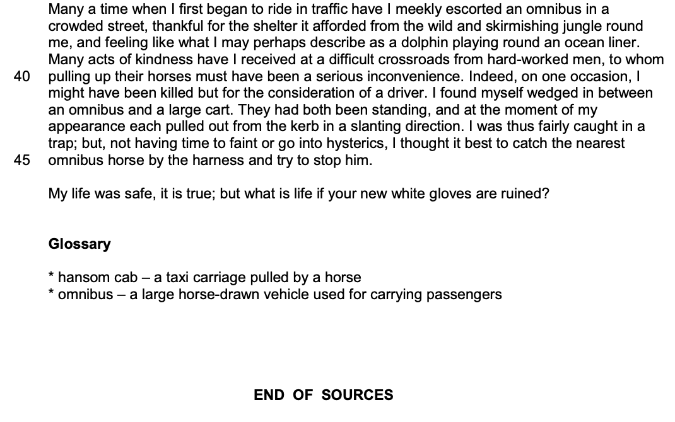

…………………………………………………………………………………………………………………………….……………

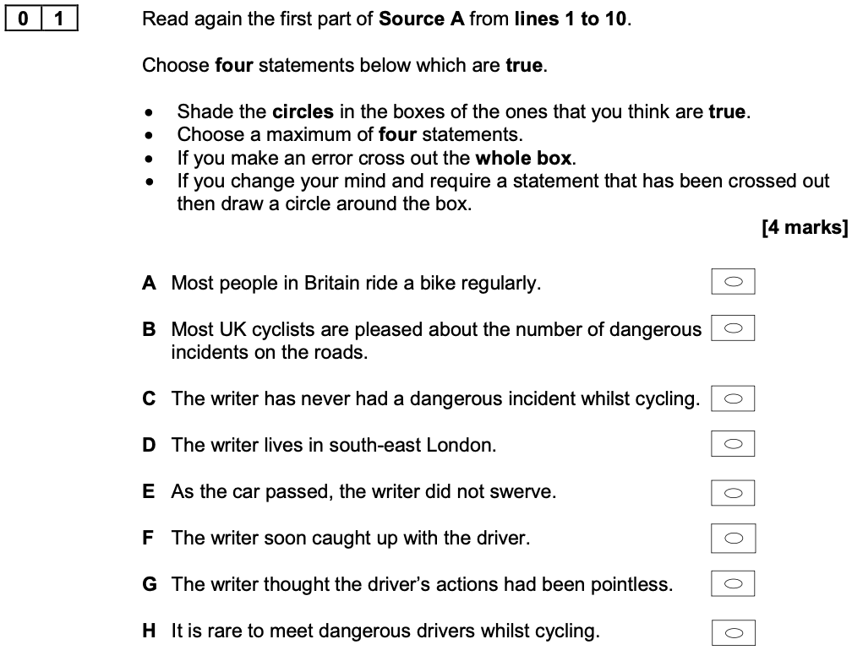

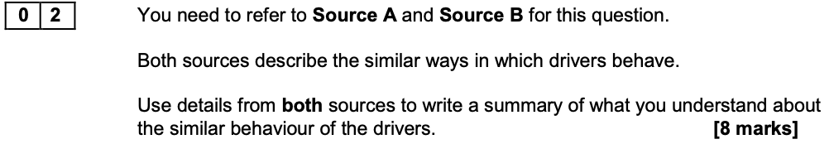
What can you infer about the similar ways in which drivers behave?

Feedback from the Chief Examiner

Many students were able to identify the similarities in the attitudes of modern drivers and the Victorian hansom cab drivers, both showing a reprehensible indifference to the safety of others on the roads. They selected textual detail to support their points, often citing how the drivers passed very close to the cyclists without worrying about the consequences. Clear similarities were identified with the suggestion that their actions gave both sets of drivers a sense of triumph, and the best students were able to move beyond the similarity to explain the more subtle and perceptive difference between the aggressive but rational behaviour of the modern drivers in contrast to the sadistic pleasure and psychotic actions of the cabmen for a mark in Level 4.

Extract from a Level 4 Response

The driver in Source A who ‘decided to overtake’ shows behaviour which is irresponsible but rational. He assesses the risk in passing ‘very closely and at speed’ and does not intend any harm, although he knows that the odds are stacked in his favour, ‘cocooned’ as he is in his car where he will not get hurt. On the other hand, the drivers in Source B are intentionally targeting cyclists by ‘passing so close,’ which suggests behaviour that is equally irresponsible, as they too know they are protected by their relative size to the bicycle, and are unlikely to get hurt, but their behaviour is irrational and immoral too because it is planned. The motivation of the cabmen who are ‘chasing the lady,’ and targeting the female writer, suggests perhaps a particular hostility towards women who ride bicycles.

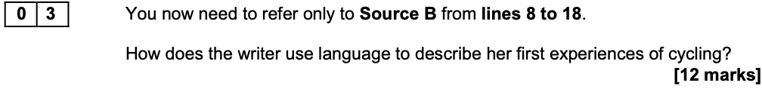

Feedback from the Chief Examiner

The metaphor of the ‘stormy oceans of Sloane Street’ was a favourite. Some students mistook this image as a literal description of the weather, which made it very difficult to comment clearly on the effect of the metaphor. However, other students were able to explore how this metaphor offered a comparison of the chaos and danger of the streets of London in relation to the unpredictability and mayhem of the sea in stormy weather.

Extract from a Level 4 Response

The writer establishes a series of hunting images to reflect her sense of being a victim on the roads and uses the simile ‘as nervous as a hare that feels the greyhound’s breath’ to describe her fear of being hounded. The image is a reference to greyhound racing, where the delicate hare races for its life ahead of a much larger, faster and more aggressive dog, emphasising how intimidated and vulnerable the writer feels as she sets off, unprotected, on her fragile bicycle, with much bigger and potentially life threatening vehicles breathing down her neck - a victim of a cruel sport, for the sake of another’s entertainment.

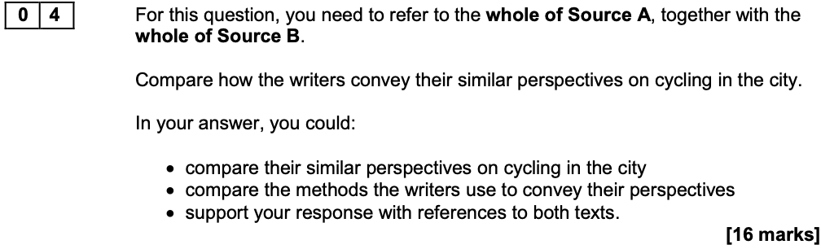

Feedback from the Chief Examiner

Students progressed naturally from an identification of the writers’ similar perspectives to explore the different methods the writers used to present their points of view. So it was common to read that whilst both writers felt that cycling was very dangerous, the writer in Source A used facts and statistics to support his argument, whereas the writer in Source B used emotive language and vivid imagery to illustrate the same thing, with different effects. There were a reassuring number of students commenting on methods, a central expectation of this task and one of the key skills, and doing so with some confidence and success.

Extract from a Level 4 Response

The underlying moral view in Source A is that selfish drivers are guilty of creating danger for innocent cyclists. Walker uses the imperative form of the verb in the final paragraph: ‘remember that these are human beings’ to command readers to change their minds - and their behaviour. The emotive phrase ‘flesh and bone’ reinforces a sense of the fragility of human life beneath the cyclist’s lycra. This deadly serious tone is contrasted in Source B with the writer’s humorous, almost frivolous, tone. From the opening paragraph, she uses humour to emphasise her own vulnerability, suggesting cycling would be nicer ‘to use a mild expression’ if she didn’t get killed. The juxtaposition of her politeness and the brutal reality of her own death creates an irony which encourages the reader to share her cheerful, naive perspective and portrays herself as intrepid and fearless, in contrast to the more cautious, experienced Walker.

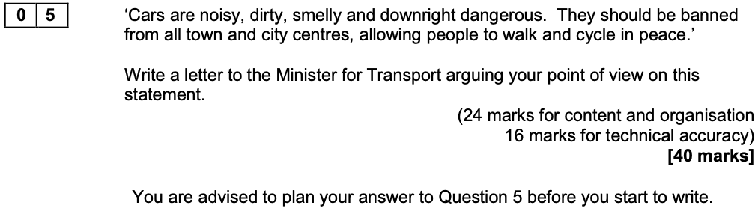

Feedback from the Chief Examiner

There were a roughly equal number of students agreeing and disagreeing with the statement, either of which is a totally acceptable response to Question 5. There were arguments presented regarding the importance of public health and safety, a discussion of the benefits of public transport and some inspiring proposals for converting car park space in town centres once cars are banned. On the other hand, students argued forcefully that it would be inconceivable to ban the most useful invention that humanity had ever conceived, that it was inherently unfair to the elderly and the disabled, and that it was inadvisable for the Minister to alienate large swathes of the population by such autocratic decisions as banning cars.

Exam Paper 2

June 2018

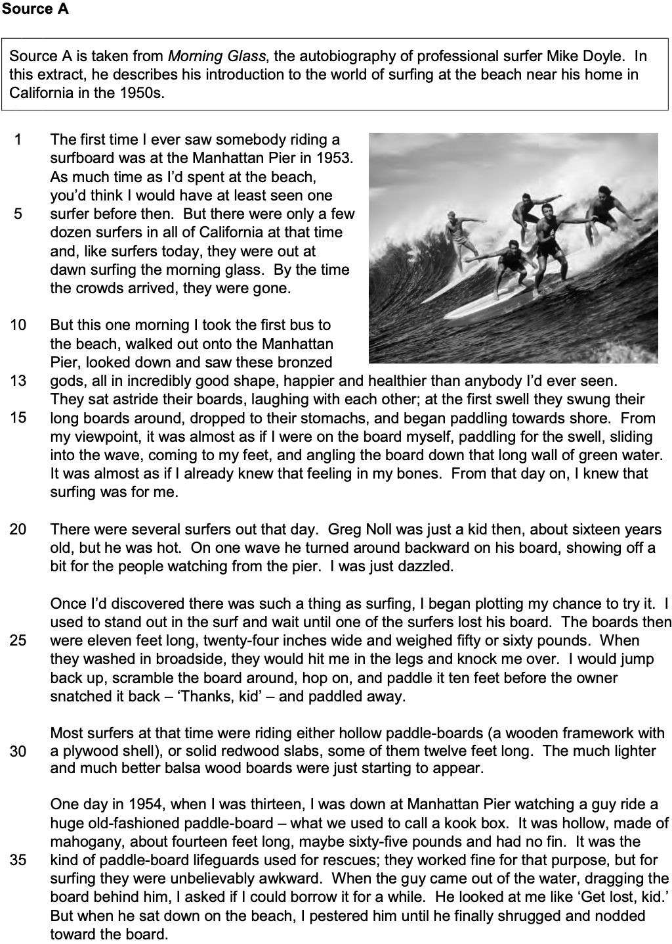

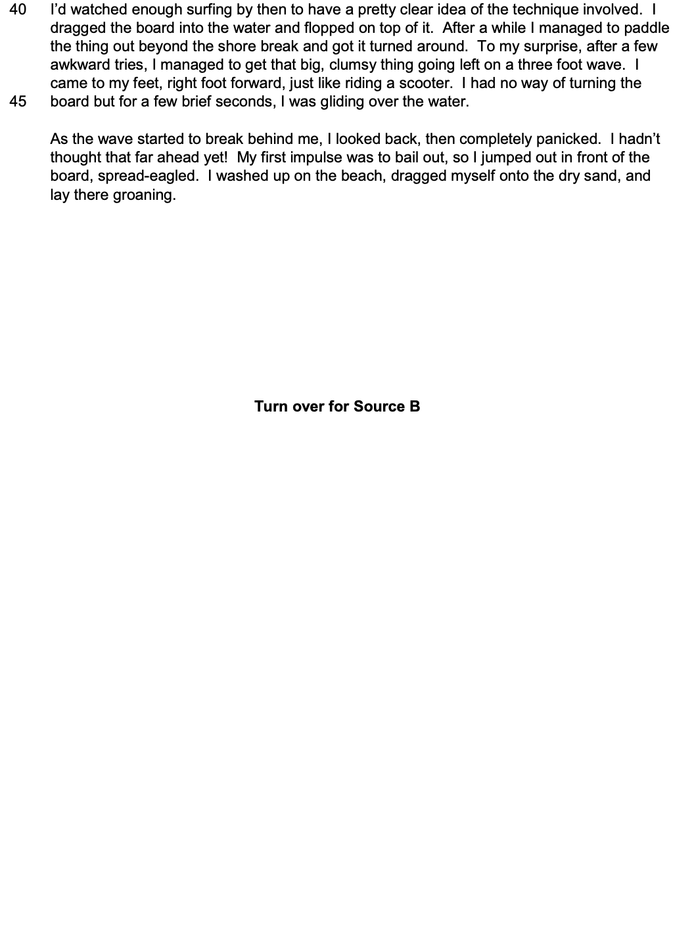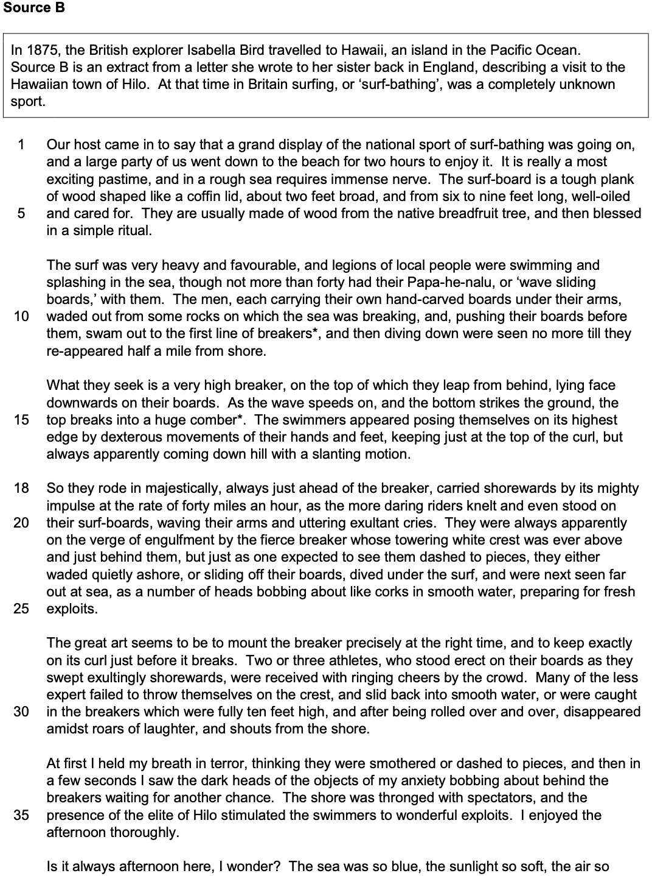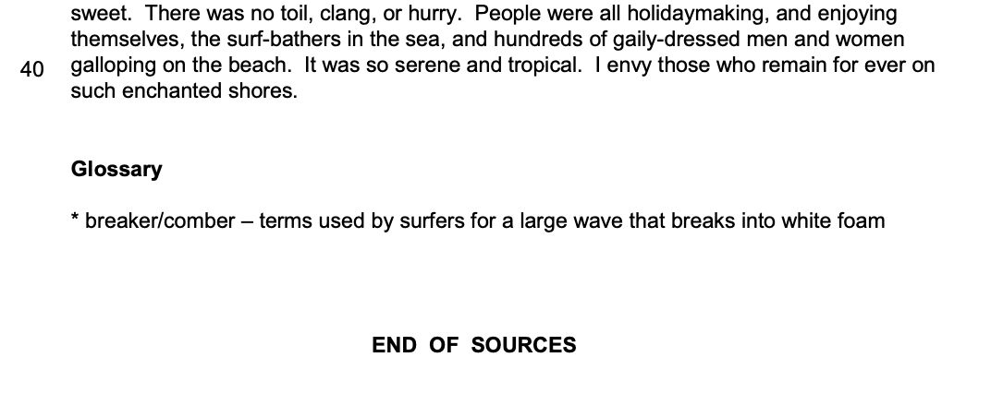
…………………………………………………………………………………………………………………………….……………

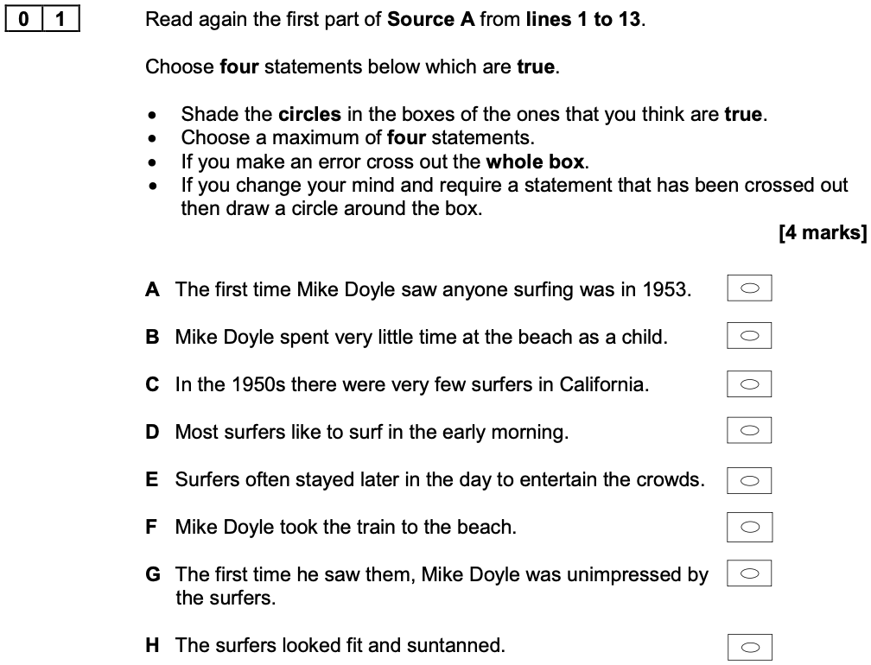

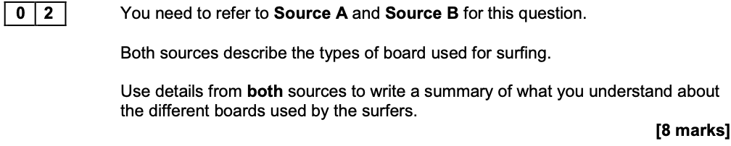
What can you infer about the different types of board used for surfing?

Feedback from the Chief Examiner

Encouraging students to write in detail is an approach well worth adopting, as it can often be the means of moving up a level. For example, a student working at level 2 might typically attempt to make one inference, and then move on to make a separate point. However, by focusing and commenting further on the same point, the student is more likely to provide the explanation they need to meet the criteria for ‘clear’ at level 3.

Extract from a Level 4 Response

Although the surfboards appear outwardly similar, the Hawaiian boards are no more sophisticated than a primitively shaped ‘plank of wood’ cut from ‘the native breadfruit tree,’ whereas some of the Californian boards use new ‘lighter’ materials such as ‘balsa wood,’ suggesting the Americans are keen to develop their boards for a smoother performance. There is a sense of innovation in the way the surfers regard their boards, as the mahogany paddleboard is dismissed as ‘old fashioned’ and ‘unbelievably awkward’. The Hawaiians use natural resources to create ‘hand-carved’ surfboards in the same traditional way as they would make ‘a coffin lid’ which suggests that their boards are an important part of their cultural way of life, not just a fashion accessory.

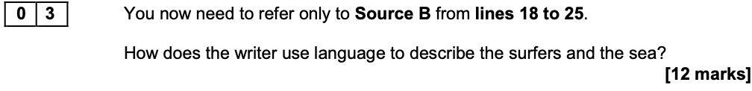

Feedback from the Chief Examiner

At Level 4, students were able to analyse language choices in detail. Some explored the effect of the surfers being described as ‘majestic’ royalty, appearing to dominate the waves over which they rode so triumphantly. Others explored how the battle between the surfers and the engulfing power of the sea, whose ‘towering white crest’ was ever above and behind them, was never quite resolved.

Extract from a Level 4 Response

The writer describes the surfers riding ‘majestically’ on the waves, the adverb suggesting how dominant the surfers appear and creating the image of regal figures, riding high above the waves, like Neptune the mythical god of the sea. The royal image emphasises the confidence and assurance of the surfers and the awe they inspire.

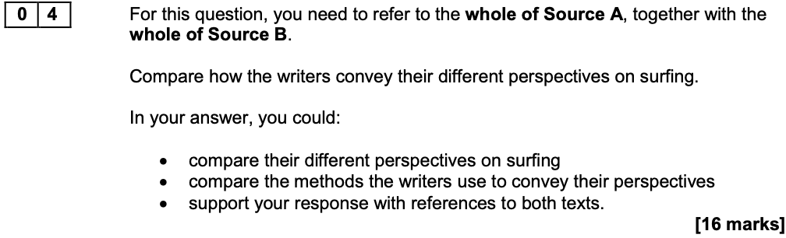

Feedback from the Chief Examiner

This question presents a demanding and multi-dimensional challenge for students. The task requires a response which includes not just a demonstration of the student’s understanding of the ideas and perspectives in both texts, but also a comparison of these ideas and the writers’ different perspectives, supported by relevant textual detail, and an explanation of how both writers have used a range of methods to convey their points of view.

Extract from a Level 4 Response

Both writers admire the surfing, but whereas in Source B, Bird appreciates the surfing display as a spectator from afar, Doyle in Source A is ‘dazzled’ and desperate to take part, aspiring to become one of them. Bird uses a repetitive pattern to suggest she sees the world of surfing as a paradise of endless bliss: ‘so blue… so soft … so sweet,’ the alliteration adding to the slow, soothing ‘serene’ tone she creates. Doyle, however, is at home, not a tourist, and idolises the surfers, metaphorically describing them as ‘bronzed gods,’ viewing them as supernatural beings, tanned and confident. Having established his hopes at the start, Doyle shows the progress of his dream as the text develops, like a wave, with his first attempt at surfing as the climax or crest, and ending with the humorous image of himself ‘spread-eagled’ on the shore in the final line, echoing structurally his first experience of surfing.

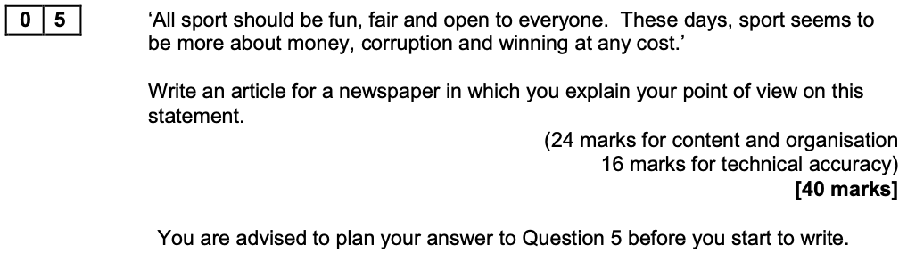

Feedback from the Chief Examiner

Those working at the upper end of the ability range were often able to project an individual voice, sometimes adopting an alternative point of view, such as those students who voiced their perspective that corruption was rife in every area of life so why object to it in sport. These students typically offered a conscious crafting of language, characterised by a subtle moulding of features to suit the context: extending metaphor and other imagery, incorporating puns, and deploying rhetorical devices to devastating effect. The sequencing of their ideas was also exceptional, with a sense of momentum building in their response as the reader was drawn inexorably into a series of increasingly convincing and then compelling points, leading to a carefully structured conclusion.

Exam Paper 3

June 2019

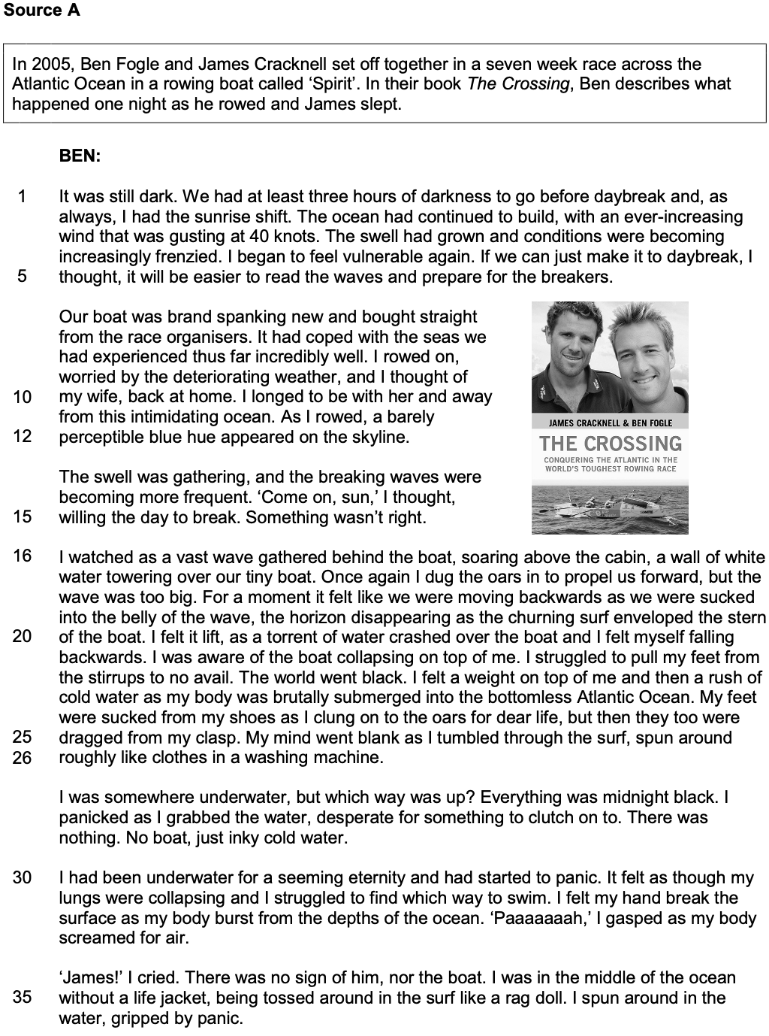

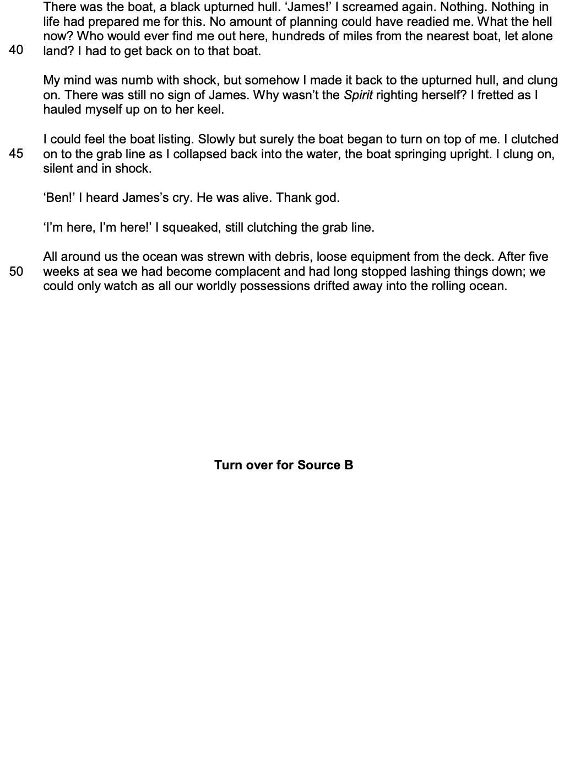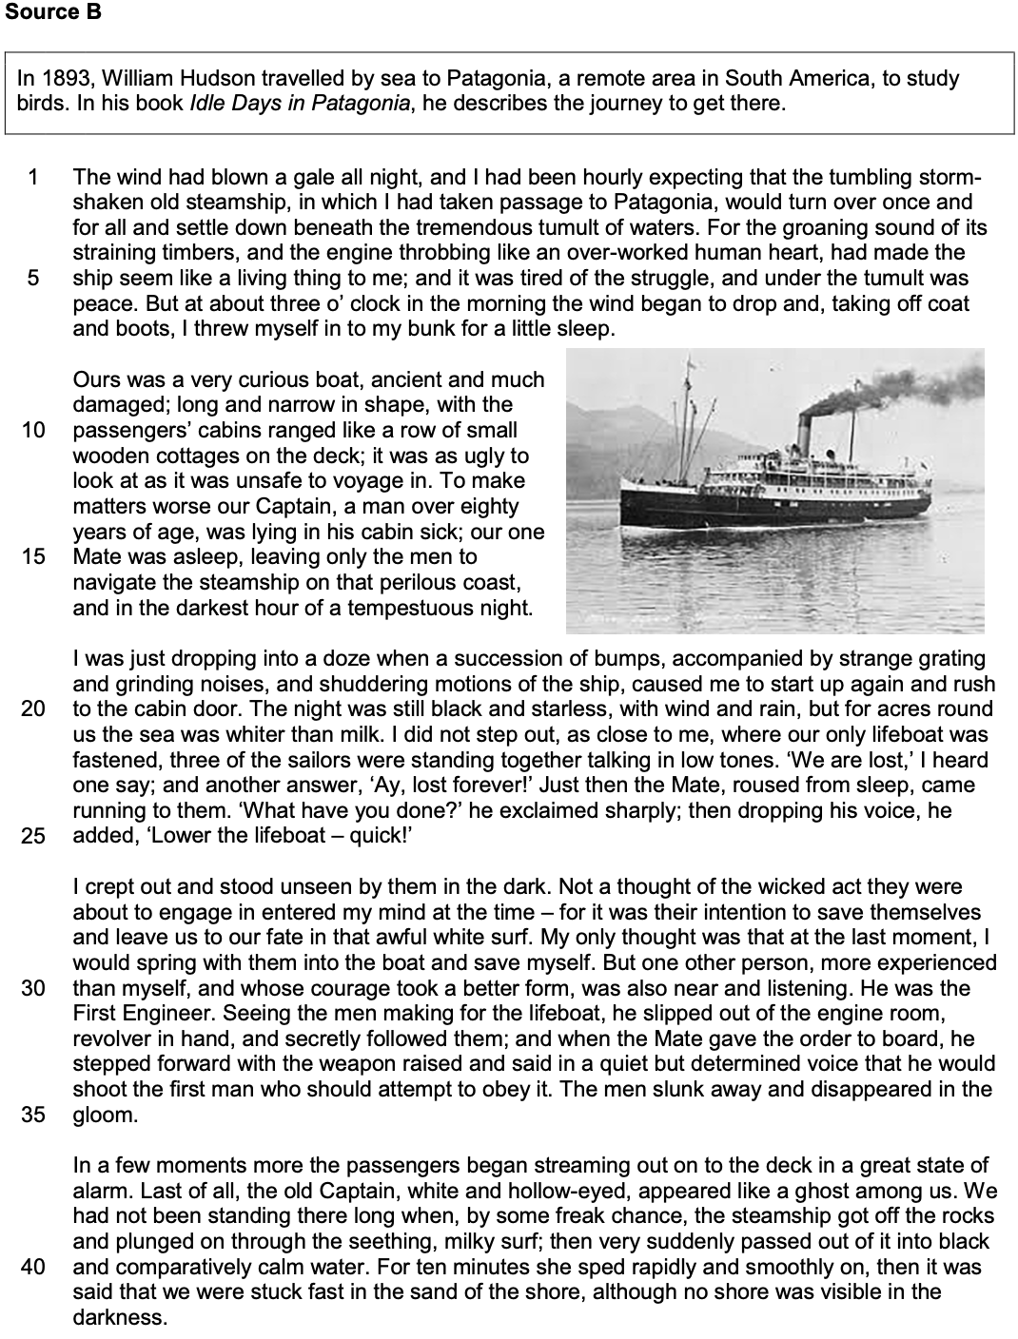

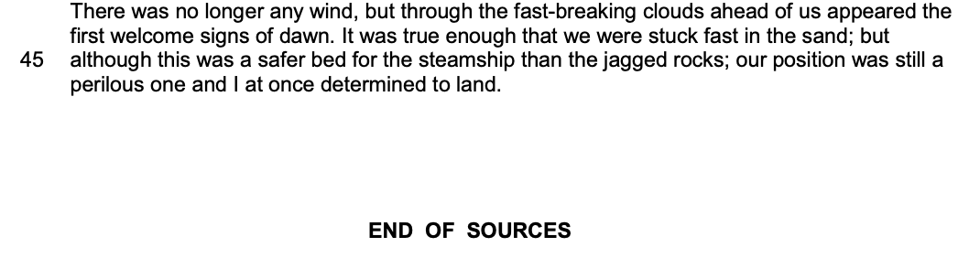

…………………………………………………………………………………………………………………………….……………

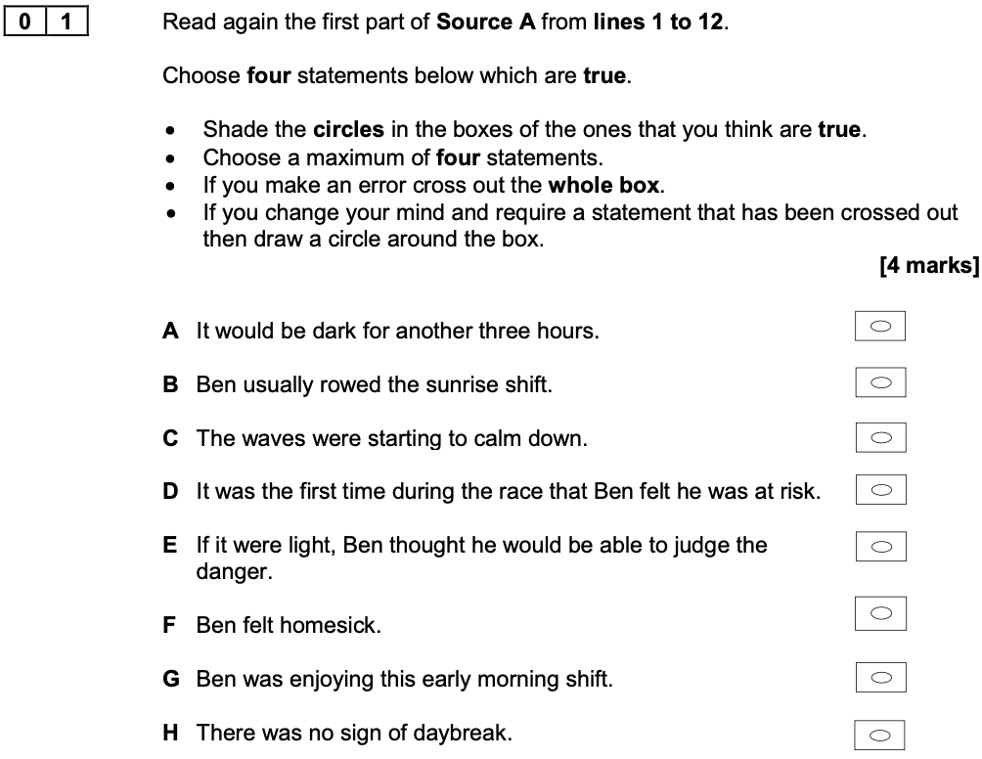

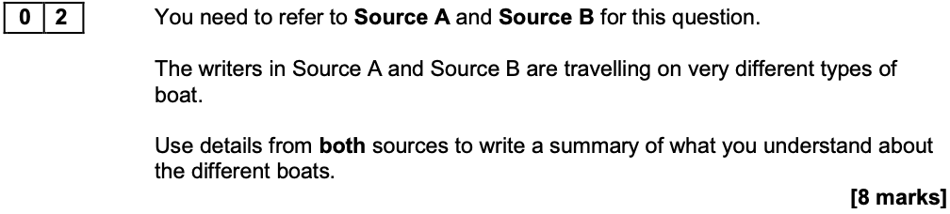
What can you infer about the differences between the boats?

A Warning from the Chief Examiner

At the lowest level, students were able to identify that one boat was older than the other or that they were different in size. At level 2, students attempted to interpret these differences by commenting, for example, on how the size of the boats made them more or less safe, but without explaining clearly the correlation between size and safety.

Ideas to Explore Further

- Age
- Size
- Condition
- Safety features
- Number of passengers
- Power source
- Number of cabins
- Purpose/design

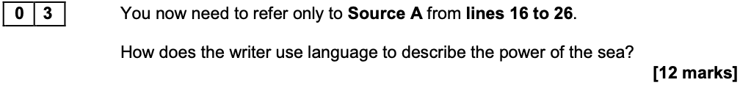

A Warning from the Chief Examiner

Typical of students awarded marks in levels 1 and 2 were comments which provided generalised or generic effects. For example, a comment such as ‘The writer describes the sea as powerful by using the metaphor “sucked into the belly of the wave” which makes the reader feel scared’ is too generic. Speculative comments on how ‘the reader’ might respond are less helpful than specific references to the effects within the context of the source material.

Ideas to Explore Further

- Metaphor: ‘wall of white water’
- Simile: ‘like clothes in the washing machine’
- Onomatopoeia: ‘rush’, ‘crashed’, ‘churning’, ‘surf’
- Adverbial phrases: ‘brutally submerged’, ‘spun around roughly’
- Noun phrases: ‘vast wave’, ‘churning surf’, ‘torrent of water’
- Active verbs: ‘soaring’, ‘dragged’, ‘tumbled’, ‘enveloped’, ‘crashed’, ‘grabbed’
- Personification: ‘into the belly of the wave’
- Simple sentences: ‘The world went black’

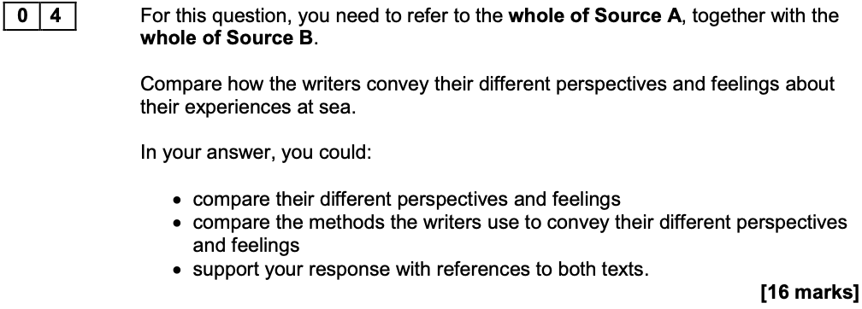

A Warning from the Chief Examiner

There are still some students who do not address the ‘how’ in this question, and their marks are reduced as a result. Students are reminded once again that exploring the methods used by the writers is an integral and necessary strand.

Ideas to Explore Further

Perspectives and Feelings

- Complacency / calmness
- Active resistance / helplessness
- Sense of isolation / surrounded by others
- Regret / no self-pity
- Aware of own fear / aware of own cowardice
- Desperation and panic / composure and action
- Relief / determination

Methods

- Chronological narrative structure
- Shifts between action and reflection
- Pace of action increases towards climax
- Cyclical structure created in final lines of Source A
- Emotive imagery used in Source B
- Sensory language
- First person narrative accounts

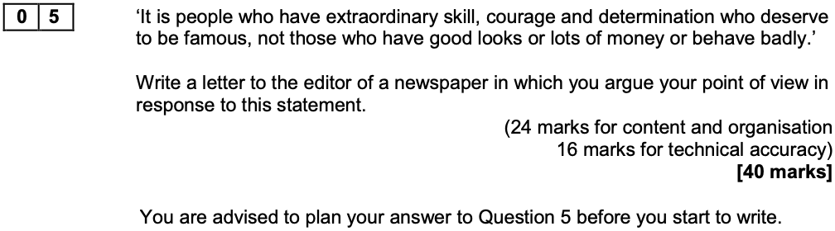

A Warning from the Chief Examiner

The length of students’ responses is significant. Although there were a few students who benefited from extending their response to question 5 beyond three sides of the answer book, there was a huge number of students for whom the opposite could be said: writing at great length makes it far harder for students to sustain both the clarity of their argument and the accuracy of their technical skills. It cannot be emphasised too strongly that a concentrated, crafted and concise response is almost always going to be rewarded more highly than a diluted, rambling and elongated response.

Exam Paper 4

June 2020

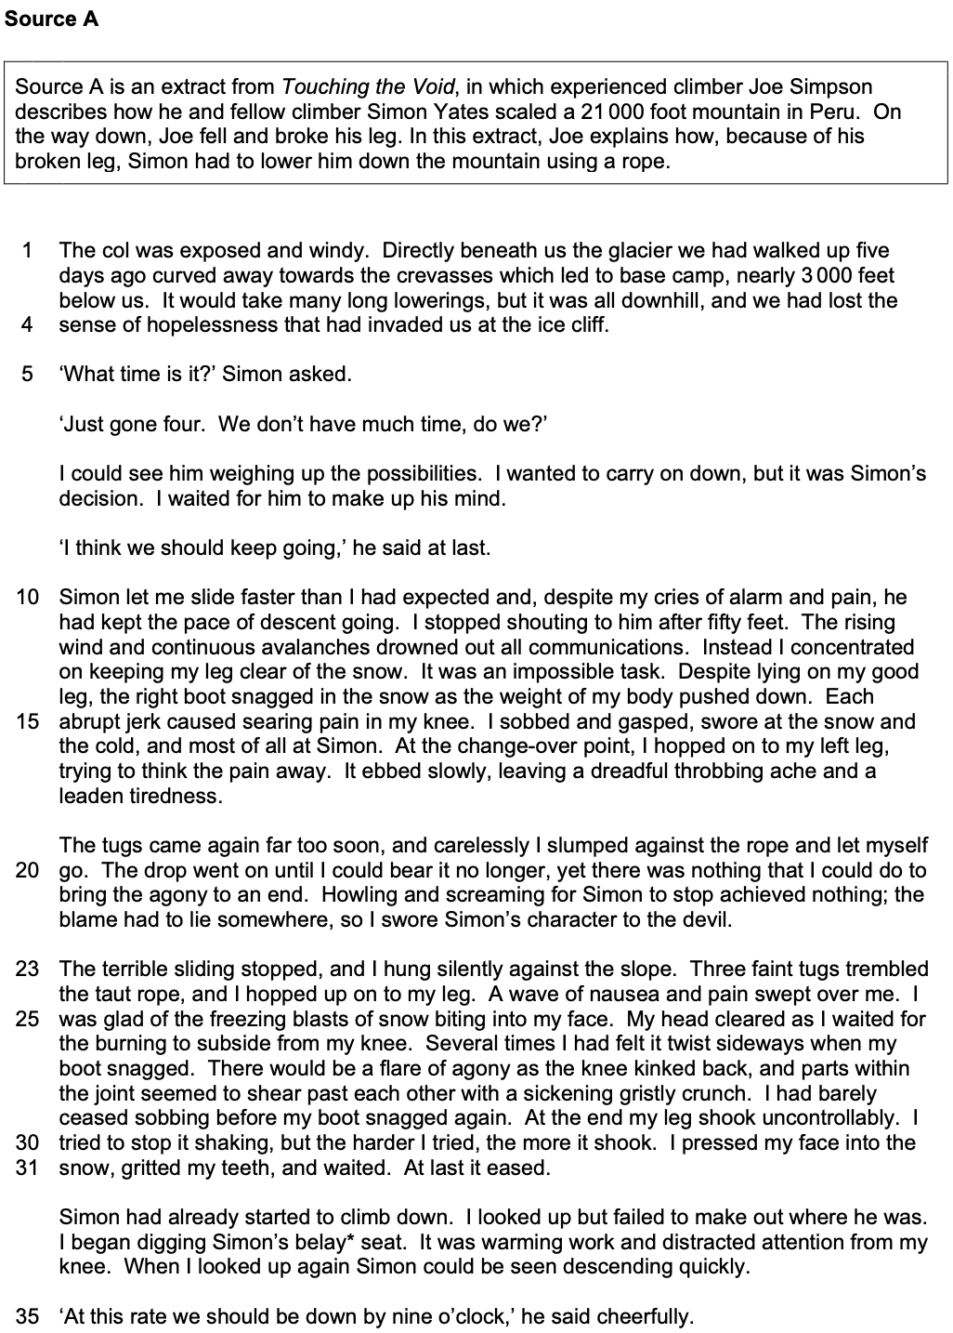

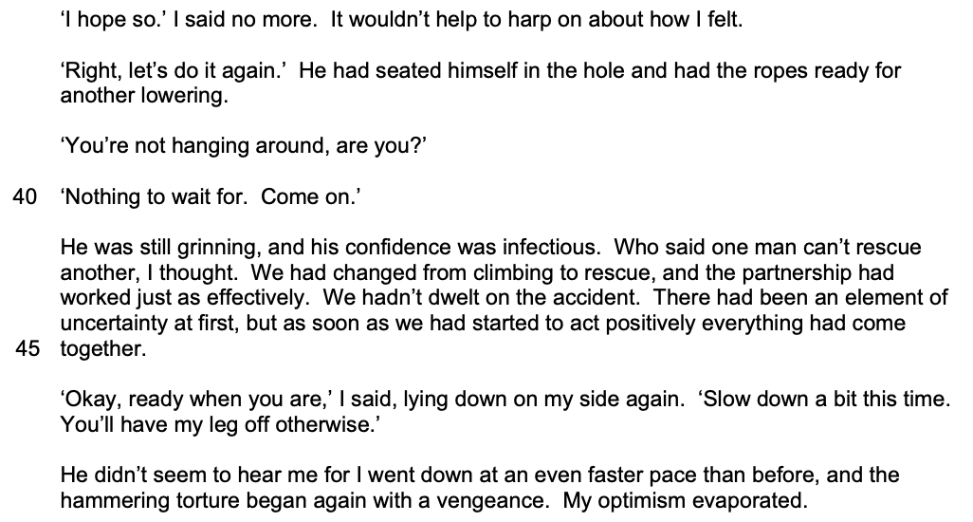

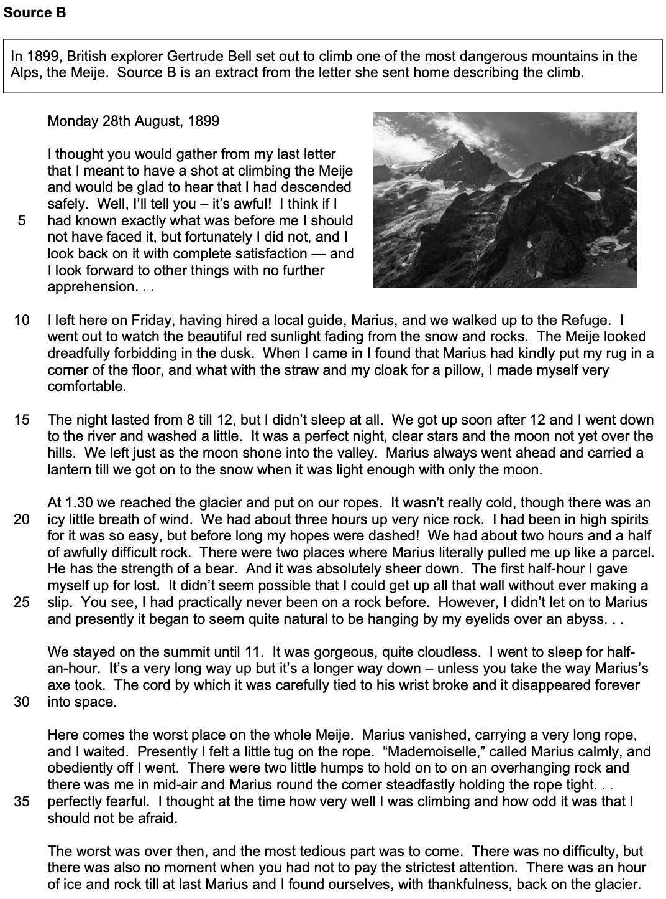

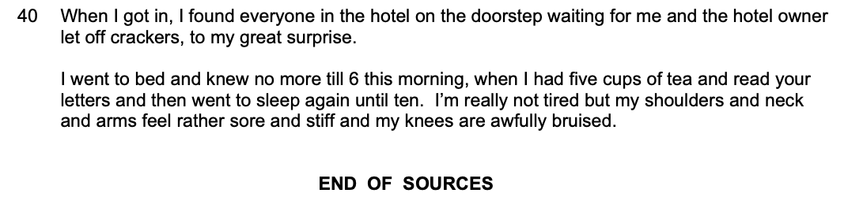

…………………………………………………………………………………………………………………………….……………

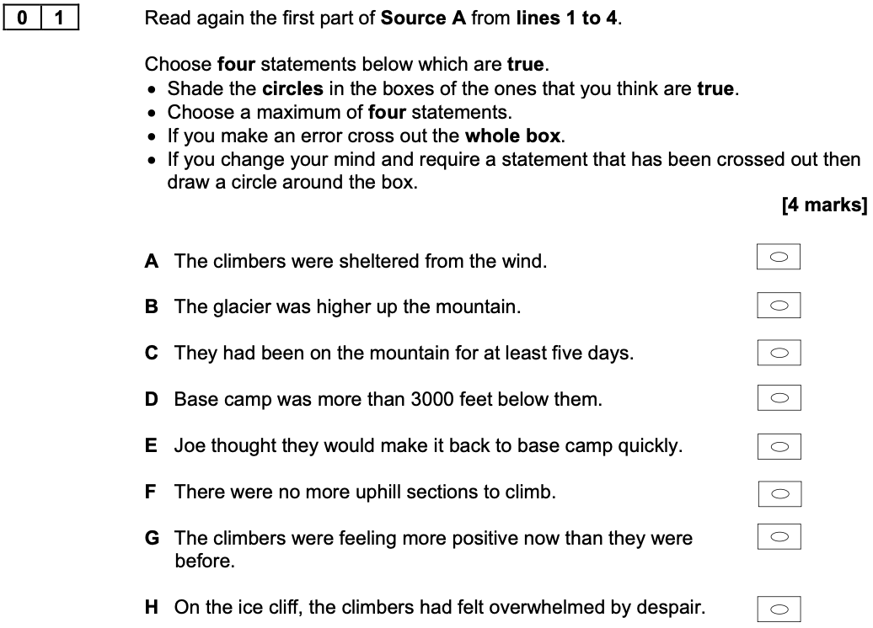

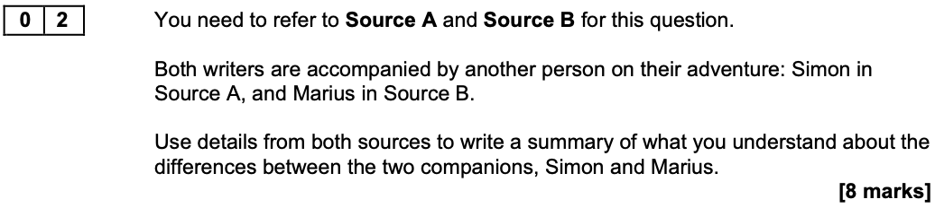
What can you infer about the differences between the two companions?

Extract from a Level 2 Response to Develop

The companion in Source B is a ‘local guide’ who has been ‘hired’ to help the writer climb the mountain which means she has paid him to help because without his help she wouldn’t manage it. This is different to Source A because Joe and Simon know each other already and are climbing together, so Simon is not being paid to help like Marius is. In Source A, Joe says that it is a ‘partnership’ which means they work together well.

Ideas to Explore Further

- Their relationship to the writer
- Their actions
- Their experience
- Their knowledge
- Their confidence
- Their skills
- Their decision-making

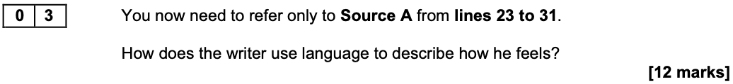

Extract from a Level 2 Response to Develop

The writer uses lots of different language features to describe how he feels. He uses a metaphor which is ‘flare of agony’ to show how he is in pain. A match flares up when you light it and that’s how it feels when he slides down the mountain.

Ideas to Explore Further

- Metaphor: ‘a wave of nausea’, ‘flare of agony’
- Personification: ‘freezing blasts of snow biting into my face’
- Violent verbs: ‘snagged’, ‘kinked’, ‘gritted’, ‘shear’, ‘twist’
- Onomatopoeia: ‘sickening gristly crunch’
- Repetition: ‘shook’, ‘shaking’, ‘shook’
- Rule of three: ‘pressed my face into the snow, gritted my teeth, and waited.’
- Adverbs: ‘silently’, ‘uncontrollably’

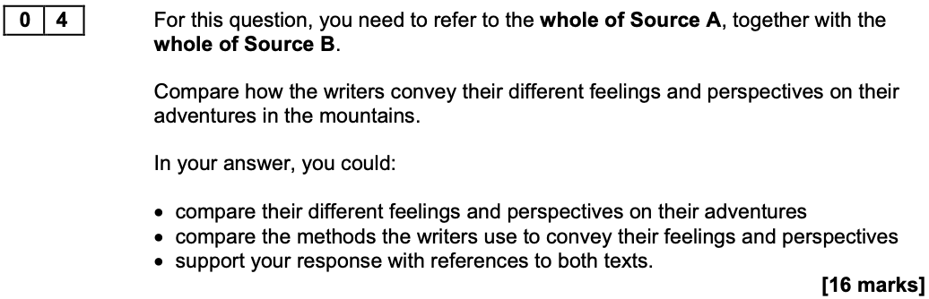

Extract from a Level 2 Response to Develop

The writer in Source A is not very happy about his adventure, but he still hopes that they are going to get down the mountain safely. In the first paragraph he says ‘we had lost that sense of hopelessness’ which makes the reader think that they might make it back to base camp. This is different to the way the other source starts because in Source A we don’t know what will happen but in Source B we know what happens as the writer tells us straight away. She says ‘descended safely’ in the first paragraph so the reader knows before they read the rest of the letter that she will be safe and to show that she is really pleased.

Ideas to Explore Further

Perspectives and Feelings

- Their previous experience
- Their enjoyment
- Their suffering
- Their success
- Their gender
- Their expectations
- Their purpose in writing

Methods

- Structural shifts: highly detailed focus in Source A; episodic shifts in Source B
- Structural viewpoint: first person; descriptive in Source A, reflective in Source B
- Whole text structure: mostly chronological in both sources but openings very different
- Tone: dramatic and distressed in Source A; cheerful and ironic in Source B
- Language: figurative in Source A; understatement and hyperbole in Source B

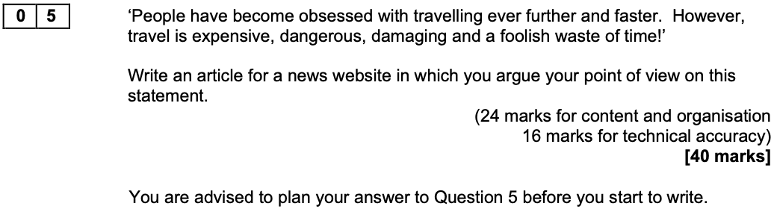

A Reminder of the Level Descriptors

- L4: compelling, convincing communication
- L3: consistent, clear communication
- L2: some successful communication
- L1: simple, limited communication

