GCSE English Language Paper 2 Year 11

Name Teacher

…………………………………………………………………………………………………………………………………….

Contents

Page 1 Overview of the Questions
Page 3 June 2021 Exam Paper (Sweets)
Page 11 June 2022 Exam Paper (Camping)
Page 20 November 2022 Exam Paper (Insomnia)
Page 29 June 2023 Exam Paper (Trains)
Page 37 June 2024 Exam Paper (Hospitals)

Overview of the Questions

Overview of the Questions

Q1 | - Read the statements carefully and double-check your answers
Q2 | - Use the key word/s of the question in each of your points  - Remember that you need to make judgements (so don’t just retell)  - Write at least two full paragraphs  - In Source A, we learn that... This is shown through...  - Contrastingly, we learn in Source B that... This is significant because
Q3 | - Use the key word/s of the question in each of your points  - Write at least three full paragraphs  - The writer uses the word / phrase / image to show…  - This has the effect of… / This is significant because… / We learn from…
Q4 | - Think of this question as a mixture of Q2 and Q3  - Use the key word/s of the question in each of your points  - Don’t forget to analyse language  - Write at least three full paragraphs  - In Source A, one of the writer’s main thoughts / perspectives...  - The writer uses the word / phrase / image to show... This has the effect of  - In contrast / similarly, the writer of Source B feels... This is demonstrated through...  - The writer uses the word / phrase / image to show... This has the effect of...  - A further difference / similarity between the writers’ thoughts / perspectives is...
Q5 | - Technical accuracy really matters  - Craft and don’t rush  - Write at least two full pages (plus a bit)  - Vary the length and structure of your sentences  - Avoid ‘fancy language’ and aim for precision instead  - Selectively and sparingly use devices like rhetorical questions and ellipsis  - Start by stating your viewpoint clearly  - Try to avoid ‘flip-flopping’ between points

- When you look at the past papers, note that the second bullet-point on Q4 will be ‘comment on’ rather than ‘compare’ in the exam

Exam Paper 1

June 2021

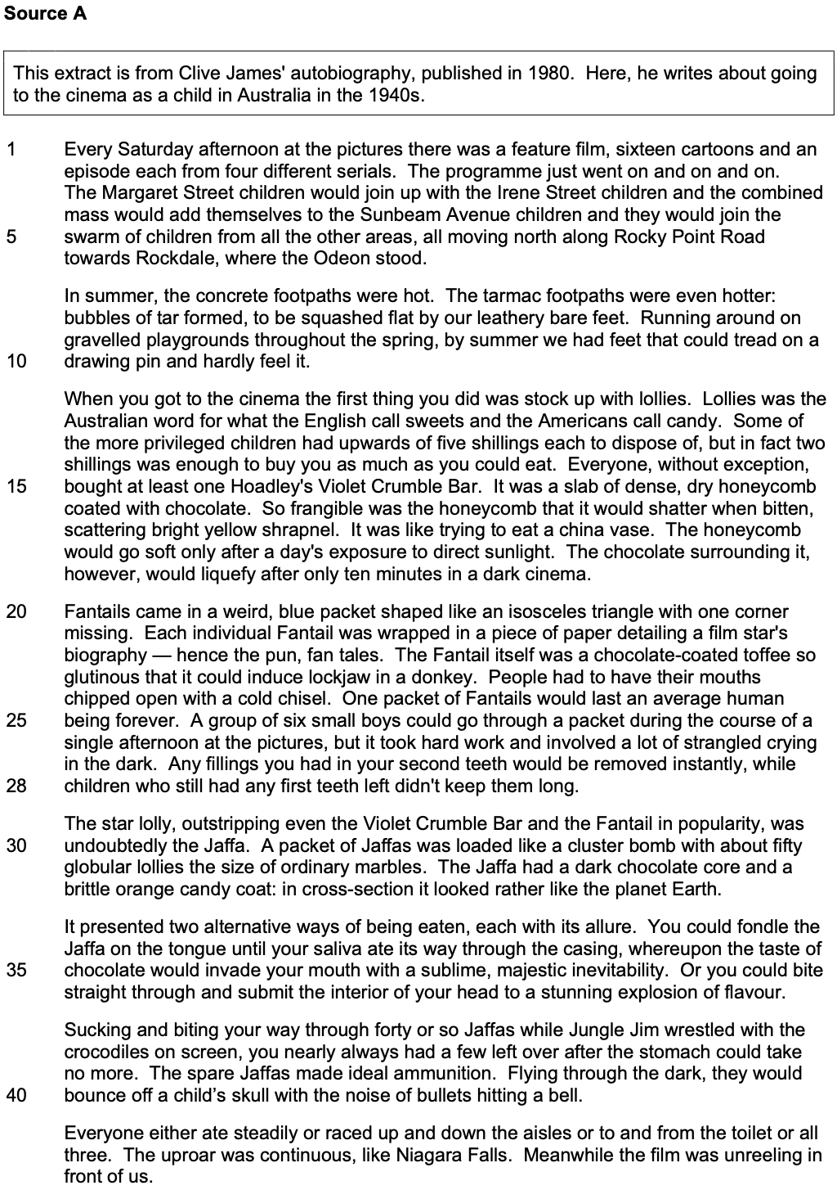

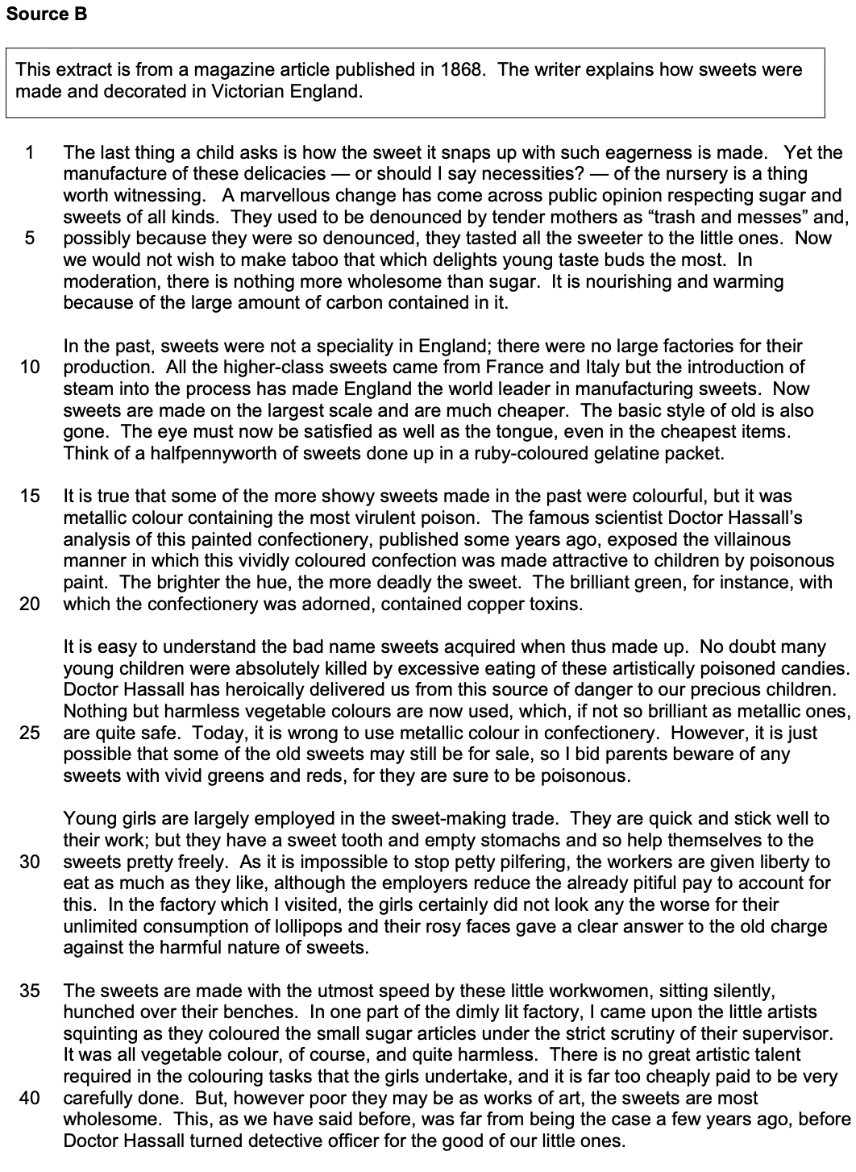

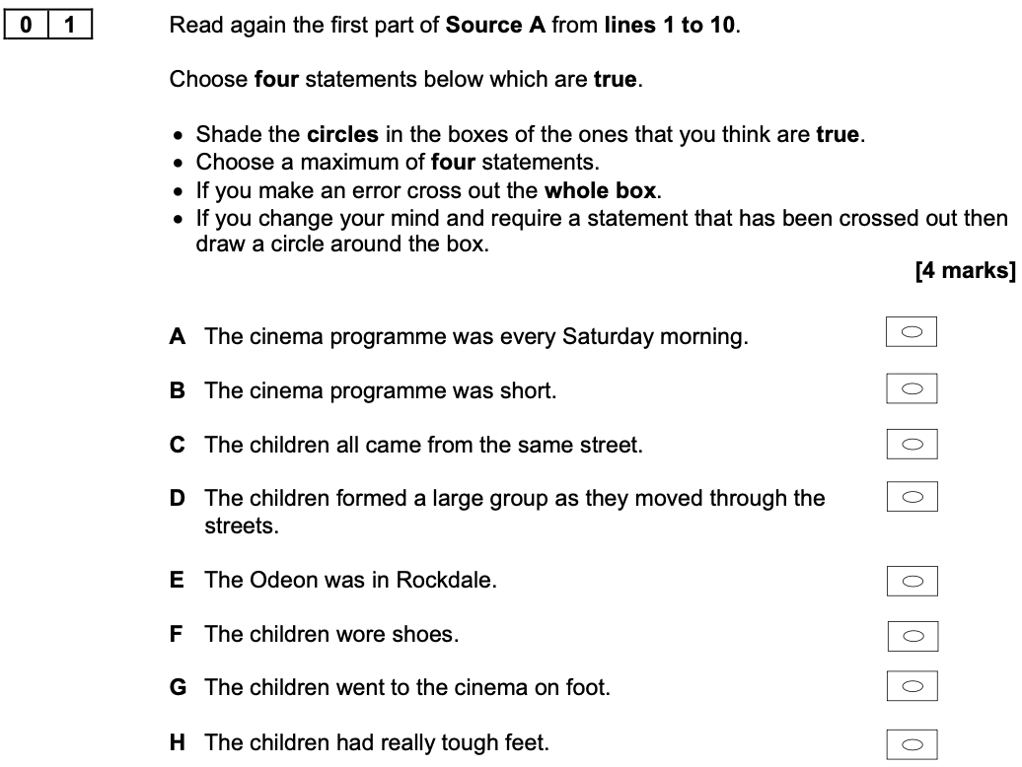

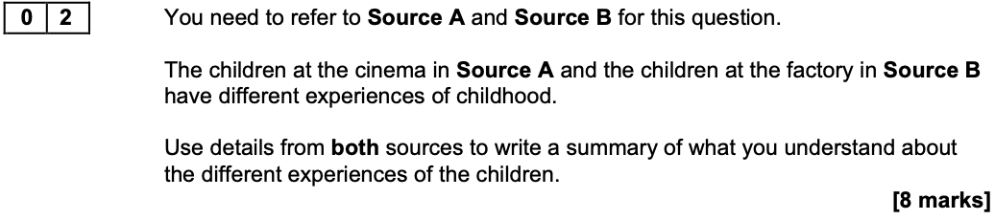
What can you infer about the different experiences of the children?

Extract from a Level 2 Response to Develop

In Source A the children are eating lots of sweets and running around, ‘Everyone either ate steadily or raced up and down the aisles or to and from the toilet or all three’ which shows that they are having fun. This happy childhood experience is different to the other children who have to do a job. In Source B, their experience is hard because it says ‘sitting silently’ which shows they are quiet and still, not allowed to speak or move as they work.

Ideas to Explore Further

- Their surroundings
- Their enjoyment
- Their level of freedom
- Their finances
- Their level of supervision
- Their physical experience
- Their gender

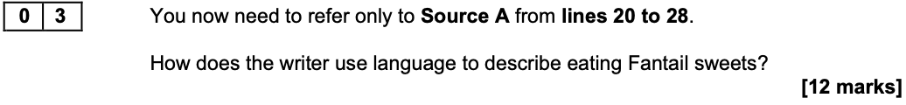

Extract from a Level 2 Response to Develop

The writer uses exaggeration to describe eating the Fantail as difficult. He says that eating these sweets ‘involved a lot of strangled crying in the dark’ which suggests that eating the sweet was like being choked because it made it difficult to breathe.

Ideas to Explore Further

- Visual details – ‘blue packet…one corner missing’
- Alliteration – ‘chipped open with a cold chisel’
- Exaggeration – ‘people had to have their mouths chipped open with a cold chisel’
- Humour – ‘induce lockjaw in a donkey’
- Interesting word choices – ‘weird’, ‘glutinous’, ‘instantly’
- Harsh vocabulary – ‘chipped’, ‘chisel’, ‘strangled’, ‘lockjaw’

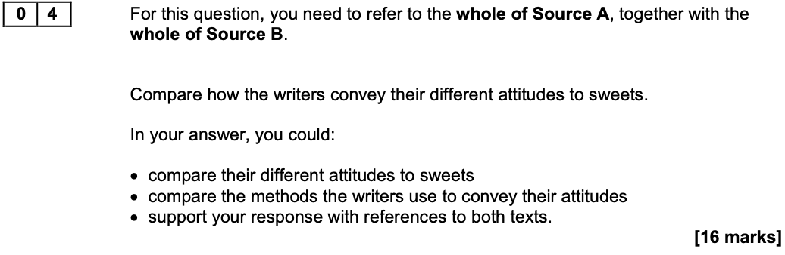

Extract from a Level 2 Response to Develop

The writer of Source A is excited about eating sweets at the cinema. He even describes the Jaffa as the ‘star lolly’ to show that this was his favourite. The adjective ‘star’ suggests that it stood out from the others. On the other hand, the writer in Source B is worried that some sweets may be dangerous for children. He uses repetition of ‘poison’ and ‘poisonous’ to show that sweets can make children poorly. This shows that he thinks sweets can be very dangerous to children’s health.

Ideas to Explore Further

Perspectives and Feelings

- The appearance and appeal of sweets
- The consumption of sweets
- The acquisition and cost of sweets
- The amount of sweets
- The nutritional value of sweets
- Their interest in sweets
- The importance of sweets

Methods

- Structural shifts to show changes of focus
- Structural viewpoint – Source A is an autobiography, Source B is contemporary report
- Tone – Source A is humorous and light-hearted, Source B is serious and informative
- Language – metaphors and similes in both
- Vocabulary – sensual in Source A, more scientific and dramatic in Source B

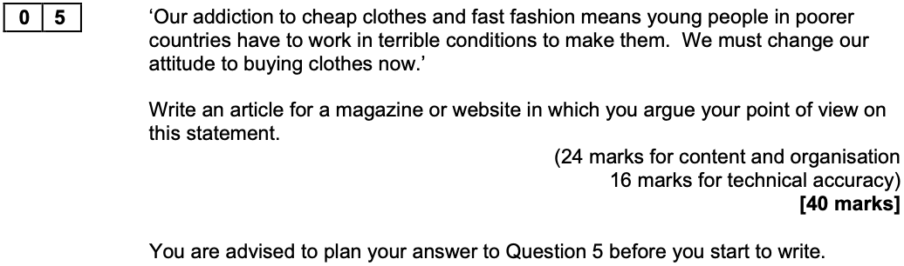

A Reminder of the Level Descriptors

- L4: compelling, convincing communication
- L3: consistent, clear communication
- L2: some successful communication
- L1: simple, limited communication

Exam Paper 2

June 2022

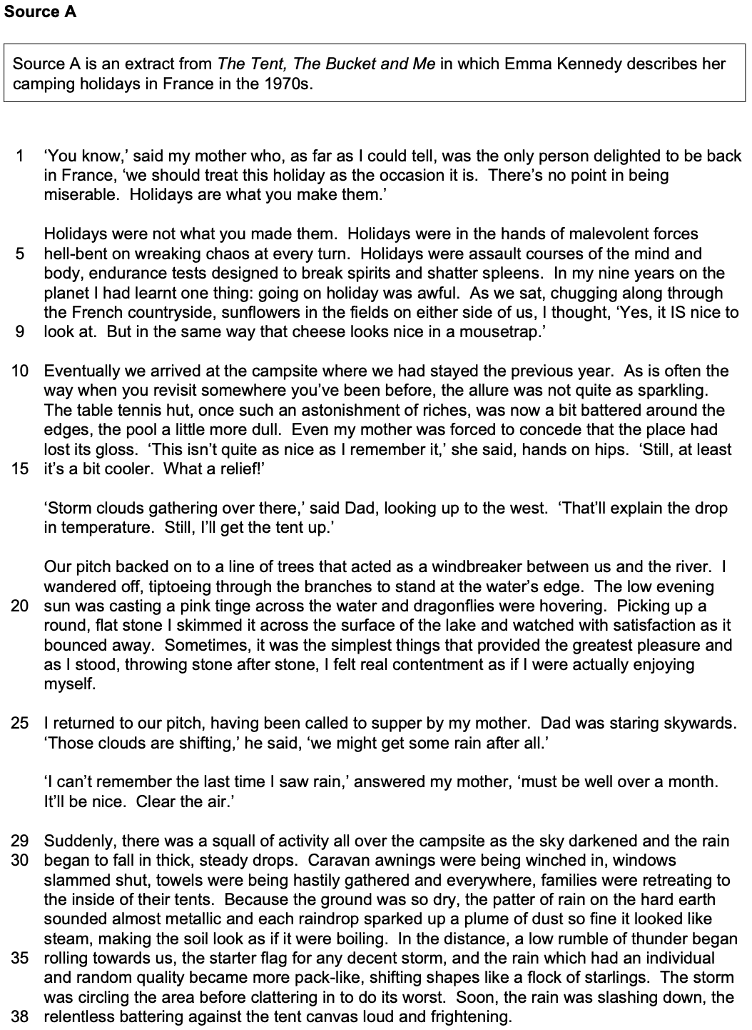

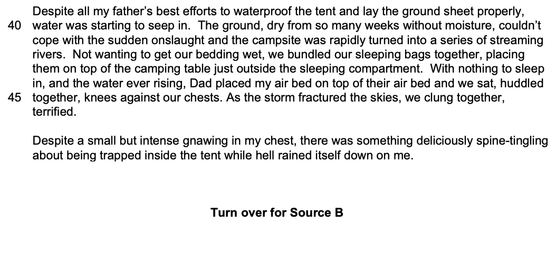
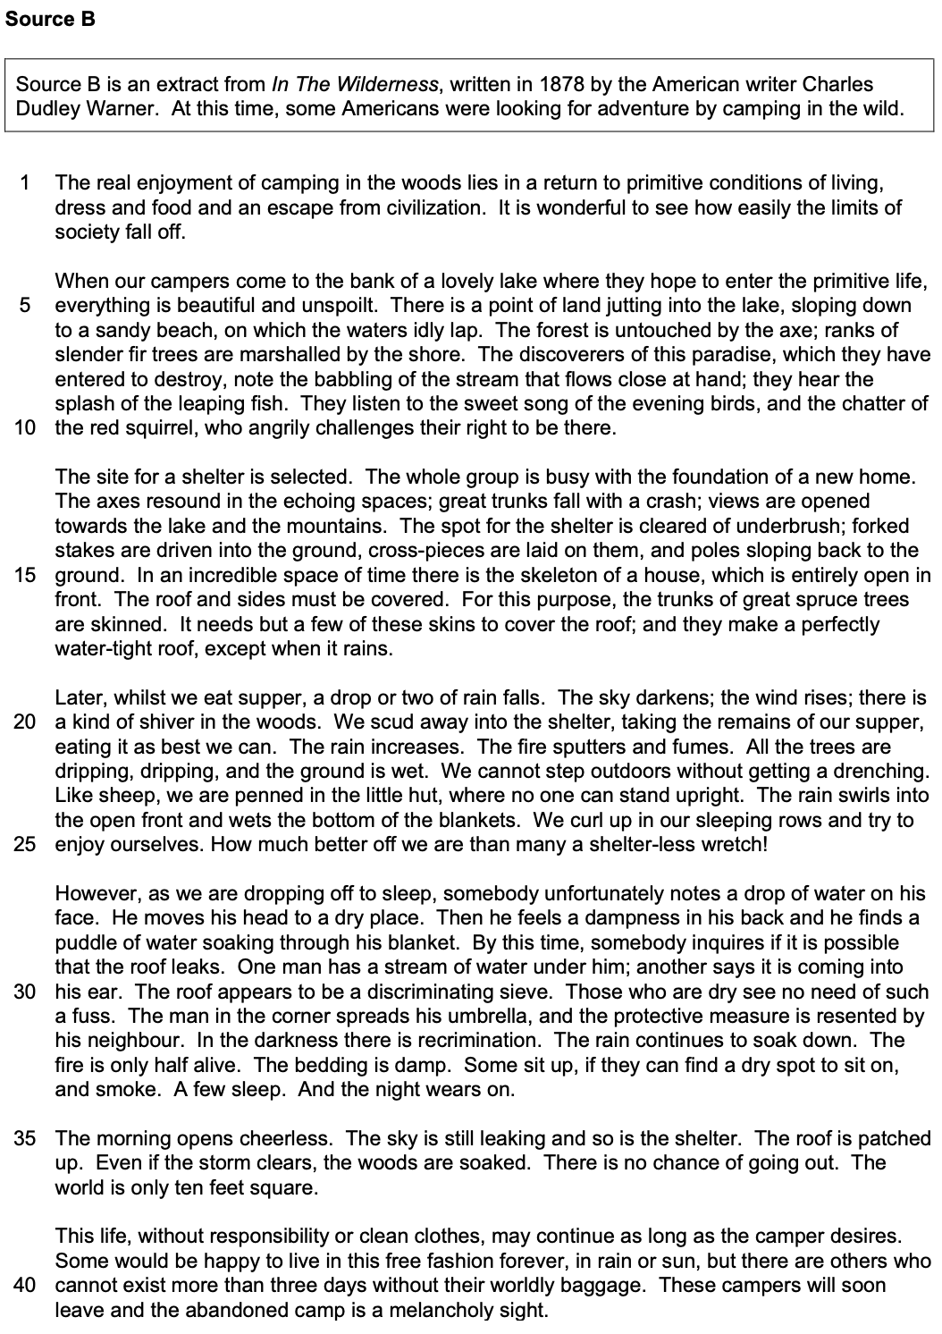
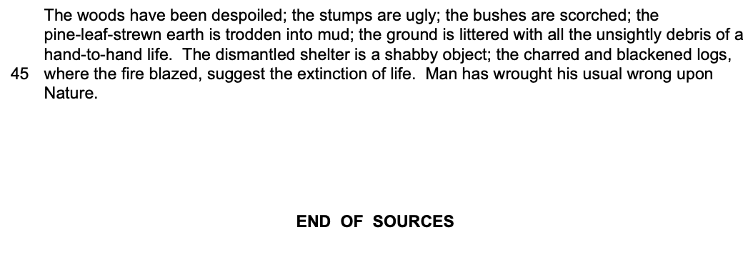

………………………………………………………………………………………………………………………………………….

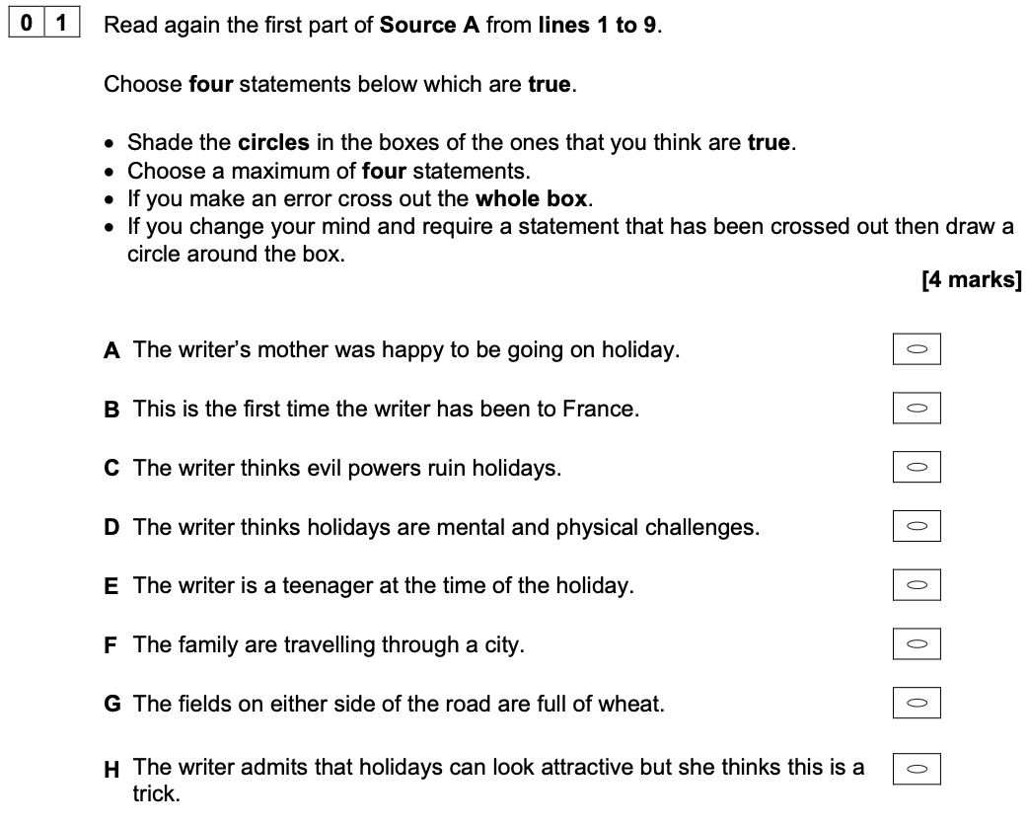

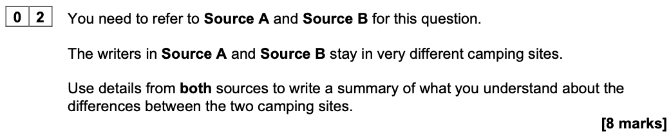
What can you infer about the differences between the two camping sites?

Extract from a Level 2 Response to Develop

In Source A, the camping site has activities as it has a ‘table tennis hut’ and a ‘pool’ which means there are fun things for the campers to do. In Source B, it is very different as they are not staying in a camp site that someone else has made for them, so they have to make it themselves, ‘A site for a shelter is selected.’ This is not very good as they have to work hard.

Ideas to Explore Further

- Construction
- Facilities
- Condition
- Surroundings/locations
- Environments
- Size
- Shelter
- Other people

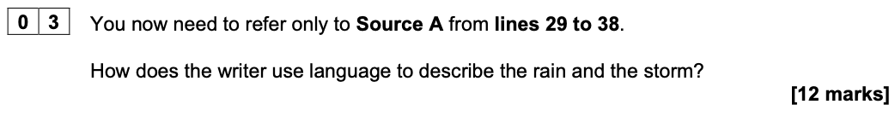

Extract from a Level 2 Response to Develop

The writer uses lots of different language to describe the rain. She uses the simile ‘shifting shapes like a flock of starlings’ to show how the storm looks like a large, dark group of birds moving about together in the sky.

Ideas to Explore Further

- Onomatopoeia – ‘squall’, ‘slammed’, ‘patter’, ‘rumble’, ‘clattering’, ‘slashing’
- Similes – ‘so fine it looked like steam, making the soil look as if it were boiling’
- Listing – ‘Caravan awnings were….retreating to the inside of their tents’
- Personification – ‘The storm was circling…to do its worst’
- Metaphors – ‘squall of activity’, ‘starter flag for any decent storm’
- Adjectives – ‘thick, steady’, ‘metallic’, ‘relentless’
- Adverbs – ‘suddenly’, ‘hastily’
- Verbs – ‘darkened’, ‘sparked up’, ‘winched’, ‘slammed’, ‘gathered’, ‘retreating’

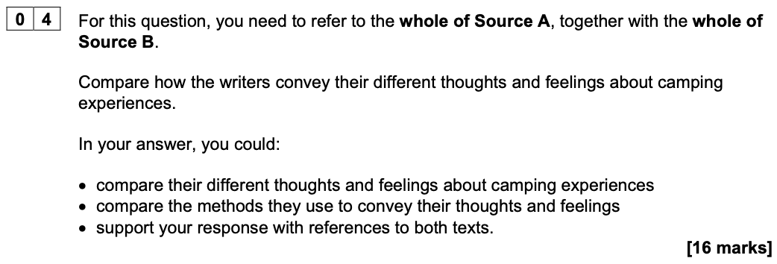

Extract from a Level 2 Response to Develop

The writer of Source A feels camping holidays are ‘assault courses’ which shows that she thinks they are not enjoyable. She makes this clear from the start, so we think she hates camping but later she describes throwing stones in the river as ’the greatest pleasure’ so she is starting to feel happier about it now. On the other hand, the change of feelings in Source B is the opposite way around as the writer is looking forward to camping. He begins with the positive idea that camping is ‘wonderful’ and ‘an escape’’, but at the end he writes, ‘the stumps are ugly’ and ‘Man has wrought his usual wrong upon Nature’ which shows he has changed his mind completely. This shows that he feels that when people go camping it causes damage.

Ideas to Explore Further

Perspectives and Feelings

- The philosophy
- The locations / environments
- The accommodation
- The difficulties / challenges
- The attraction / appeal
- The companions
- The weather

Methods

- First person – although this is less obvious in Source B
- Chronological narrative – arrival in Source A, and arrival and departure in Source B
- Whole text structure – shifts between action, reflection, description and dialogue
- Tone – dramatic and excited in Source A, ironic and critical in Source B
- Language – sensory and figurative in Source A; emotive and figurative in Source B

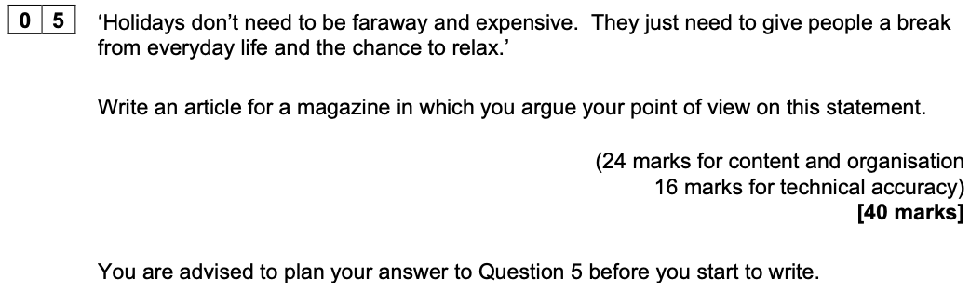

Focus Areas

- Precise and varied vocabulary
- Accurate spelling
- Varied sentence structures
- Range of punctuation
- Fluently linked paragraphs

Exam Paper 3

November 2022

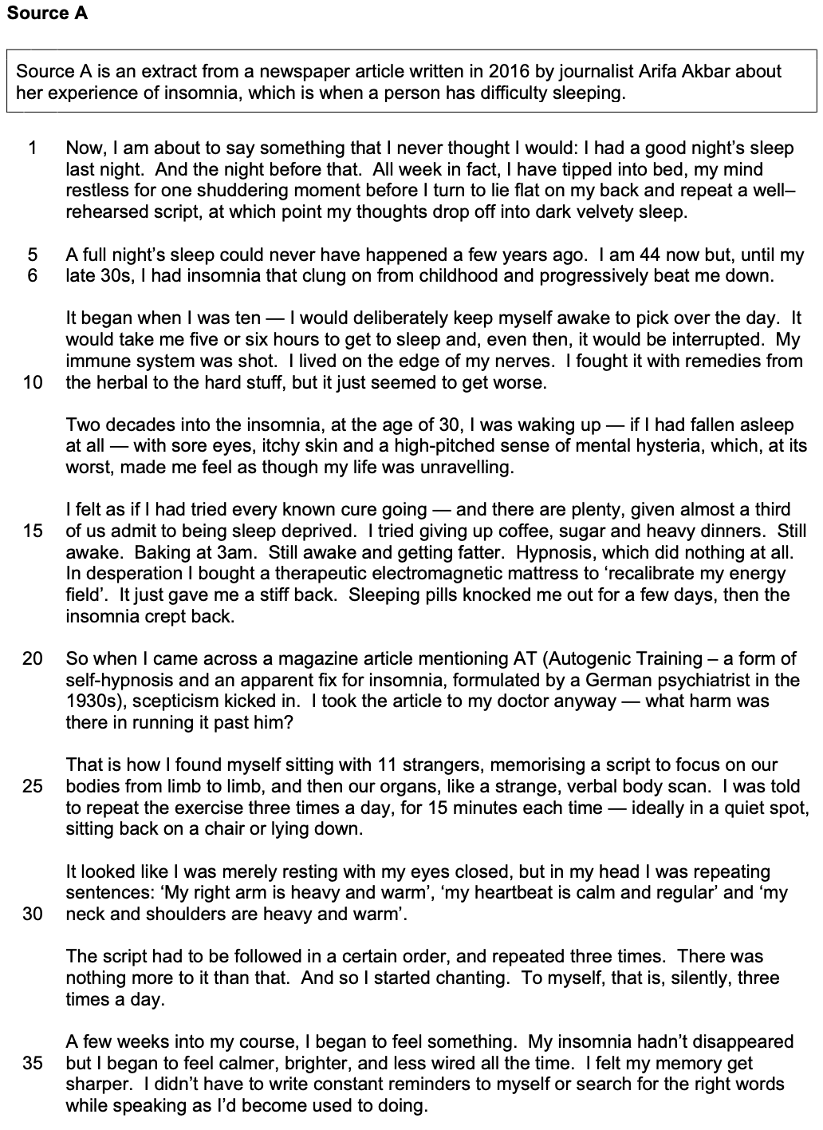

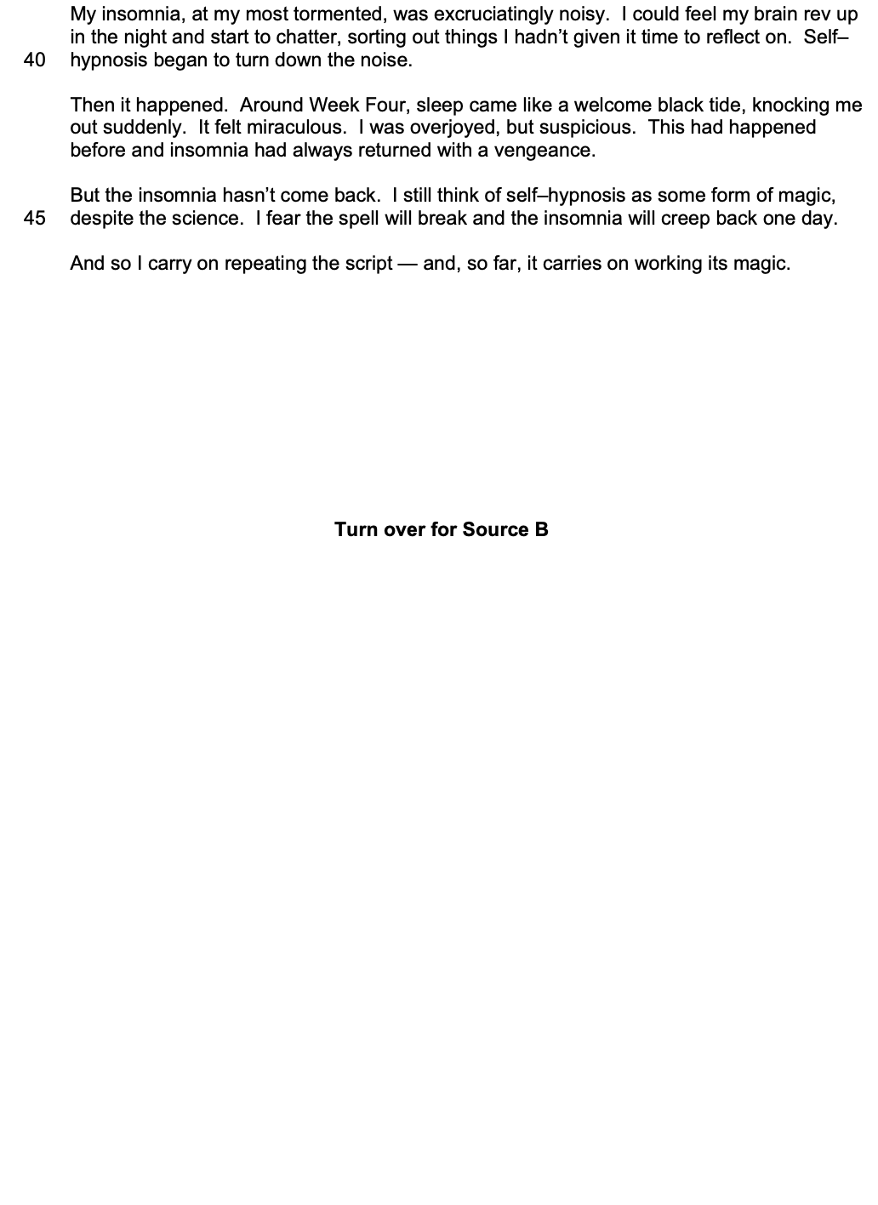

…..

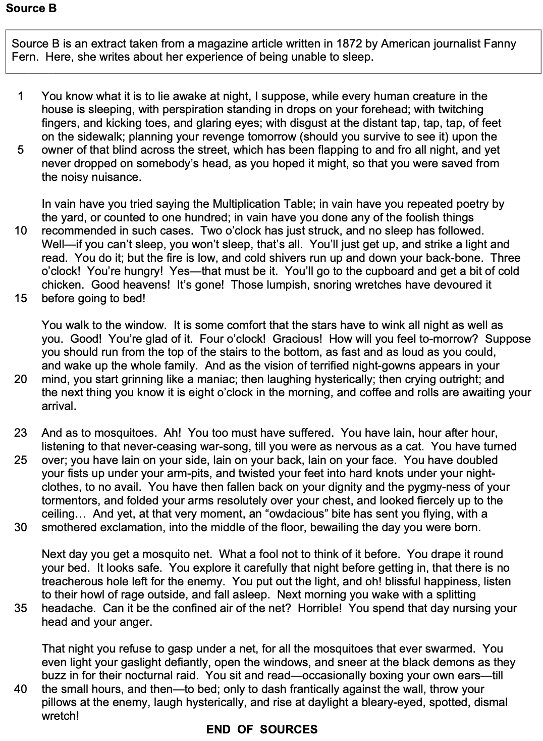

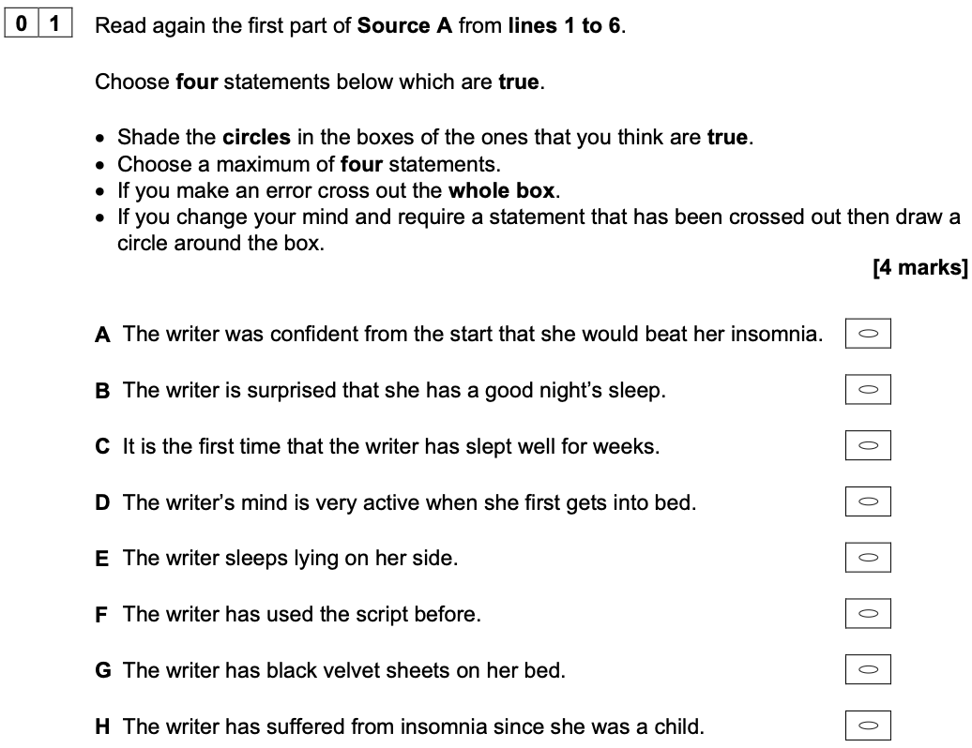

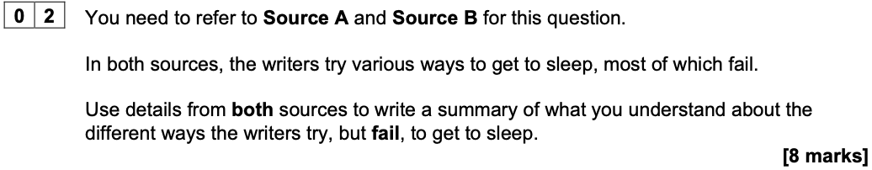
What can you infer about the different ways the writers try, but fail, to get to sleep?

A Warning from the Chief Examiner

Weaker responses were characterised by paraphrase rather than interpretation. Many students provided a full list of the different methods the writers used, with textual detail to support the response, but without any attempt to interpret the information and ideas.

Ideas to Explore Further

- Counting
- Reciting
- Listing
- Reading
- Baking
- Eating / drinking
- Hypnosis
- Moving about / changing position
- Taking medication / drugs
- Using gadgets / equipment

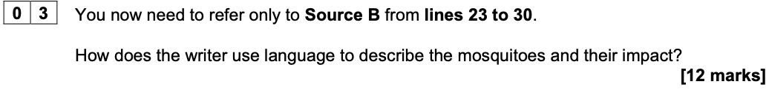

A Warning from the Chief Examiner

At Level 1, students tended to select examples of language and identify the language technique with general accuracy but failed to comment on what effect it created beyond a generic comment.

Ideas to Explore Further

- Metaphor: ‘never-ceasing war-song’
- Personification: ‘the pygmy-ness of your tormentors’
- Made-up words / pun: ‘an ‘owdacious’ bite’
- Simile: ‘as nervous as a cat’
- Repetition: ‘lain…’
- Pattern of three: ‘lain on your side…’
- Active verbs: ‘twisted’, ‘doubled’, ‘folded’, ‘flying’
- Emotive language: ‘fiercely’, ‘dignity’, ‘resolutely’, ‘bewailing’
- Metaphor: ‘twisted your feet into hard knots’
- Battle or conflict vocabulary: ‘fists’, ‘suffered’, ‘war-song’, ‘fiercely’
- Hyperbole: ‘bewailing the day you were born’

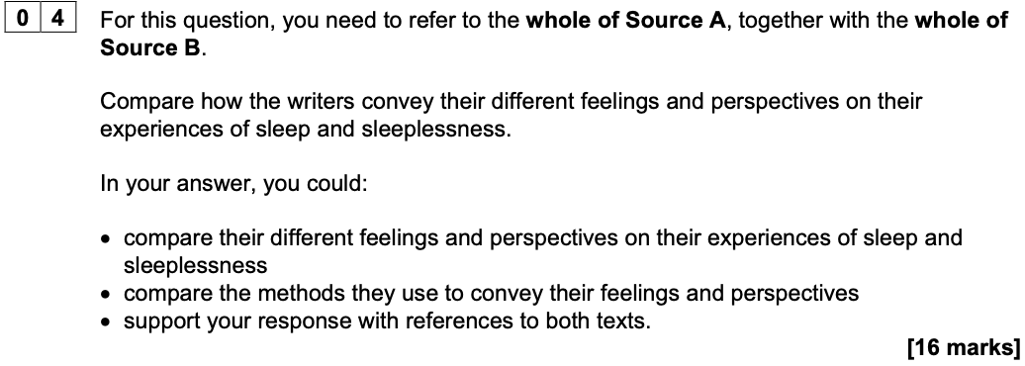

A Warning from the Chief Examiner

Weaker responses tended to revert to paraphrase. Level 1 responses recounted explicit ideas from the text and made basic cross references without any evidence of independent understanding.

Ideas to Explore Further

Perspectives and Feelings

- The time frame
- The impact on their lives
- Their response
- Their actions
- Their thoughts
- Their feelings

Methods

- Structure – chronological, flashbacks in Source A, chronological, diary-like in Source B
- Viewpoint – first person, anecdotal in Source A, interior monologue in Source B
- Tone – mostly serious and desperate in Source A; exaggerated and comic in Source B
- Language – metaphor, alliteration, facts in Source A; hyperbole, imagery, list of Source B

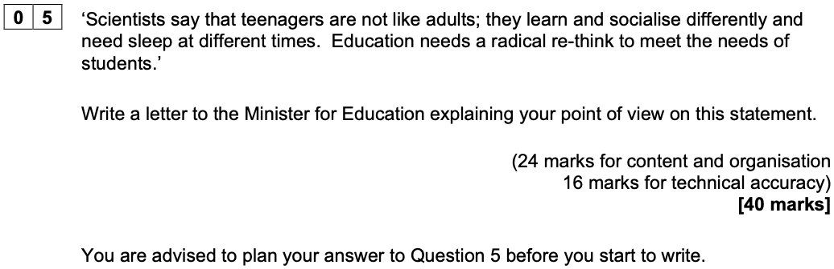

A Warning from the Chief Examiner

There were a few weak responses which failed to meet the criteria for Level 2. These tended to be very short, simple in their approach and offered a limited range of ideas. At Level 2, students typically presented their ideas in poorly structured paragraphs without a sense of overall coherence or a clear set of proposals: the letter ended with the reader unsure what was expected to happen next. There were fewer instances of pre-prepared vocabulary, which was an improvement on the summer series, but in many responses at Level 2 there was little conscious choice of vocabulary or use of linguistic devices to lift the style of writing above the mundane. Shaping and developing a series of points into a coherent argument is what is most likely to take a student into Level 3.

Exam Paper 4

June 2023

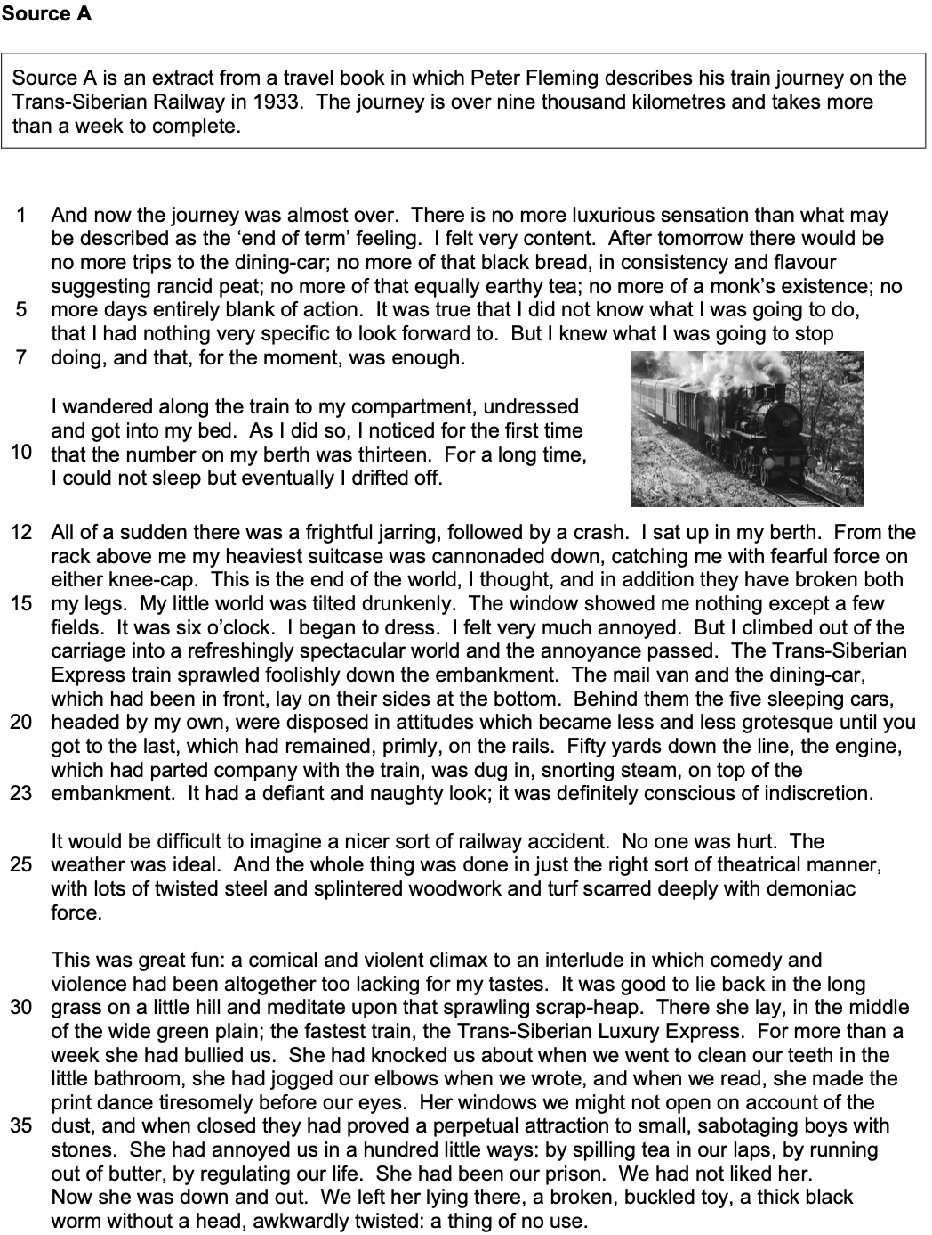

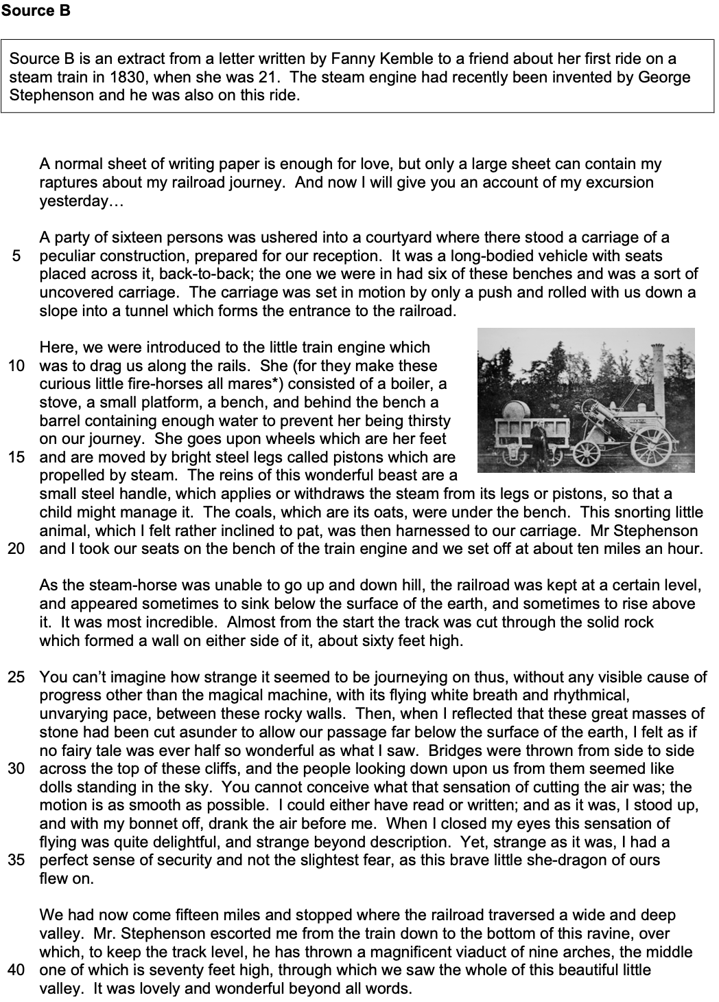

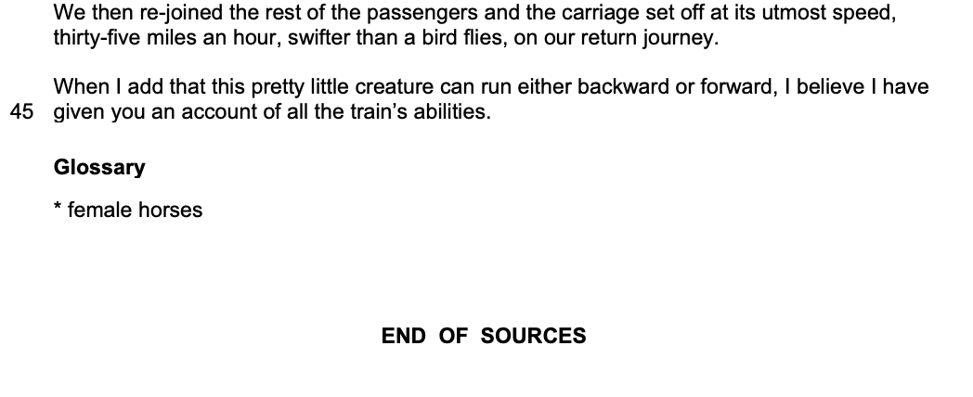
………………………………………………………………………………………………………………………………………….

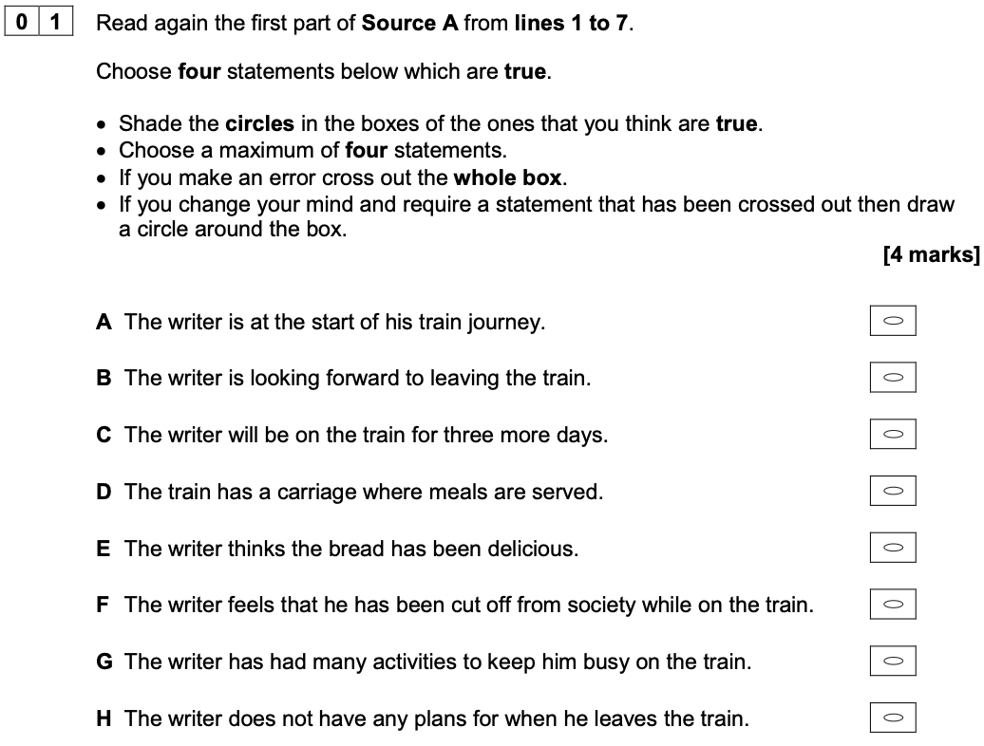

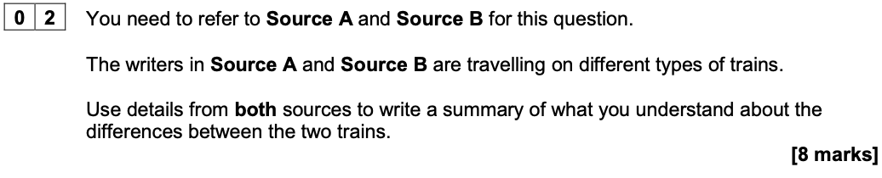
What can you infer about the differences between the two trains?

A Warning from the Chief Examiner

Students are advised to read the task carefully and ensure they have understood the correct focus. Many students overlooked easily accessible information about the trains, such as the size of them, which could have been the foundation for inferential understanding. Using the focus of the question as the subject of each sentence is one means of ensuring the focus is maintained. Once a detail has been selected, such as the train having a dining car, the student needs to develop their response from what this tells us explicitly – that you could eat on the train – to what you can interpret about the train – such as that eating meals meant you could stay on the train longer and travel further. It is the development and explanation of these relatively simple points which will lift students from Level 2 to Level 3.

Ideas to Explore Further

- Size
- Number of carriages
- Facilities / comfort
- Performance / ability
- Stage in development
- Number of passengers
- Purpose / design
- Duration of journey
- Materials
- Safety

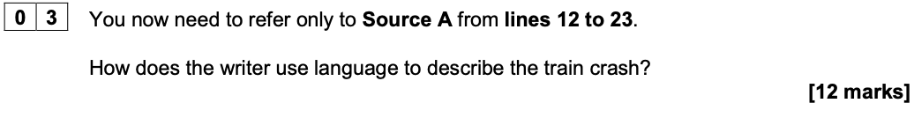

A Warning from the Chief Examiner

Another area where students struggled to comment on effect was where they chose to write about sentences. Many students selected the series of short sentences as an example of language use, and then found they had little or nothing to say about the reasons why the writer might have used them. Unless students are very confident about the effect – as here, where the writer deliberately chooses brief, factual, unembellished simple sentence forms to emphasise the pragmatic approach he is taking to the potential trauma of the crash, which creates a sense of British stiff upper lip and a stoic tone, or similar comment – then students are well-advised to avoid writing about sentences.

Ideas to Explore Further

- Onomatopoeia – ‘crash’
- Adjectives – ‘frightful’, ‘heaviest’, ‘spectacular’
- Verbs – ‘cannonaded’, ‘tilted’, ‘dug in’, ‘disposed’
- Alliteration – ‘fearful force’
- Short sentences – ‘I sat up in my bed’, ‘It was six o'clock. I began to dress.’
- Adverbs – ‘drunkenly’, ‘refreshingly’, ‘primly’, ‘definitely’
- Zoomorphism – ‘snorting steam’
- Personification – ‘defiant and naughty look’, ‘definitely conscious of indiscretion’
- Metaphors – ‘cannonaded’, ‘dug in’, ‘little world’
- Juxtaposition of ‘grotesque’ and ‘primly’
- Hyperbole – ‘end of the world’, ‘broken both my legs’

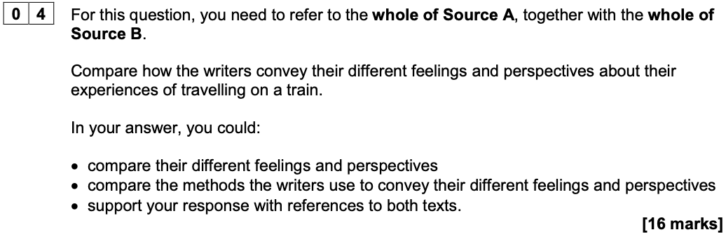

A Warning from the Chief Examiner

Some students working at a lower level compared the writers’ perspectives as being ‘positive’ and ‘negative’. This is essentially saying no more than one is good and the other is bad or one likes it and the other one doesn’t. Unless there is further detail provided to indicate what, why or how the writers feel as they do, the comment is judged to be generalised and, therefore, Level 1.

Ideas to Explore Further

Perspectives and Feelings

- Boredom / intrigue
- Loathing / liking
- Familiarity / novelty
- Apathy / curiosity
- Experience / innocence
- Underwhelmed / overwhelmed
- Confinement / freedom
- Contempt / admiration for the trains

Methods

- First-person accounts – though Source A is for the public, Source B is a private letter
- Chronological structure – end of experience in Source A, whole experience in Source B
- Shifts between action and reflection in both Source A and Source B
- Climax of the train crash in Source A and the experience of the journey in Source B
- Tone – mocking but also dramatic in Source A; dramatic, but also explanatory in Source B
- Language – personification in both Source A and B; listing in both Source A and B

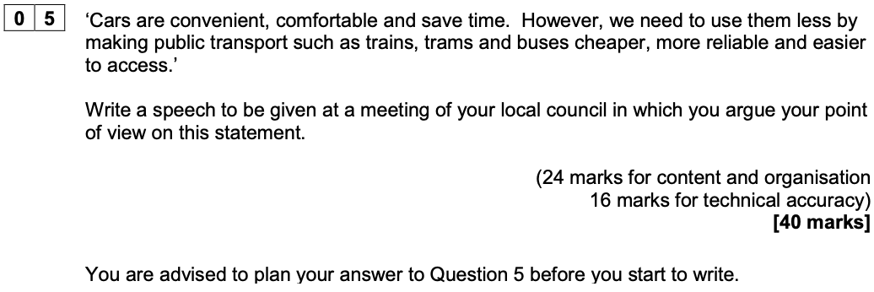

A Warning from the Chief Examiner

Weaker responses demonstrated a lack of variety in the sentence structures attempted, and a subsequent absence of a range of punctuation. Lack of control of agreement was frequently evident in these responses as students struggled to maintain secure syntax. The absence of demarcation and other punctuation was a particular feature seen in the response of those students who typed their work. What is certain is that many students working at Level 1 and Level 2 demonstrated an erratic approach to their technical skills.

Exam Paper 5

June 2024

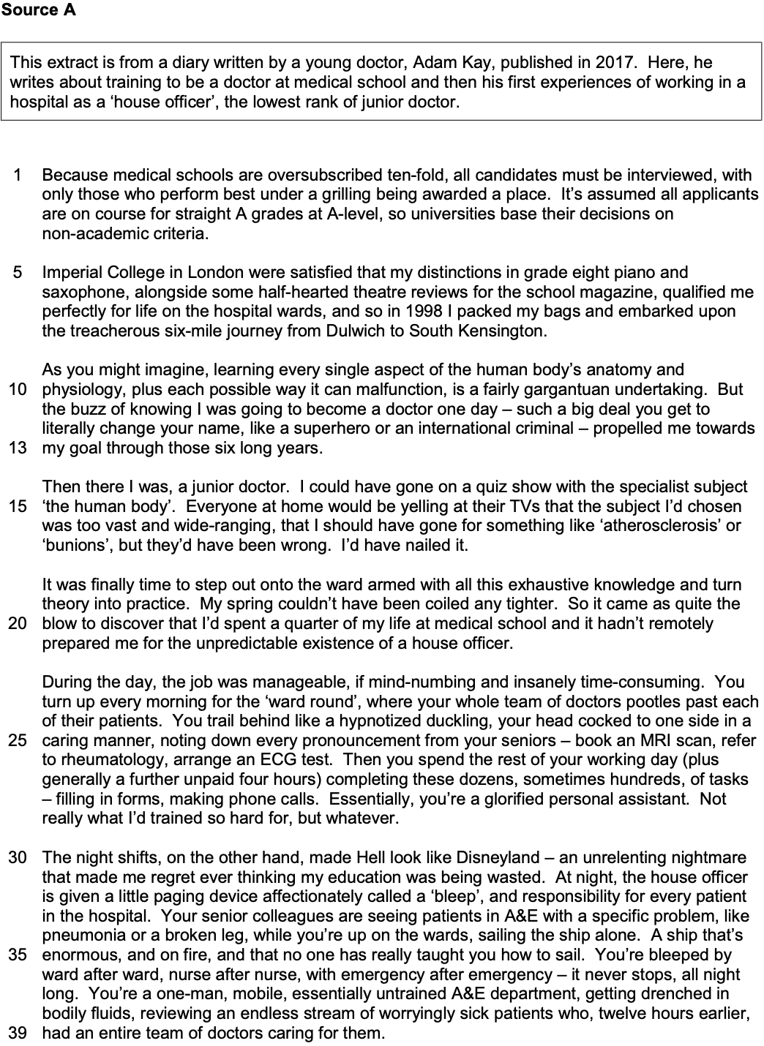
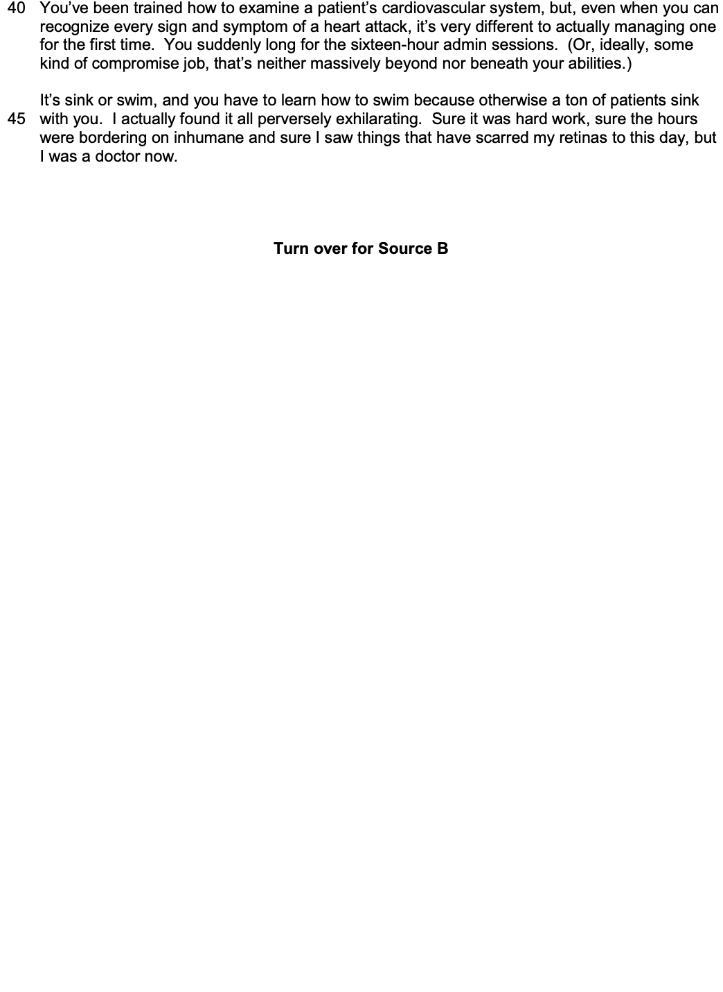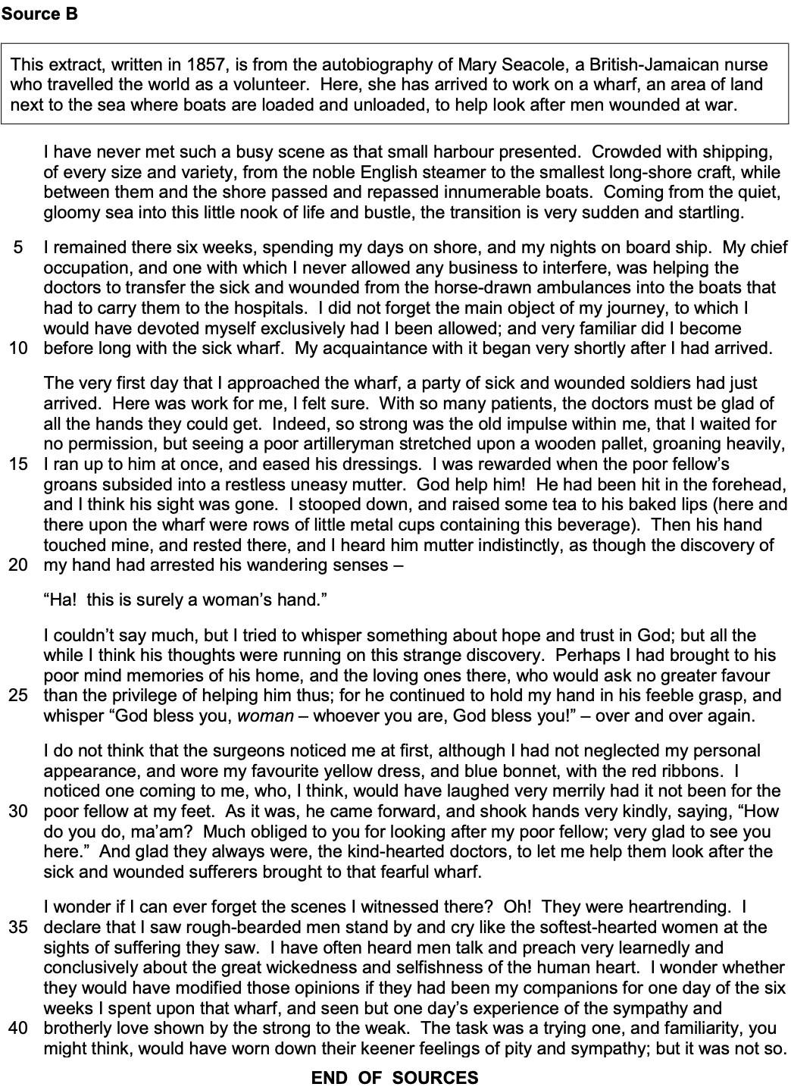

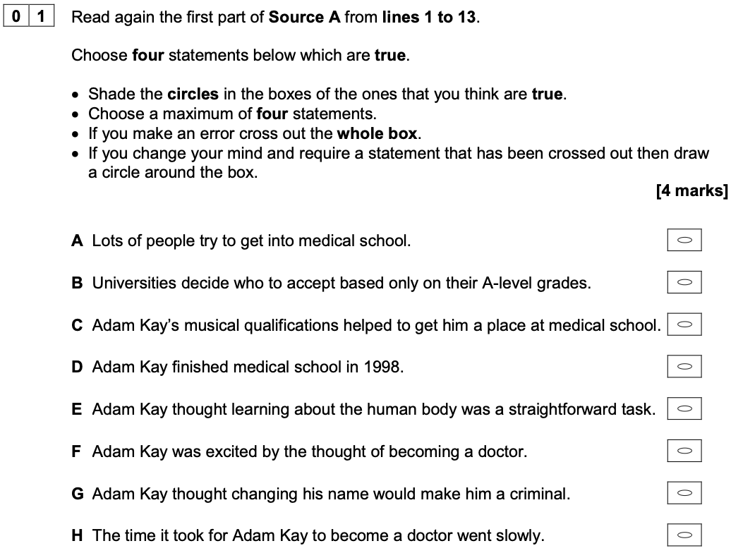

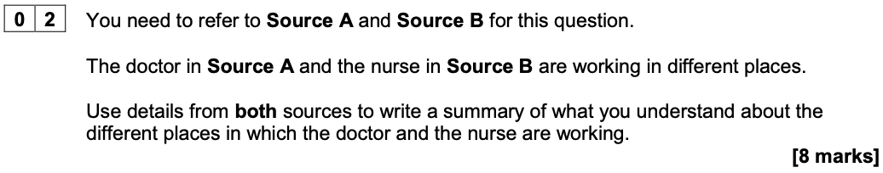
What can you infer about the different places in which the doctor and nurse are working?

Extract from a Level 2 Response to Develop

In Source A the doctor is part of a busy hospital. It says, ‘book an MRI scan, refer to rheumatology, arrange an ECG test’, showing there are lots of options for helping people. However, the wharf in Source B is very different as there are not so many options because it says, ‘a poor artilleryman stretched upon a wooden pallet’. This suggests a much more basic place without as much equipment.

Ideas to Explore Further

- Their surroundings
- Their purpose
- Their level of permanence
- The working conditions
- Their equipment
- Their facilities
- Their atmosphere
- Other staff / level of supervision

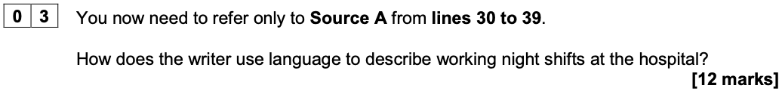

Extract from a Level 2 Response to Develop

The writer uses a metaphor to compare the difficulty of working on the night shift to ‘sailing the ship alone’. The use of ‘ship’ suggests that he has a big job to do and there is nobody there to help him with it.

Ideas to Explore Further

- Juxtaposition / comparison – ‘made Hell look like Disneyland’
- Extended metaphor – ‘sailing the ship alone... enormous and on fire’
- Adjectives – ‘unrelenting’, ‘endless’
- Repetition – ‘ward after ward, nurse after nurse, with emergency after emergency’
- Listing / triplet – ‘one-man, mobile, essentially untrained A&E department’
- Metaphor – ‘stream of… patients’; ‘unrelenting nightmare’
- Direct address – ‘Your senior colleagues…’
- Onomatopoeia – ‘bleep’

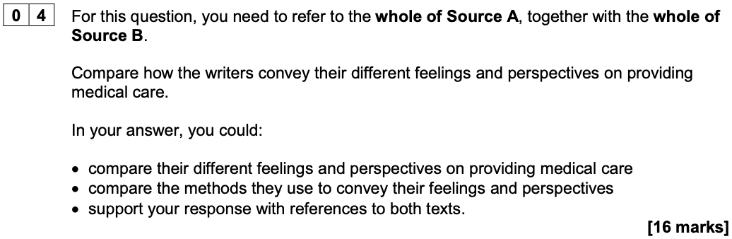

Extract from a Level 2 Response to Develop

The doctor in Source A had a tough experience training to be a doctor. He says, ‘Sure it was hard work, sure the hours were bordering on inhumane and sure I saw things that have scarred my retinas to this day, but I was a doctor now.’ This list shows that he had some difficult experiences on his way to being a doctor. However, in Source B, the nurse is glad to have helped the wounded soldiers. She says, ‘the sympathy and brotherly love shown by the strong to the weak’. She uses the word ‘brotherly’ to describe how they treat the patients as if they were as close as brothers. This shows that she was impressed by how caring they were.

Ideas to Explore Further

Perspectives and Feelings

- Their motivation
- The nature of their work
- Their experiences of treating others
- Their training
- Their purpose

Methods

- Tone – Source A as humorous, sarcastic, caustic; Source B as emotive, serious, worthy
- Use of first person, but use of direct address in both for different purposes
- Use of speech in Source B to bring the scene to life
- Structural shifts in both pieces, moving from training / arrival to actual practice
- Language – metaphor, hyperbole in Source A; emotive language, exclamations in Source B

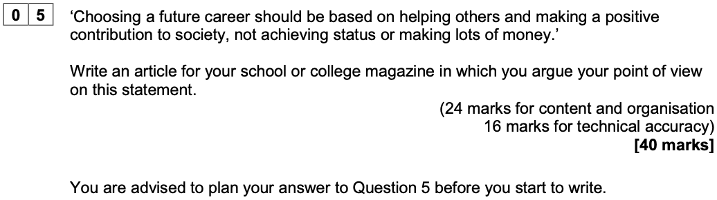

A Reminder of the Level Descriptors

- L4: compelling, convincing communication
- L3: consistent, clear communication
- L2: some successful communication
- L1: simple, limited communication

