**Section B: Writing**

You are advised to spend about 45 minutes on this section.

Write in full sentences.

You are reminded of the need to plan your answer.

You should leave enough time to check your work at the end.

**0 5** A newspaper is running a creative writing competition.

Choose **one** of the following options below for your entry.

**Either**

Write a description of a busy city street from your imagination. You may choose to use the picture provided for ideas.

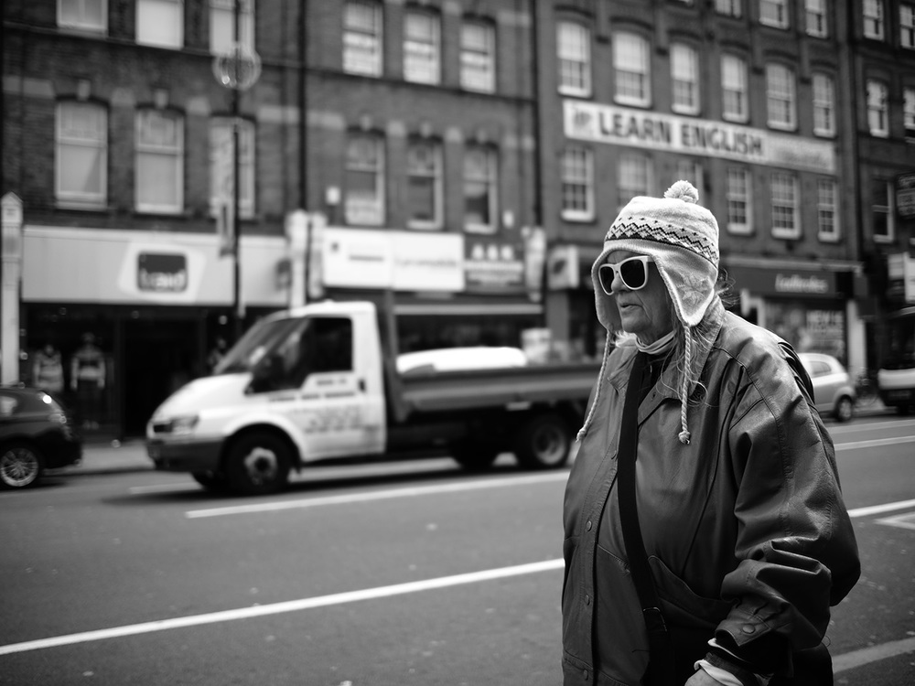

**or**

Write the opening of a story about an important journey through a busy city.

(24 marks for content and organisation

16 marks for technical accuracy)

**[40 marks]**

**Section B: Writing**

You are advised to spend about 45 minutes on this section.

Write in full sentences.

You are reminded of the need to plan your answer.

You should leave enough time to check your work at the end.

**0 5** A newspaper is running a creative writing competition.

Choose **one** of the following options below for your entry.

**Either**

Write a description of a busy shopping centre from your imagination. You may choose to use the picture provided for ideas.

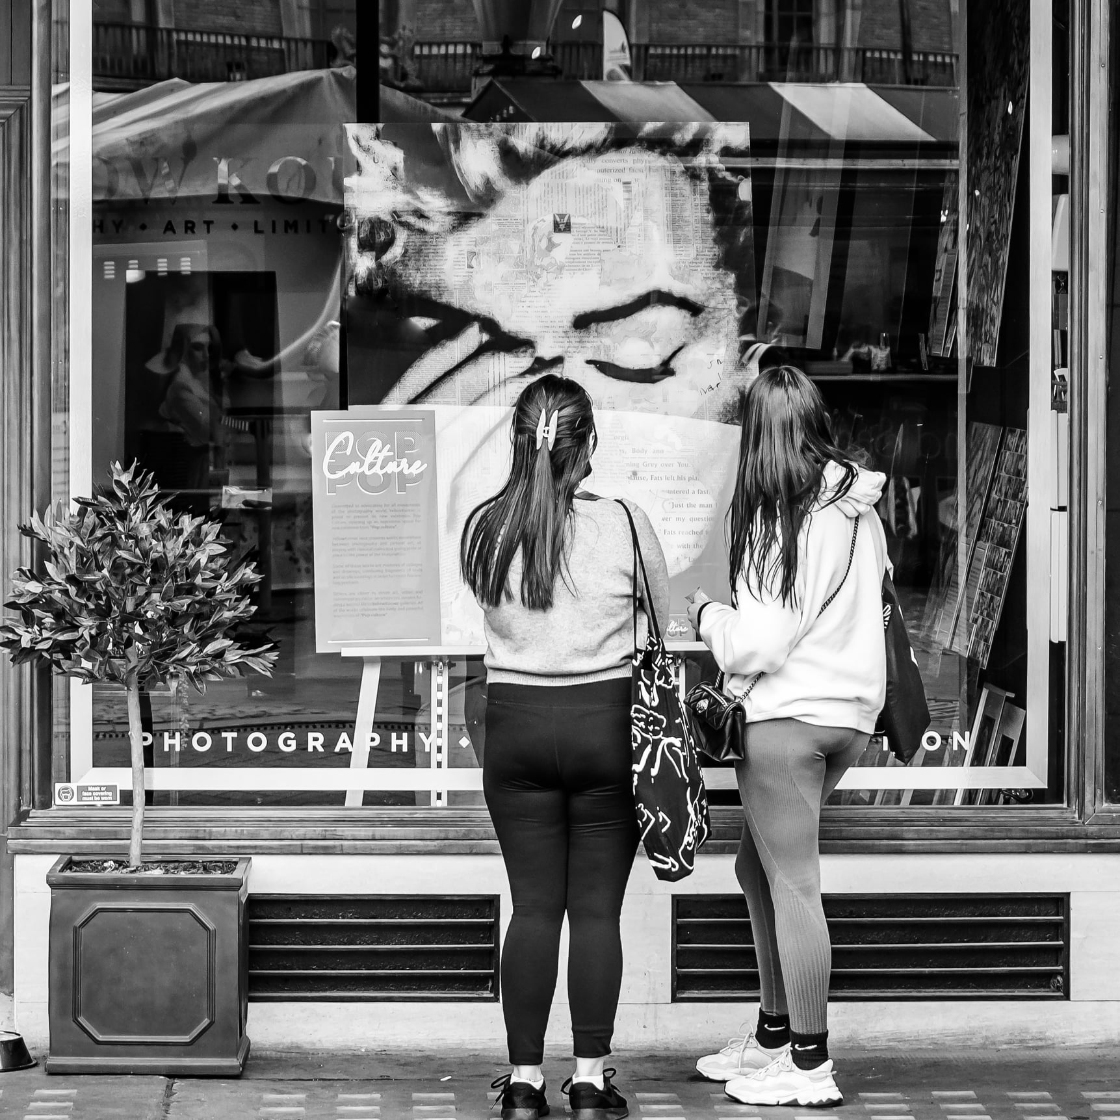

**or**

Write the opening of a story about two friends who meet to go shopping.

(24 marks for content and organisation

16 marks for technical accuracy)

**[40 marks]**

**Section B: Writing**

You are advised to spend about 45 minutes on this section.

Write in full sentences.

You are reminded of the need to plan your answer.

You should leave enough time to check your work at the end.

**0 5** A newspaper is running a creative writing competition.

Choose **one** of the following options below for your entry.

**Either**

Write a description of an important journey. You may choose to use the picture provided for ideas.

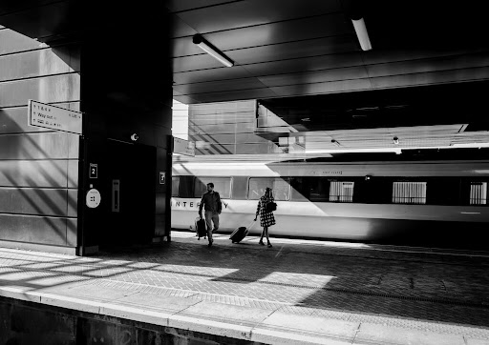

**or**

Write the opening of a story about a two people who meet at a station.

(24 marks for content and organisation

16 marks for technical accuracy)

**[40 marks]**

**Section B: Writing**

You are advised to spend about 45 minutes on this section.

Write in full sentences.

You are reminded of the need to plan your answer.

You should leave enough time to check your work at the end.

**0 5** A newspaper is running a creative writing competition.

Choose **one** of the following options below for your entry.

**Either**

Write a description of a place in the countryside. You may choose to use the picture provided for ideas.

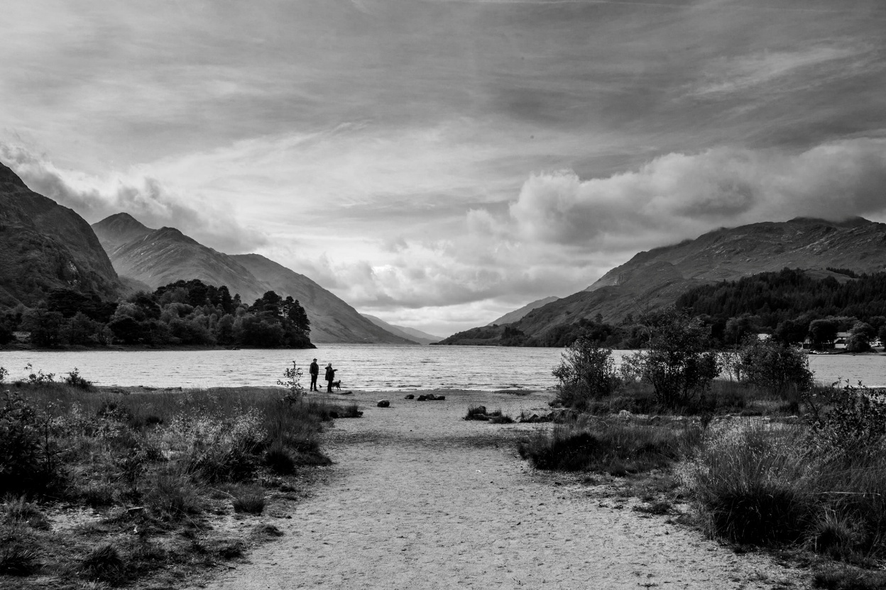

**or**

Write the opening of a story about a two people who get lost in the countryside.

(24 marks for content and organisation

16 marks for technical accuracy)

**[40 marks]**

**Section B: Writing**

You are advised to spend about 45 minutes on this section.

Write in full sentences.

You are reminded of the need to plan your answer.

You should leave enough time to check your work at the end.

**0 5** A newspaper is running a creative writing competition.

Choose **one** of the following options below for your entry.

**Either**

Write a description of an old shop. You may choose to use the picture provided for ideas.

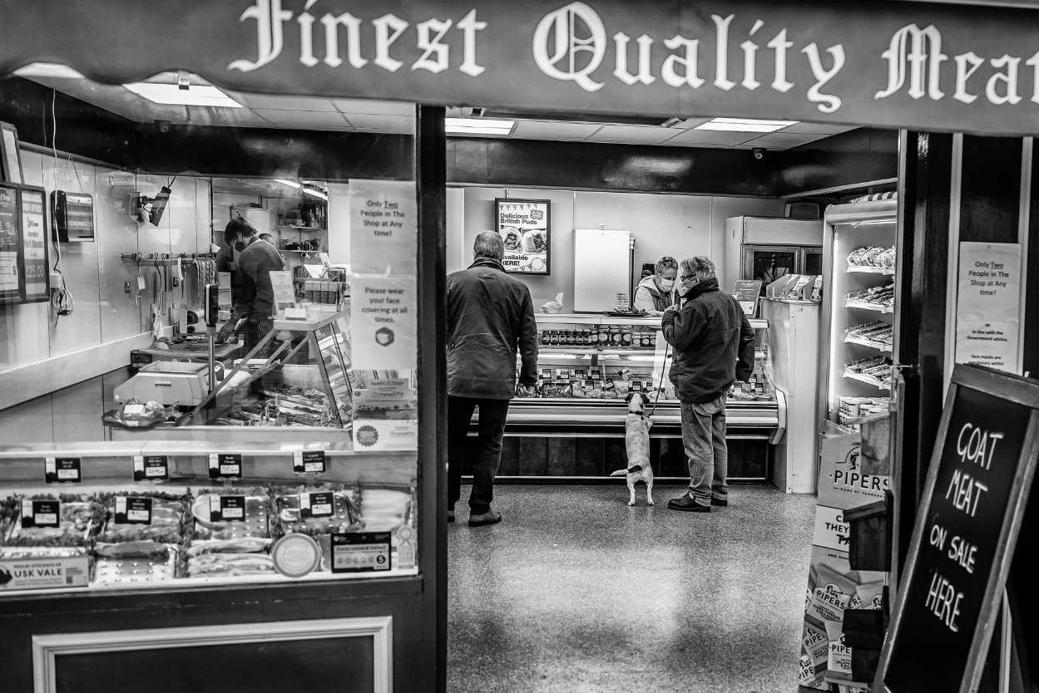

**or**

Write the opening of a story about a customer who makes an unusual request.

(24 marks for content and organisation

16 marks for technical accuracy)

**[40 marks]**

**Section B: Writing**

You are advised to spend about 45 minutes on this section.

Write in full sentences.

You are reminded of the need to plan your answer.

You should leave enough time to check your work at the end.

**0 5** A newspaper is running a creative writing competition.

Choose **one** of the following options below for your entry.

**Either**

Write a description of a café on a busy road. You may choose to use the picture provided for ideas.

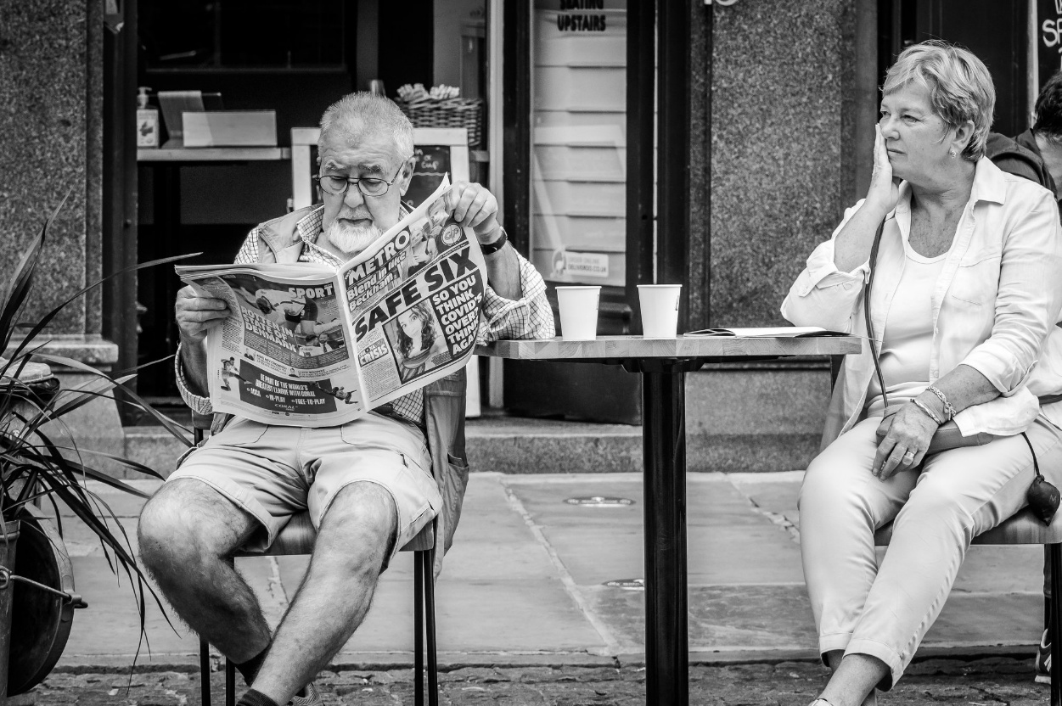

**or**

Write the opening of a story about two old friends who meet again after ten years.

(24 marks for content and organisation

16 marks for technical accuracy)

**[40 marks]**

**Section B: Writing**

You are advised to spend about 45 minutes on this section.

Write in full sentences.

You are reminded of the need to plan your answer.

You should leave enough time to check your work at the end.

**0 5** A newspaper is running a creative writing competition.

Choose **one** of the following options below for your entry.

**Either**

Write a description of a group of builders from your imagination. You may choose to use the picture provided for ideas.

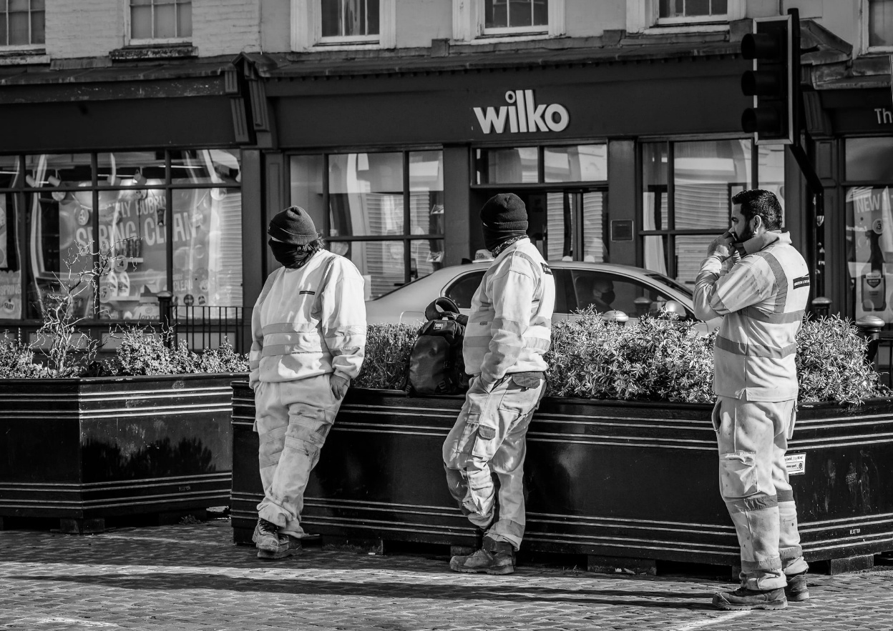

**or**

Write the opening of a story about a group of workers who notice a big problem.

(24 marks for content and organisation

16 marks for technical accuracy)

**[40 marks]**

**Section B: Writing**

You are advised to spend about 45 minutes on this section.

Write in full sentences.

You are reminded of the need to plan your answer.

You should leave enough time to check your work at the end.

**0 5** A newspaper is running a creative writing competition.

Choose **one** of the following options below for your entry.

**Either**

Write a description of someone who has just got married. You may choose to use the picture provided for ideas.

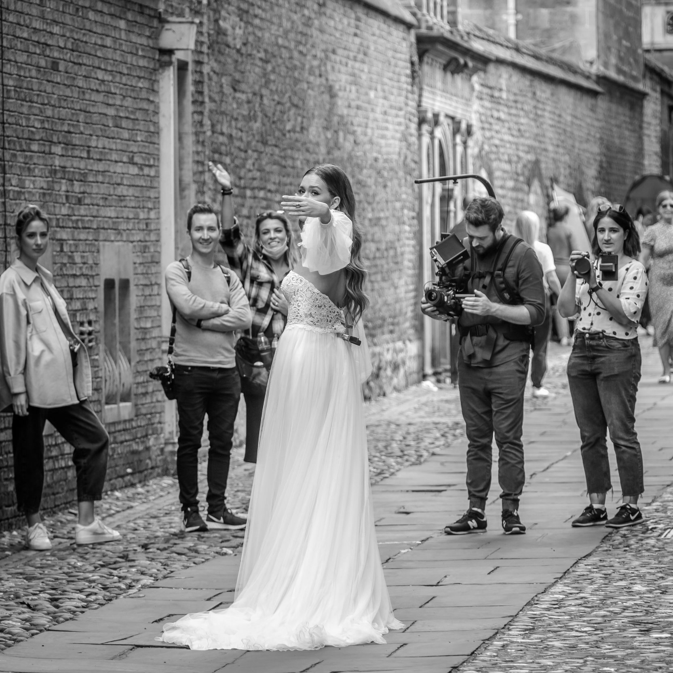

**or**

Write the opening of a story about a photoshoot that goes wrong.

(24 marks for content and organisation

16 marks for technical accuracy)

**[40 marks]**

**Section B: Writing**

You are advised to spend about 45 minutes on this section.

Write in full sentences.

You are reminded of the need to plan your answer.

You should leave enough time to check your work at the end.

**0 5** A newspaper is running a creative writing competition.

Choose **one** of the following options below for your entry.

**Either**

Write a description of an abandoned passageway from your imagination. You may choose to use the picture provided for ideas.

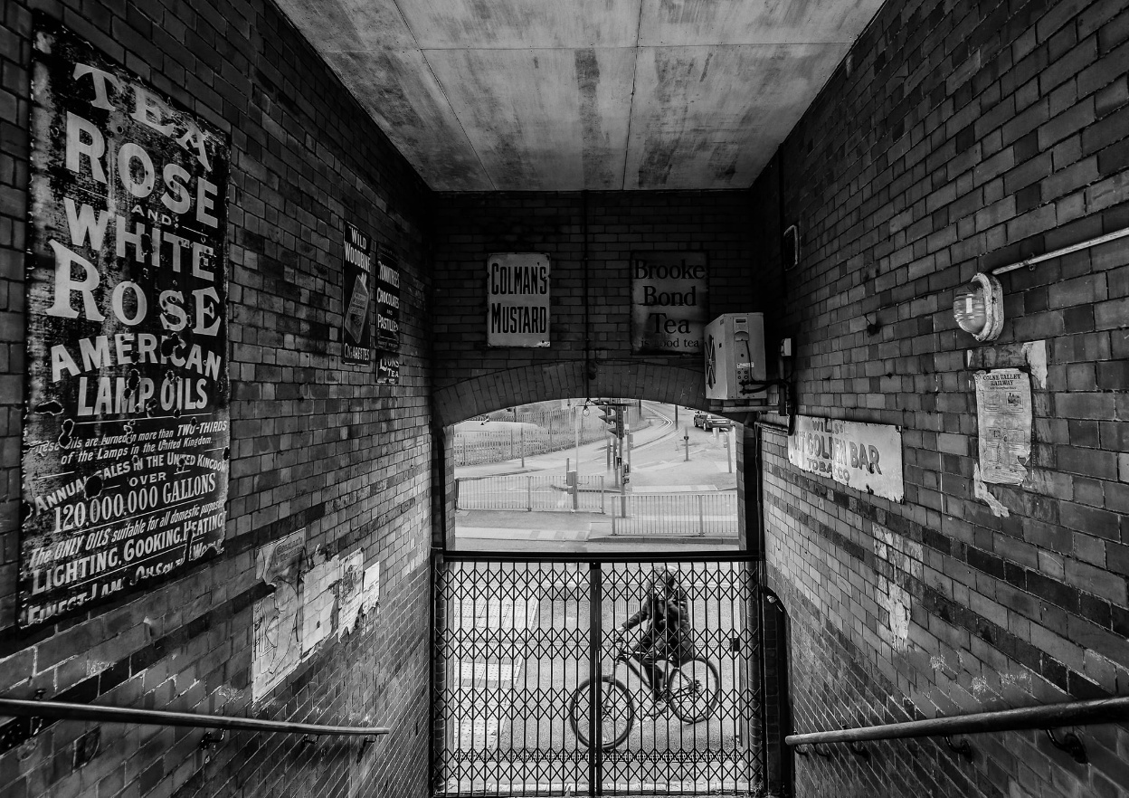

**or**

Write the opening of a story about someone who has lost their way.

(24 marks for content and organisation

16 marks for technical accuracy)

**[40 marks]**

**Section B: Writing**

You are advised to spend about 45 minutes on this section.

Write in full sentences.

You are reminded of the need to plan your answer.

You should leave enough time to check your work at the end.

**0 5** A newspaper is running a creative writing competition.

Choose **one** of the following options below for your entry.

**Either**

Write a description of a bench in the middle of town from your imagination. You may choose to use the picture provided for ideas.

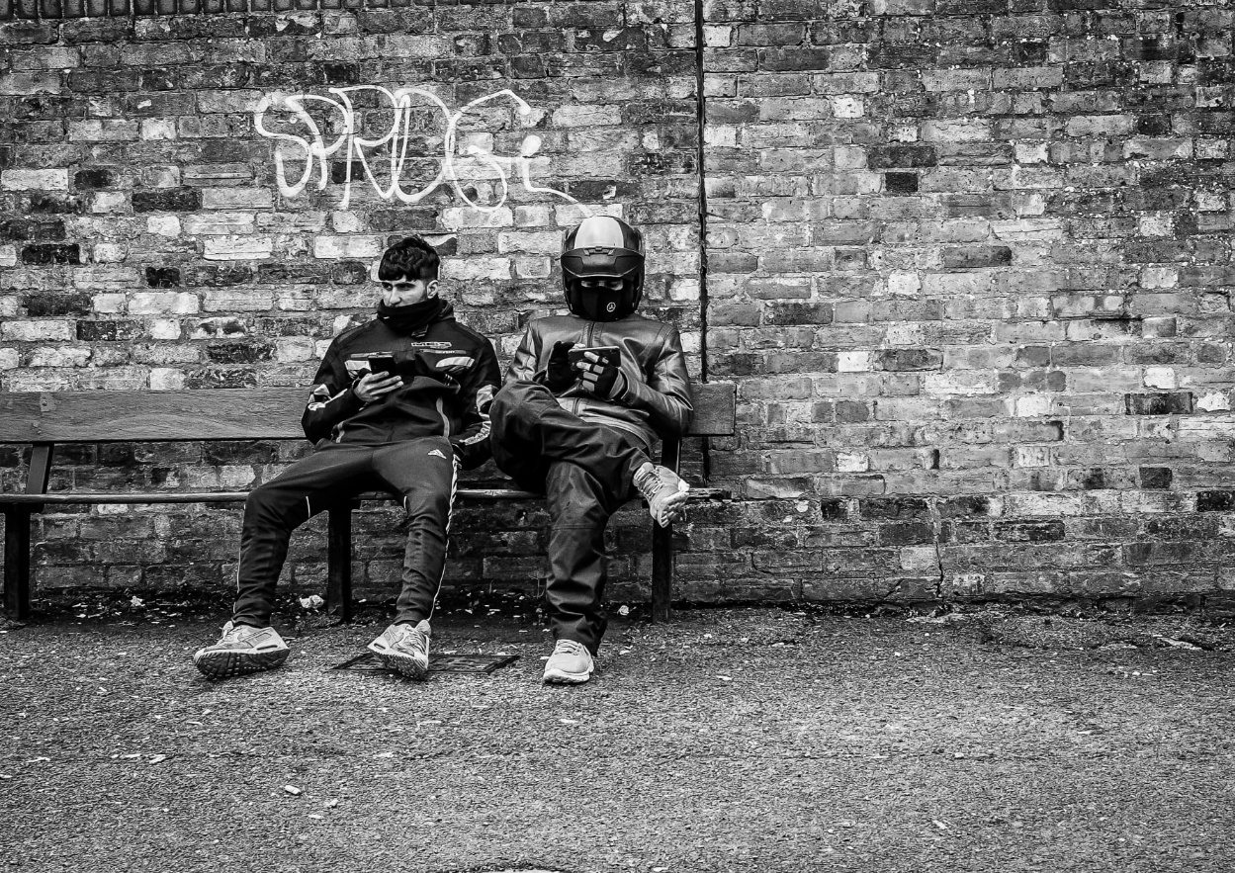

**or**

Write the opening of a story about a worker who makes a surprising discovery.

(24 marks for content and organisation

16 marks for technical accuracy)

**[40 marks]**