Section A

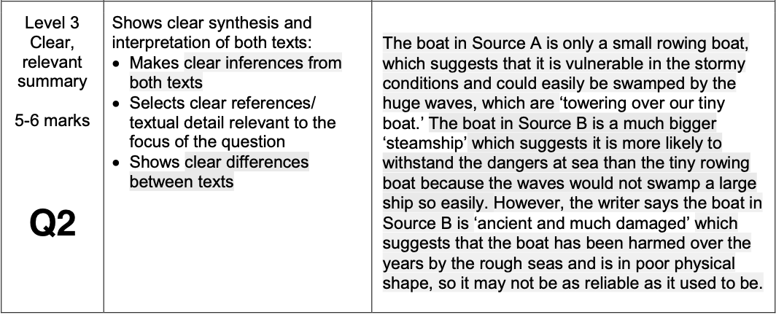 | How close is my response to  Level 3?
 | o Missed – Lv1
 | o Nearly – Lv2
 | o Met – Lv3
 | o Exceeded – Lv4

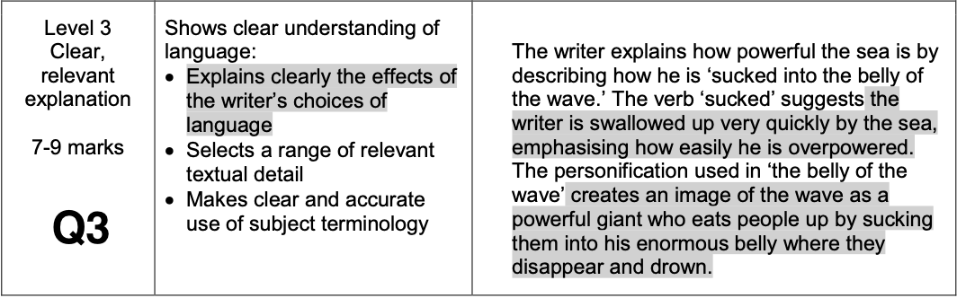 | o Missed – Lv1
 | o Nearly – Lv2
 | o Met – Lv3
 | o Exceeded – Lv4

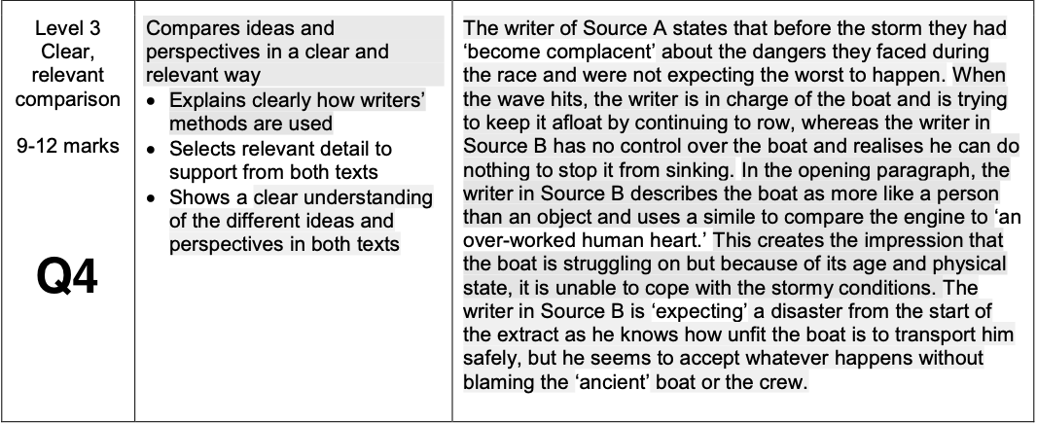 | o Missed – Lv1
 | o Nearly – Lv2
 | o Met – Lv3
 | o Exceeded – Lv4

Targets

- Write more in the time available. Think: Could I have got started more quickly and focused more?

- Develop your points further. Think: What else could I add?

- Make a wider range of points. Think: What other aspects of the source (or sources) could I focus on?

- Continue to think deeply about what each task requires. Think: What’s the point I really want to make?

- Refine the clarity of your written expression. Think: Does my writing make sense when I read it back to myself?

- Aim for precision with your vocabulary choices. Think: Do my choices make it clear that I understand?

- Zoom-in on single words, phrases, images and techniques for Q3 and Q4. Think: What effect do they have?

- Keep practising. Think: What are the similarities and differences between my writing and the exemplars?
Section B

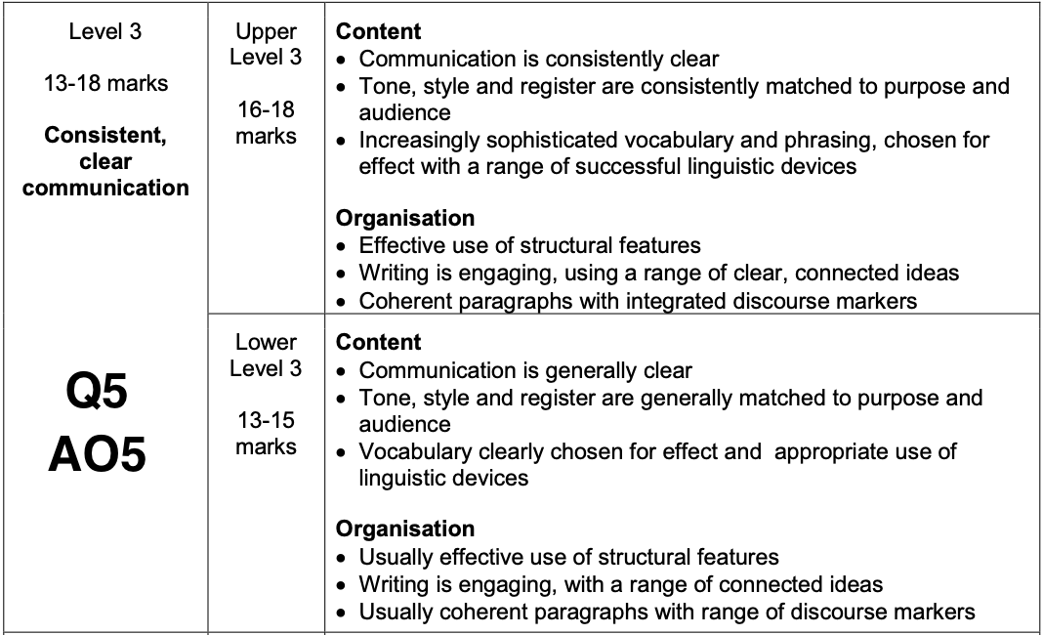 | How close is my response to  Level 3?
 | o Missed – Lv1
 | o Nearly – Lv2
 | o Met – Lv3
 | o Exceeded – Lv4

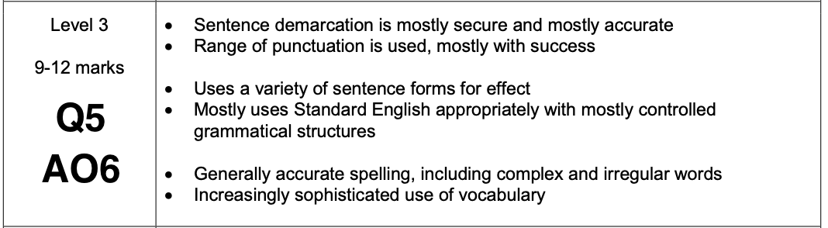 | o Missed – Lv1
 | o Nearly – Lv2
 | o Met – Lv3
 | o Exceeded – Lv4

Targets

- Begin your first paragraph by clearly and firmly stating your viewpoint

- Provide evidence to support your arguments. For example: Personal stories, facts, examples...

- Clearly signpost the transitions between your paragraphs. For example: A further point is…

- Construct a counter-argument. and then expose the flaws in it. For example: Although some believe…

- Vary the structure of your sentences. For example: adverb starters, one worders, rhetorical questions...

- Aim for precision with your vocabulary choices

- Continue to craft rather than rush

- Include a wider range of punctuation marks. For example: brackets to create a ‘whispering’ effect, a colon...

- Be meticulous when you proof-read at the end

- Keep practising and remember that developing as a writer happens over time

