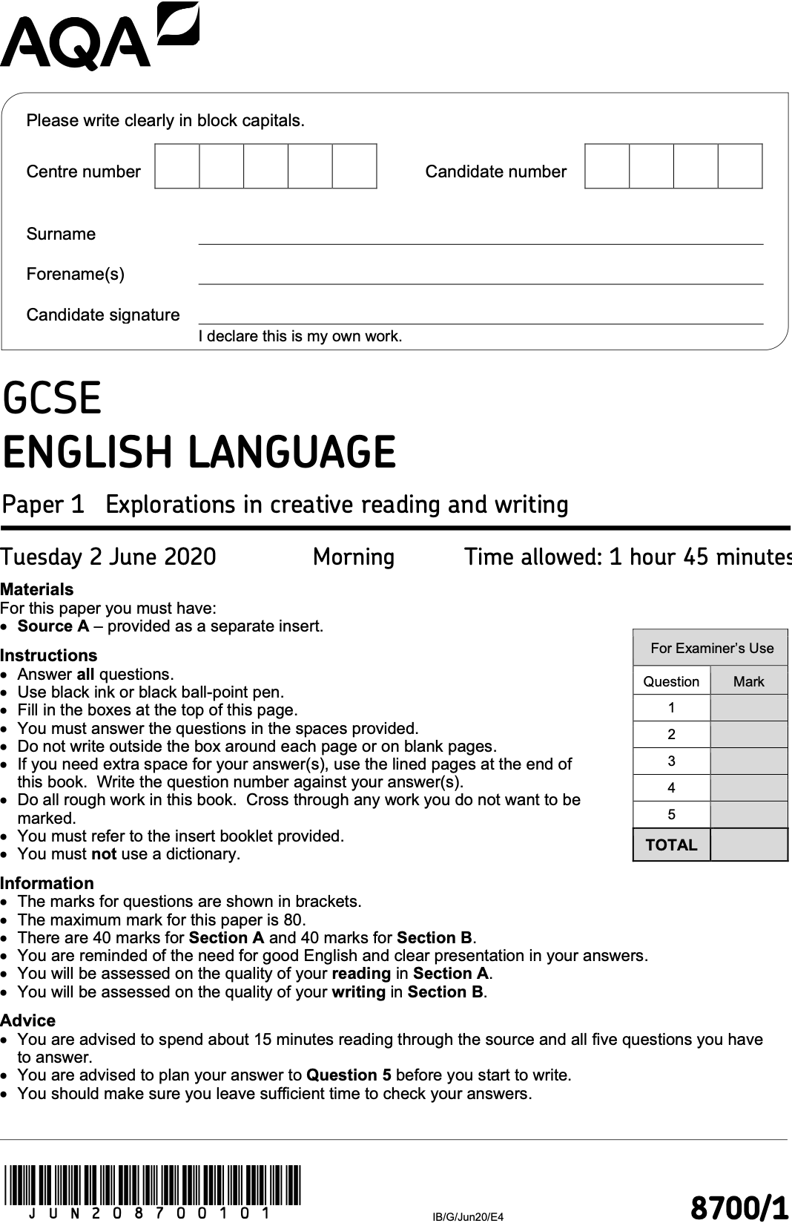

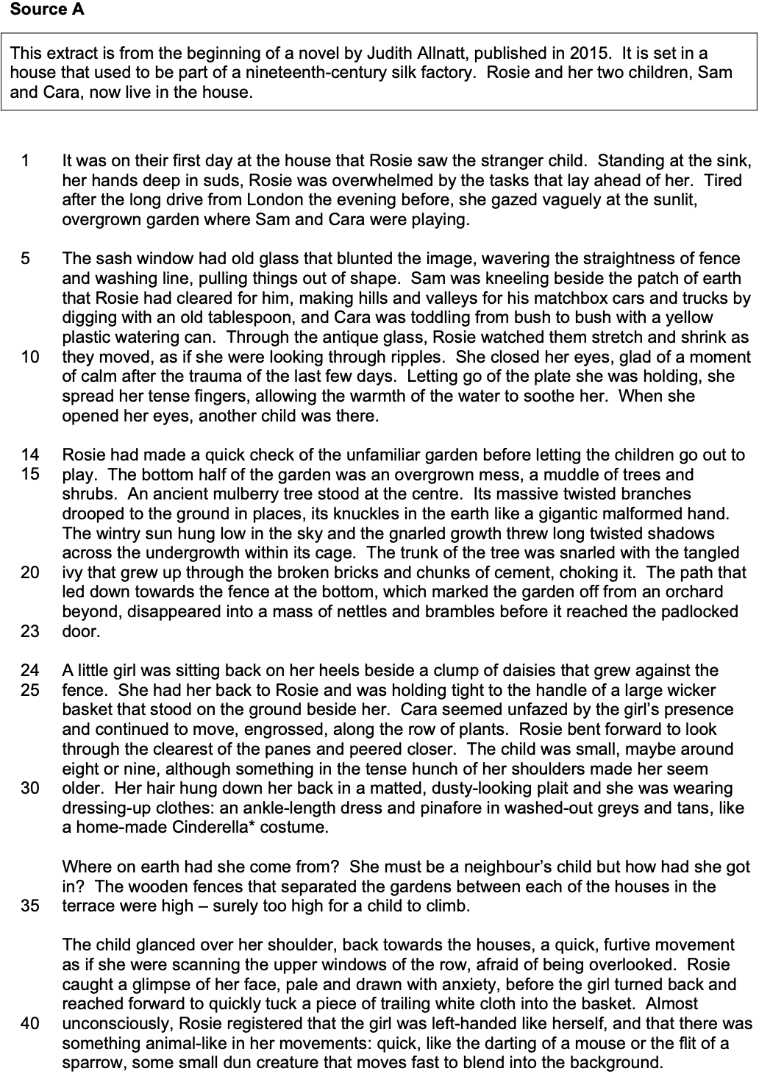

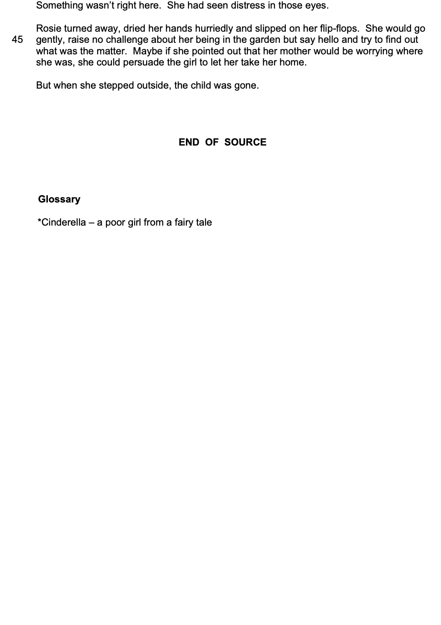

Section A: Reading

Answer all questions in this section.
You are advised to spend about 45 minutes on this section.

_______________________________________________________________________________________________________

Q1 Read again the first part of Source A from lines 1 to 4.

Answer all parts of this question.

Tick ( ü ) one box for each question.

Q1 . 1 Where was Rosie standing when she saw the child?

In the garden
At the sink
In the street
[1 mark]
Q1 . 2 What was she doing when she saw the child?

She was driving
She was making lunch
She had her hands in water
[1 mark]
Q1 . 3 Where had she driven from the evening before?

London
Birmingham
Manchester
[1 mark]
Q1 . 4 What is the garden like?

Carefully maintained
Rather overgrown
Full of exotic plants
[1 mark]

Q2 Look in detail at this extract, from lines 14 to 23 of the source.

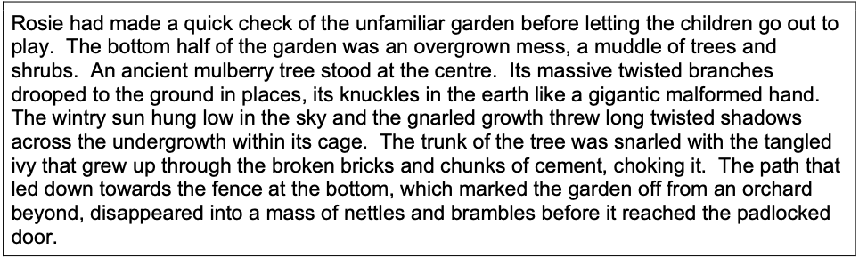

How does the writer use language here to describe the garden?

You could include the writer’s choice of:

- words and phrases
- language features and techniques
- sentence forms.
[8 marks]

- The writer uses the word [ ? ] to show…
- This has the effect of...
- This is important because…
- The writer uses the image of [ ? ] to show...
- We learn from this...
- This shows…
- Furthermore...

_______________________________________________________________________________________________________

_______________________________________________________________________________________________________

_______________________________________________________________________________________________________

_______________________________________________________________________________________________________

_______________________________________________________________________________________________________

_______________________________________________________________________________________________________

_______________________________________________________________________________________________________

_______________________________________________________________________________________________________

_______________________________________________________________________________________________________

_______________________________________________________________________________________________________

_______________________________________________________________________________________________________

_______________________________________________________________________________________________________

_______________________________________________________________________________________________________

_______________________________________________________________________________________________________

_______________________________________________________________________________________________________

_______________________________________________________________________________________________________

_______________________________________________________________________________________________________

_______________________________________________________________________________________________________

_______________________________________________________________________________________________________

_______________________________________________________________________________________________________

_______________________________________________________________________________________________________

_______________________________________________________________________________________________________

_______________________________________________________________________________________________________

_______________________________________________________________________________________________________

_______________________________________________________________________________________________________

_______________________________________________________________________________________________________

_______________________________________________________________________________________________________

_______________________________________________________________________________________________________

_______________________________________________________________________________________________________

_______________________________________________________________________________________________________

_______________________________________________________________________________________________________

_______________________________________________________________________________________________________

_______________________________________________________________________________________________________

_______________________________________________________________________________________________________

_______________________________________________________________________________________________________

_______________________________________________________________________________________________________

_______________________________________________________________________________________________________

_______________________________________________________________________________________________________

_______________________________________________________________________________________________________

_______________________________________________________________________________________________________

_______________________________________________________________________________________________________

_______________________________________________________________________________________________________

_______________________________________________________________________________________________________

_______________________________________________________________________________________________________

_______________________________________________________________________________________________________

_______________________________________________________________________________________________________

_______________________________________________________________________________________________________

_______________________________________________________________________________________________________

_______________________________________________________________________________________________________

_______________________________________________________________________________________________________

_______________________________________________________________________________________________________

_______________________________________________________________________________________________________

_______________________________________________________________________________________________________

_______________________________________________________________________________________________________

_______________________________________________________________________________________________________

Q3 You now need to think about the whole of the source.

This text is from the beginning of a novel.

How has the writer structured the text to create a sense of mystery?

You could write about:

- how the sense of mystery has increased or decreased by the end of the source
- how the write uses structure to create an effect
- the writer’s use of any other structural features, such as changes in mood, tone or perspective.

[8 marks]

- At the beginning of the source, the focus is on…
- The writer zooms-in / zooms-out...
- One reason for this is...
- This has the effect of...
- As the source progresses, the focus shifts to…
- This is important because...
- At the end of the source, the focus is on...
- This is similar / different to the start because...

_______________________________________________________________________________________________________

_______________________________________________________________________________________________________

_______________________________________________________________________________________________________

_______________________________________________________________________________________________________

_______________________________________________________________________________________________________

_______________________________________________________________________________________________________

_______________________________________________________________________________________________________

_______________________________________________________________________________________________________

_______________________________________________________________________________________________________

_______________________________________________________________________________________________________

_______________________________________________________________________________________________________

_______________________________________________________________________________________________________

_______________________________________________________________________________________________________

_______________________________________________________________________________________________________

_______________________________________________________________________________________________________

_______________________________________________________________________________________________________

_______________________________________________________________________________________________________

_______________________________________________________________________________________________________

_______________________________________________________________________________________________________

_______________________________________________________________________________________________________

_______________________________________________________________________________________________________

_______________________________________________________________________________________________________

_______________________________________________________________________________________________________

_______________________________________________________________________________________________________

_______________________________________________________________________________________________________

_______________________________________________________________________________________________________

_______________________________________________________________________________________________________

_______________________________________________________________________________________________________

_______________________________________________________________________________________________________

_______________________________________________________________________________________________________

_______________________________________________________________________________________________________

_______________________________________________________________________________________________________

_______________________________________________________________________________________________________

_______________________________________________________________________________________________________

_______________________________________________________________________________________________________

_______________________________________________________________________________________________________

_______________________________________________________________________________________________________

_______________________________________________________________________________________________________

_______________________________________________________________________________________________________

_______________________________________________________________________________________________________

_______________________________________________________________________________________________________

_______________________________________________________________________________________________________

_______________________________________________________________________________________________________

_______________________________________________________________________________________________________

_______________________________________________________________________________________________________

_______________________________________________________________________________________________________

_______________________________________________________________________________________________________

_______________________________________________________________________________________________________

_______________________________________________________________________________________________________

_______________________________________________________________________________________________________

_______________________________________________________________________________________________________

_______________________________________________________________________________________________________

_______________________________________________________________________________________________________

_______________________________________________________________________________________________________

_______________________________________________________________________________________________________

_______________________________________________________________________________________________________

_______________________________________________________________________________________________________

_______________________________________________________________________________________________________

_______________________________________________________________________________________________________

Q4 Focus this part of your answer on the second part of the source, from line 24 to the end.

In this part of the source, the disappearance of the stranger child at the end of the extract is not surprising. It is clear that she is part of Rosie’s imagination.

To what extent do you agree or disagree with this statement?

In your response, you could:

- consider your impressions of the disappearance of the stranger child
- comment on the methods the writer uses to present the stranger child
- support your response with references to the text.

[20 marks]

- I agree / disagree with the statement because...
- The writer’s use of the word [ ? ] / image [ ? ] supports my view because...
- This has the effect of...
- Another reason I agree / disagree with the statement is...
- An important method the writer uses is...
- This is significant because...
- Furthermore...
- As the source progresses, it is significant that...
- A quotation that supports my view is...
- This is because...

_______________________________________________________________________________________________________

_______________________________________________________________________________________________________

_______________________________________________________________________________________________________

_______________________________________________________________________________________________________

_______________________________________________________________________________________________________

_______________________________________________________________________________________________________

_______________________________________________________________________________________________________

_______________________________________________________________________________________________________

_______________________________________________________________________________________________________

_______________________________________________________________________________________________________

_______________________________________________________________________________________________________

_______________________________________________________________________________________________________

_______________________________________________________________________________________________________

_______________________________________________________________________________________________________

_______________________________________________________________________________________________________

_______________________________________________________________________________________________________

_______________________________________________________________________________________________________

_______________________________________________________________________________________________________

_______________________________________________________________________________________________________

_______________________________________________________________________________________________________

_______________________________________________________________________________________________________

_______________________________________________________________________________________________________

_______________________________________________________________________________________________________

_______________________________________________________________________________________________________

_______________________________________________________________________________________________________

_______________________________________________________________________________________________________

_______________________________________________________________________________________________________

_______________________________________________________________________________________________________

_______________________________________________________________________________________________________

_______________________________________________________________________________________________________

_______________________________________________________________________________________________________

_______________________________________________________________________________________________________

_______________________________________________________________________________________________________

_______________________________________________________________________________________________________

_______________________________________________________________________________________________________

_______________________________________________________________________________________________________

_______________________________________________________________________________________________________

_______________________________________________________________________________________________________

_______________________________________________________________________________________________________

_______________________________________________________________________________________________________

_______________________________________________________________________________________________________

_______________________________________________________________________________________________________

_______________________________________________________________________________________________________

_______________________________________________________________________________________________________

_______________________________________________________________________________________________________

_______________________________________________________________________________________________________

_______________________________________________________________________________________________________

_______________________________________________________________________________________________________

_______________________________________________________________________________________________________

_______________________________________________________________________________________________________

_______________________________________________________________________________________________________

_______________________________________________________________________________________________________

_______________________________________________________________________________________________________

_______________________________________________________________________________________________________

_______________________________________________________________________________________________________

_______________________________________________________________________________________________________

_______________________________________________________________________________________________________

_______________________________________________________________________________________________________

_______________________________________________________________________________________________________

_______________________________________________________________________________________________________

_______________________________________________________________________________________________________

_______________________________________________________________________________________________________

_______________________________________________________________________________________________________

_______________________________________________________________________________________________________

_______________________________________________________________________________________________________

_______________________________________________________________________________________________________

_______________________________________________________________________________________________________

_______________________________________________________________________________________________________

_______________________________________________________________________________________________________

_______________________________________________________________________________________________________

_______________________________________________________________________________________________________

_______________________________________________________________________________________________________

_______________________________________________________________________________________________________

_______________________________________________________________________________________________________

_______________________________________________________________________________________________________

_______________________________________________________________________________________________________

_______________________________________________________________________________________________________

_______________________________________________________________________________________________________

_______________________________________________________________________________________________________

_______________________________________________________________________________________________________

_______________________________________________________________________________________________________

_______________________________________________________________________________________________________

Section B: Writing

You are advised to spend about 45 minutes on this section.
Write in full sentences.
You are reminded of the need to plan your answer.
You should leave enough time to check your work at the end.

_______________________________________________________________________________________________________

Q5


































































































































































































