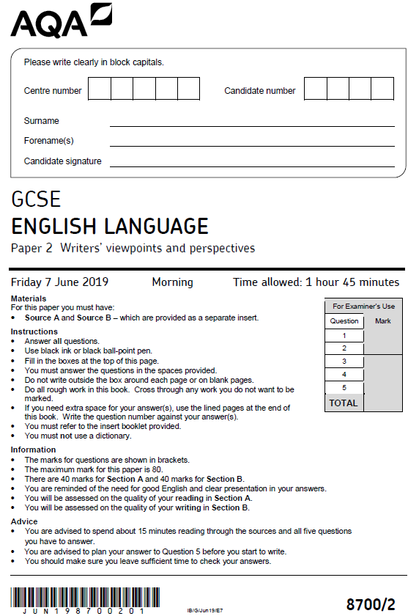
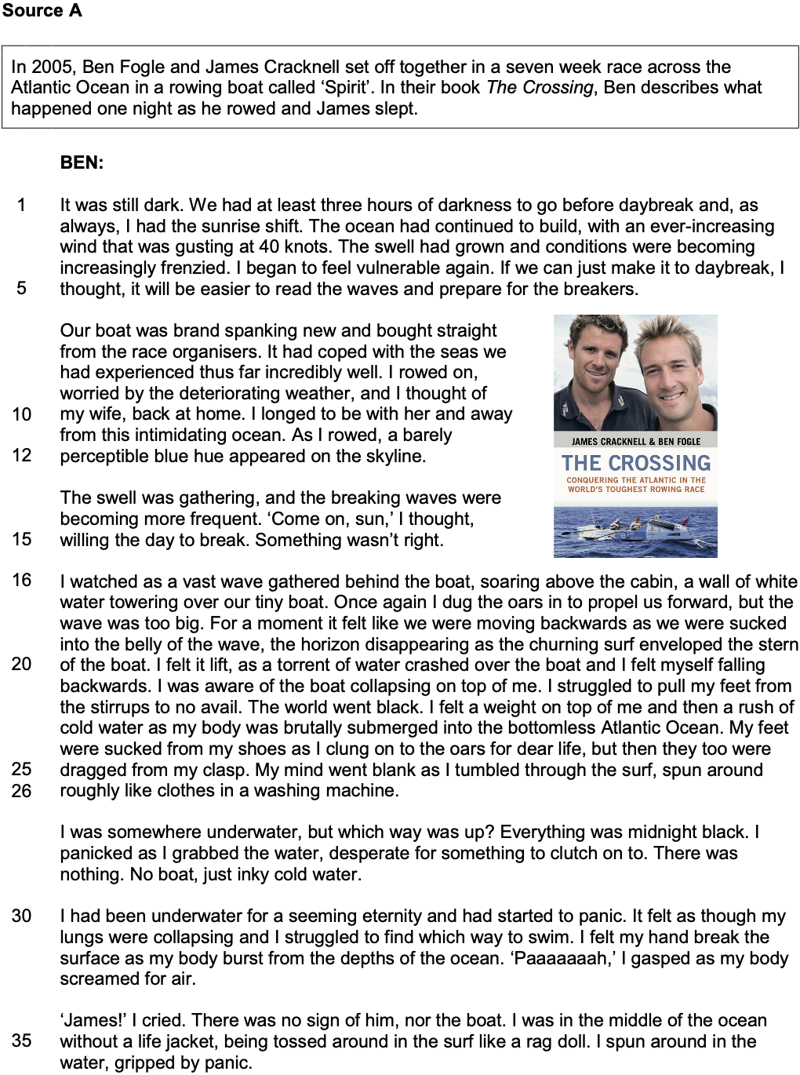
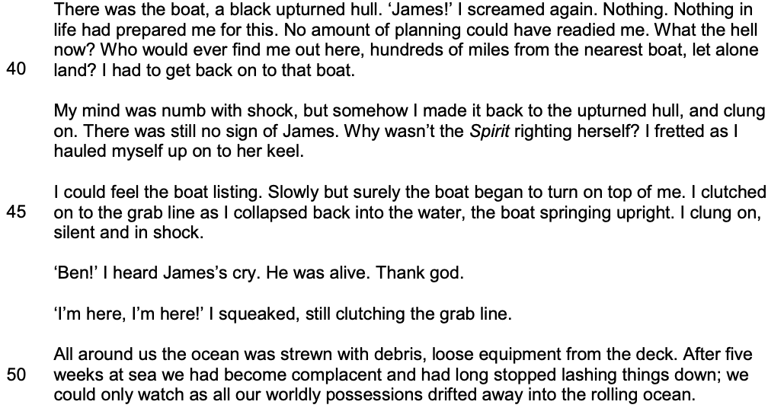

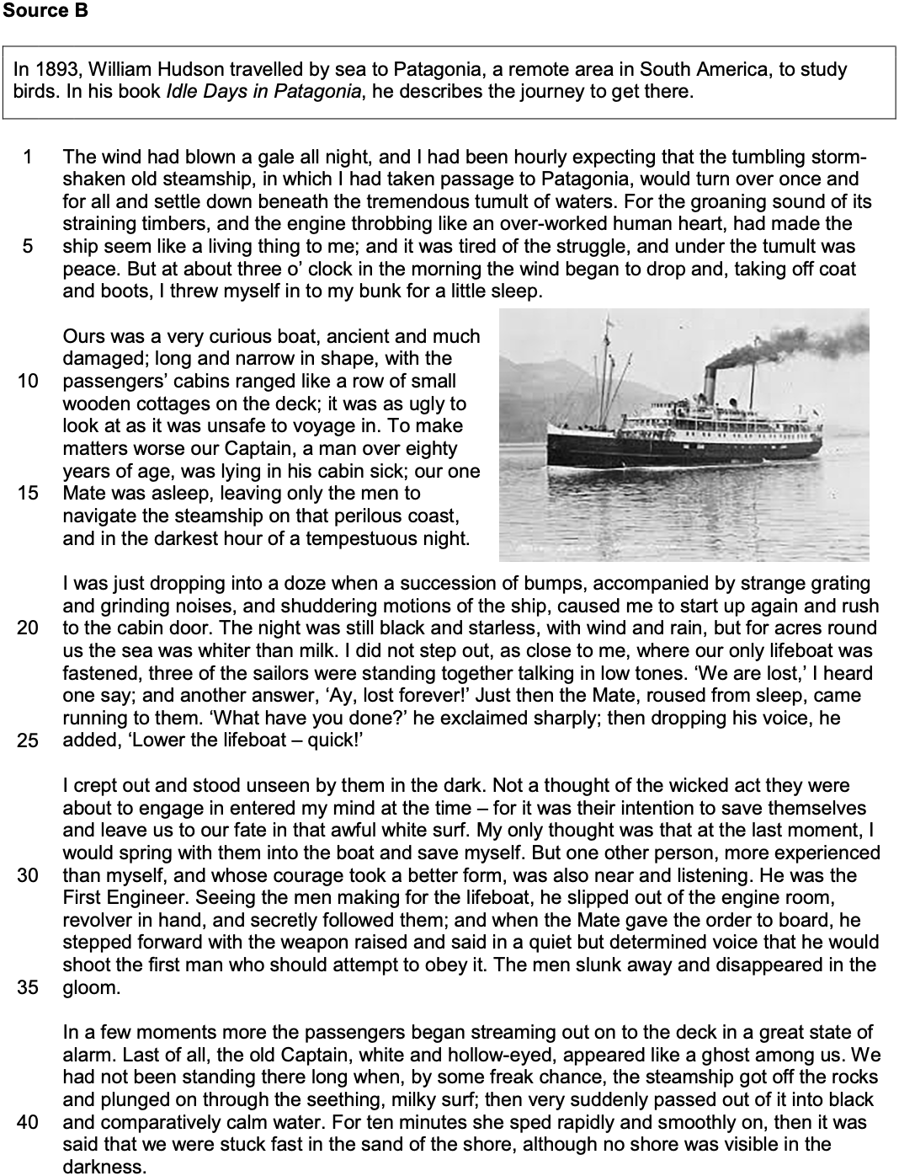

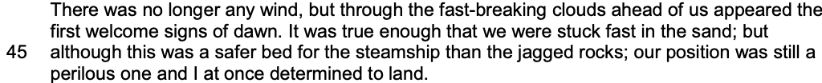

Section A: Reading

Answer all questions in this section.
You are advised to spend about 45 minutes on this section.

_______________________________________________________________________________________________________

Q1 Read again the first part of Source A from lines 1 to 12.

Choose four statements below which are true.
[4 marks]

- It would be dark for another three hours.
- Ben usually rowed the sunrise shift.
- The waves were starting to calm down.
- It was the first time during the race that Ben felt he was at risk.
- If it were light, Ben thought he would be able to judge the danger.
- Ben felt homesick.
- Ben was enjoying this early morning shift.
- There was no sign of daybreak.

Q2 You need to refer to Source A and Source B for this question.

The writers in Source A and Source B are travelling on very different types of boat.

What can you infer about the differences between the types of boat?
[8 marks]

Q3 You now need to refer only to Source A from lines 16 to 26.

How does the writer use language to describe the power of the sea?
[12 marks]

Q4 For this question, you need to refer to the whole of Source A, together with the whole of Source B.

Compare how the writers convey their different perspectives and feelings about their experiences at sea.

In your answer, you could:

- compare their different perspectives and feelings about their experiences
- comment on the methods the writers use to convey their perspectives and feelings
- support your response with references to both texts.
[16 marks]

Section B: Writing

You are advised to spend about 45 minutes on this section.
Write in full sentences.
You are reminded of the need to plan your answer.
You should leave enough time to check your work at the end.

_______________________________________________________________________________________________________

Q5 ‘It is people who have extraordinary skill, courage and determination who deserve to be famous, not those who have good looks or lots of money or behave badly.’

Write a letter to the editor of a newspaper in which you argue your point of view in response to this statement.

(24 marks for content and organisation
16 marks for technical accuracy)
[40 marks]

You are advised to plan your answer to Question 5 before you start to write.

