
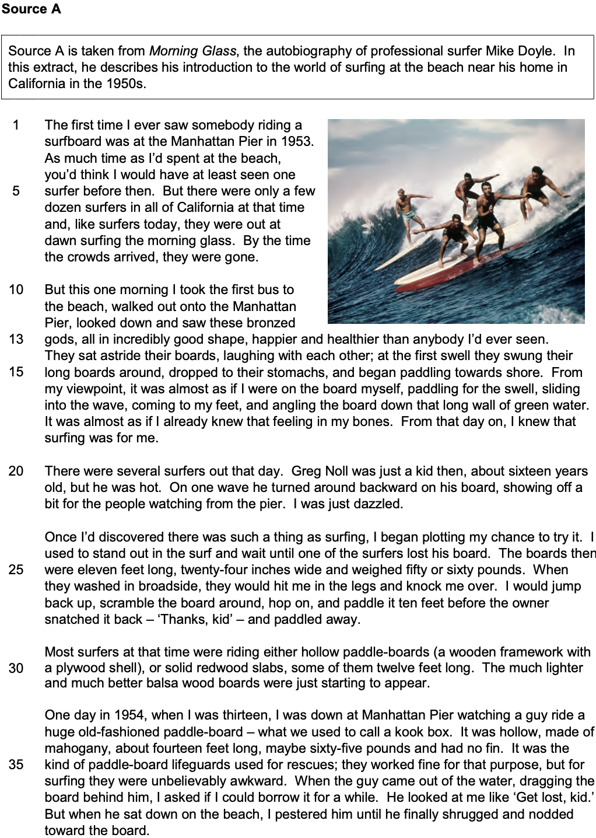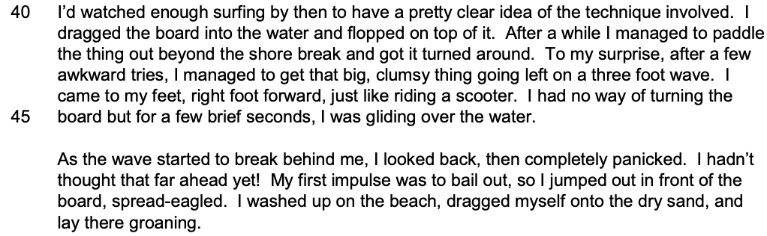
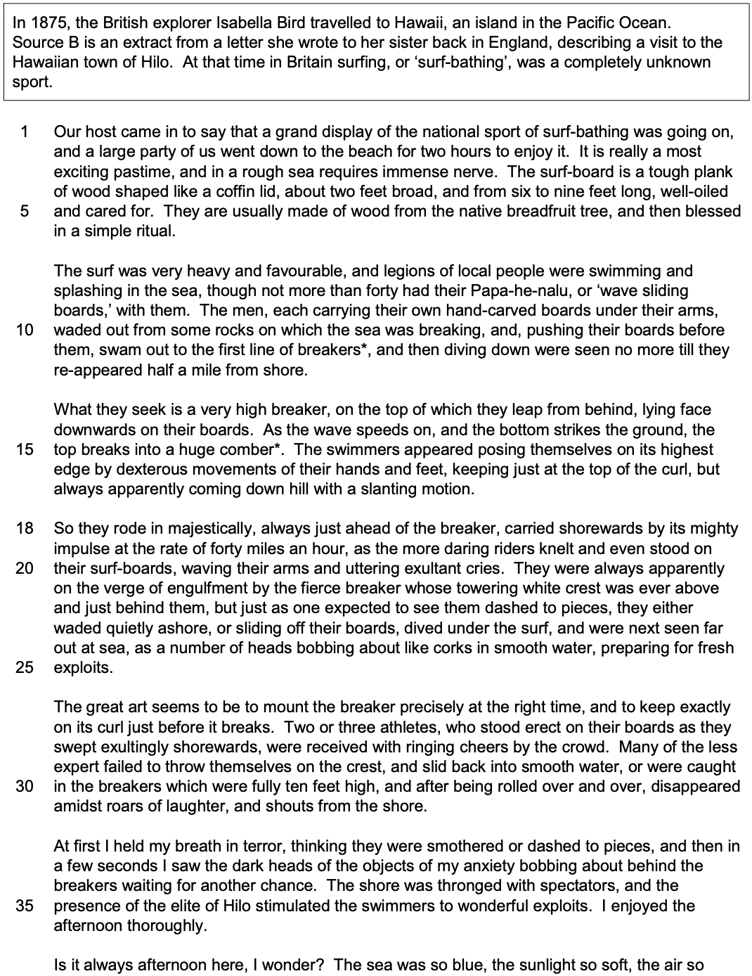

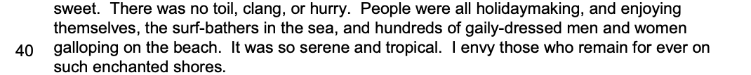

Section A: Reading

Answer all questions in this section.
You are advised to spend about 45 minutes on this section.

_______________________________________________________________________________________________________

Q1 Read again the first part of Source A from lines 1 to 13.

Choose four statements below which are true.
[4 marks]

- The first time Mike Doyle saw anyone surfing was in 1953.
- Mike Doyle spent very little time at the beach as a child.
- In the 1950s there were very few surfers in California.
- Most surfers like to surf in the early morning.
- Surfers often stayed later in the day to entertain the crowds.
- Mike Doyle took the train to the beach.
- The first time he saw them, Mike Doyle was unimpressed by the surfers.
- The surfers looked fit and suntanned.

Q2 You need to refer to Source A and Source B for this question.

Both sources describe the types of board used for surfing.

What can you infer about the differences between the types of board?
[8 marks]

Q3 You now need to refer only to Source B from lines 18 to 25.

How does the writer use language to describe the surfers and the sea?
[12 marks]

Q4 For this question, you need to refer to the whole of Source A, together with the whole of Source B.

Compare how the writers convey their different perspectives on surfing.

In your answer, you could:

- compare their different perspectives on surfing
- comment on the methods the writers use to convey their perspectives
- support your response with references to both texts.
[16 marks]

Section B: Writing

You are advised to spend about 45 minutes on this section.
Write in full sentences.
You are reminded of the need to plan your answer.
You should leave enough time to check your work at the end.

_______________________________________________________________________________________________________

Q5 ‘All sport should be fun, fair and open to everyone. These days, sport seems to be more about money, corruption and winning at any cost.’

Write an article for a newspaper in which you explain your point of view on this statement.

Compare how the writers convey their different perspectives on surfing.

(24 marks for content and organisation
16 marks for technical accuracy)
[40 marks]

