English Language Paper 1 – Guidance on the Questions

Q1 | - Read the statements carefully and double-check your answers
Q2 | - Use the key word/s of the question in each of your points  - Write at least two full paragraphs  - The writer uses the word / phrase / image to show…  - This has the effect of… / This is significant because… / We learn from this…
Q3 | - Use the key word/s of the question in each of your points  - Structure your answer around the beginning, middle and end  - Use these words: perspective, focus, shift, zoom-in / out, contrast, develop  - At the beginning of the text, the writer focuses on / describes / shows…  - The reason for this is… / This is important because… / This helps to develop…  - As the text progresses, the focus shifts to…  - At the end of the text, the focus is on…
Q4 | - Agree with the statement unless you strongly disagree with it  - Don’t forget to analyse language  - Write at least three full paragraphs  - Firstly, I agree / disagree with the statement because…  - The writer’s use of the word / phrase / image supports my view because…  - Another reason I agree / disagree with the statement is...  - As the text progresses, it is significant that…  - Finally, it’s important to note that…
Q5 | - Technical accuracy really matters  - Craft and don’t rush  - Write at least two full pages (plus a bit)  - Vary the length and structure of your sentences  - Avoid ‘fancy language’ and aim for precision instead  - Selectively and sparingly use devices like rhetorical questions and ellipsis  - Start by zooming-in on a small part of the image  - Remember that the key to success is to ‘show’ and not tell
English Language Paper 1 – A Reminder of the Questions

 5 mins
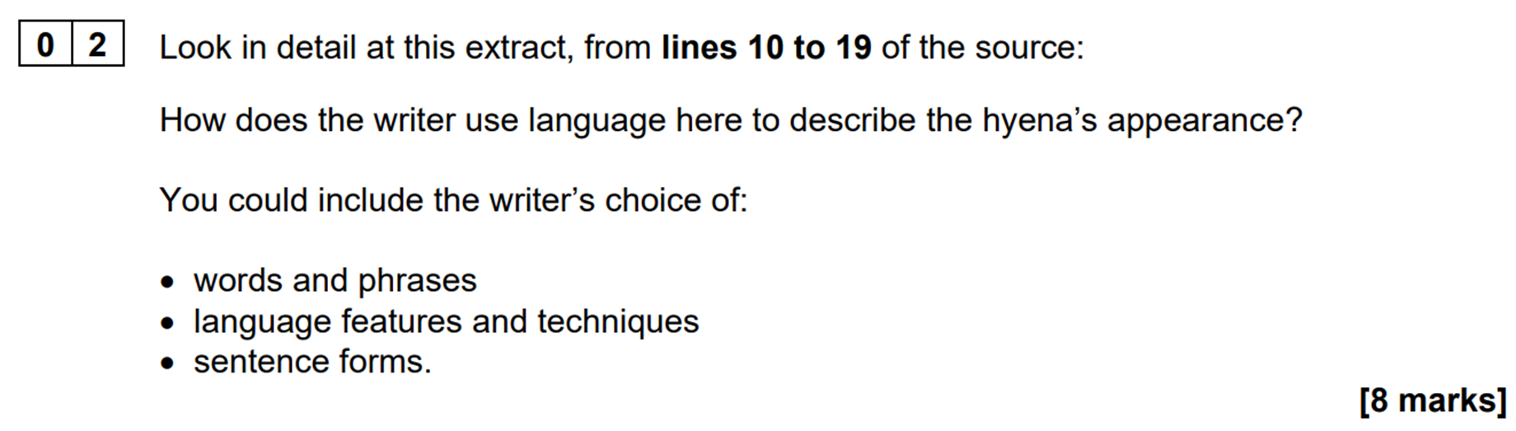 12 mins
 12 mins
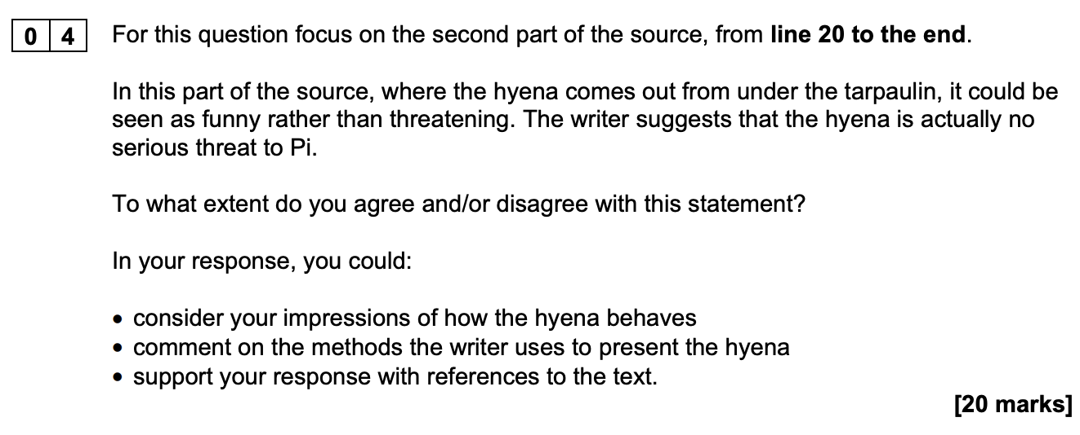 20 mins
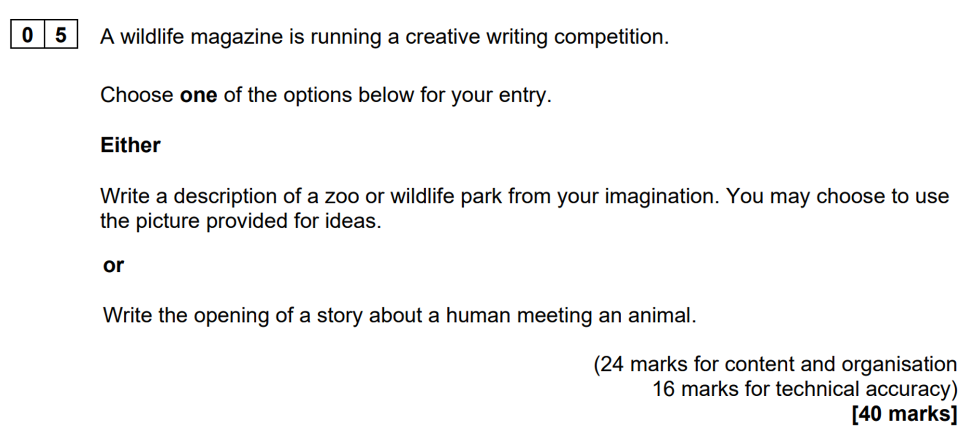 45 mins
English Language Paper 2 – Guidance on the Questions

Q1 | - Read the statements carefully and double-check your answers
Q2 | - Use the key word/s of the question in each of your points  - Remember that you need to make judgements (so don’t just retell)  - Write at least two full paragraphs  - In Source A, we learn that... This is shown through...  - Contrastingly, we learn in Source B that... This is significant because...
Q3 | - Use the key word/s of the question in each of your points  - Write at least three full paragraphs  - The writer uses the word / phrase / image to show…  - This has the effect of… / This is significant because… / We learn from this…
Q4 | - Think of this question as a mixture of Q2 and Q3  - Use the key word/s of the question in each of your points  - Don’t forget to analyse language  - Write at least three full paragraphs  - In Source A, one of the writer’s main thoughts / perspectives is...  - The writer uses the word / phrase / image to show... This has the effect of...  - In contrast, the writer of Source B feels... This is demonstrated through...  - The writer uses the word / phrase / image to show... This has the effect of...  - A further differences between the writers’ thoughts / perspectives is...
Q5 | - Technical accuracy really matters  - Craft and don’t rush  - Write at least two full pages (plus a bit)  - Vary the length and structure of your sentences  - Avoid ‘fancy language’ and aim for precision instead  - Selectively and sparingly use devices like rhetorical questions and ellipsis  - Start by clearly stating your overall perspective and go from there  - Remember that it’s usually easier to agree with the statement

English Language Paper 2 – A Reminder of the Questions

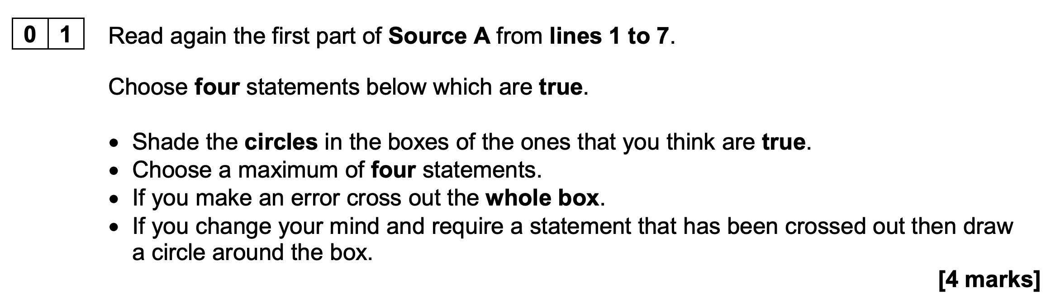 5 mins

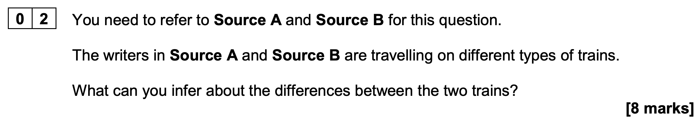 12 mins

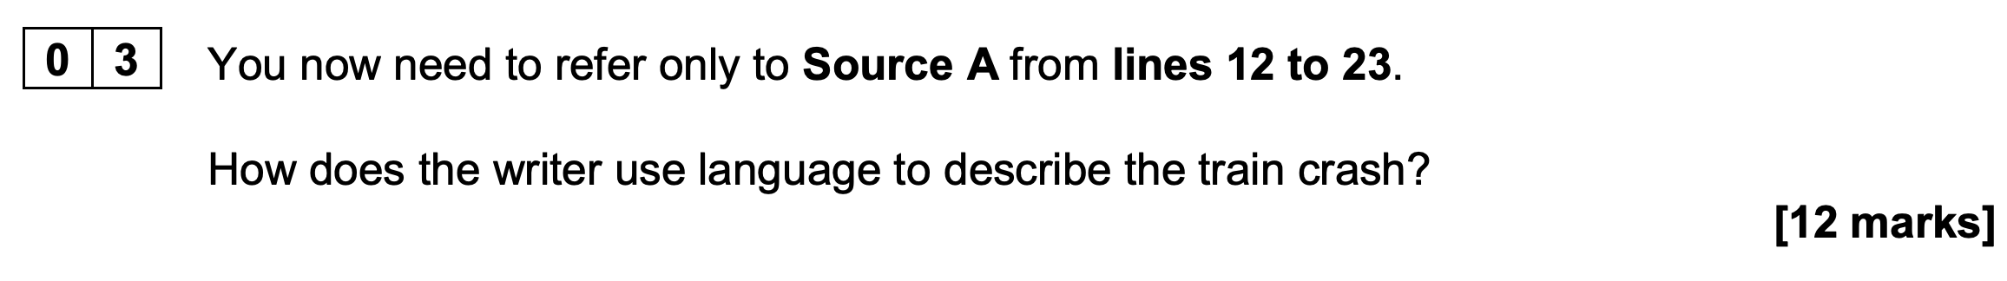 15 mins

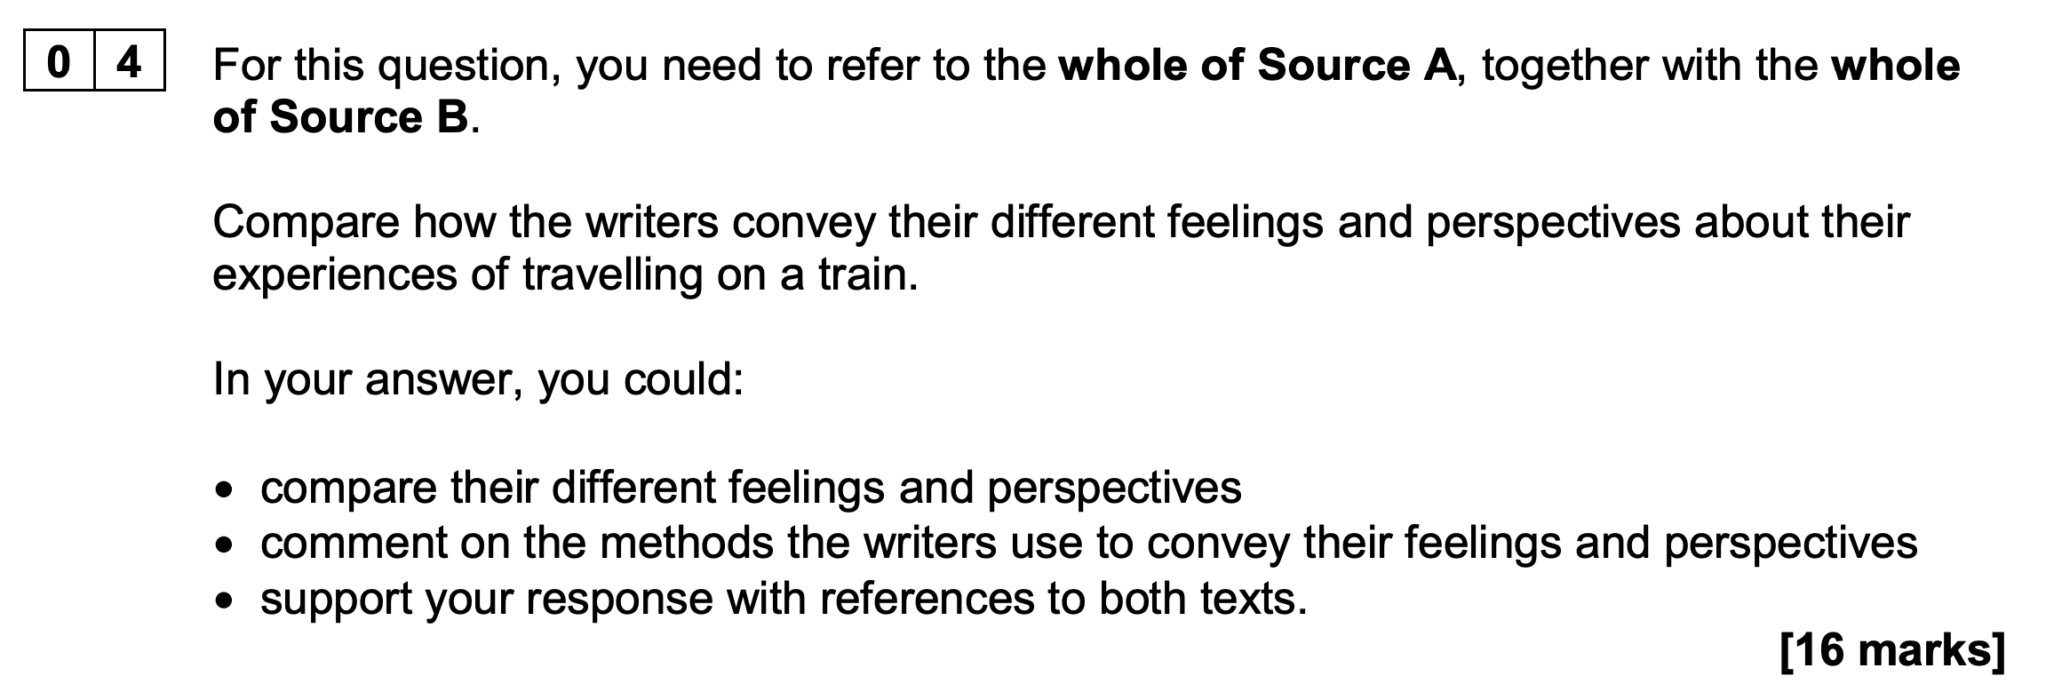 18 mins

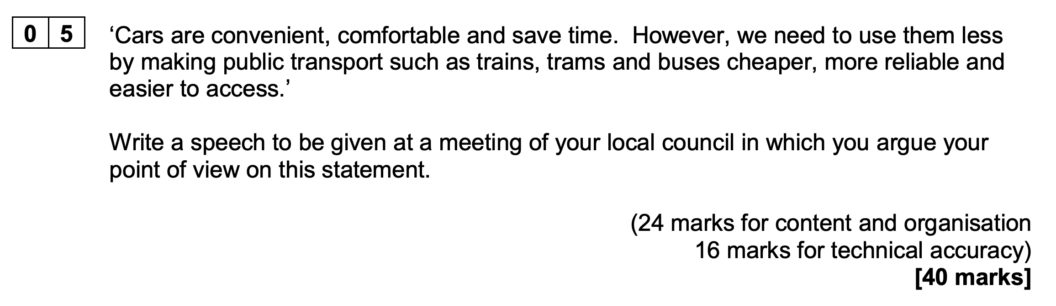 45 mins

English Literature Paper 1 – Guidance on the Questions

McB | - Write about the extract first  - Make at least two links with other scenes from different acts  - 4 marks are awarded for the accuracy of your writing  - Write at least two full pages  - Follow the What-How-Why model of analysis  - What’s happening? / What’s being described? / What idea’s being explored?  - How is it presented? / How is it described? / How is it explored?  - Why is it important? / Why is it described in that way / Why does is it relevant?  - Analyse stagecraft: soliloquies, asides and sounds  - Analyse language: stormy weather, darkness, blood and disturbed sleep  - Remember: Macbeth is a tragic hero whose downfall is inevitable  - Remember: The play warns about the dangers of excessive ambition  - Remember: Macbeth’s suffering elicits strong emptions from the audience  - Remember: Shakespeare explores what it means to be a good and a bad king  - Remember: There was a widespread belief that witches existed and were harmful
ACC | - Write about the extract first  - Make at least two links with moments from other staves  - Write at least two full pages  - Follow the What-How-Why model of analysis  - What’s happening? / What’s being described? / What idea’s being explored?  - How is it presented? / How is it described? / How is it explored?  - Why is it important? / Why is it described in that way / Why does is it relevant?  - Reference context: Dickens was writing when levels of poverty were high  - Analyse language: Caricatures, contrasts, darkness, light, warmth and cold  - Remember: Dickens wanted to entertain and gently provoke his readers  - Remember: Dickens emphasises the value of love and friendship  - Remember: The idea that poverty is the result of moral failure is contradicted  - Remember: The novel highlights the importance of kindness and generosity  - Remember: The change in Scrooge provides hope for wider social changes

English Literature Paper 1 – A Reminder of the Questions

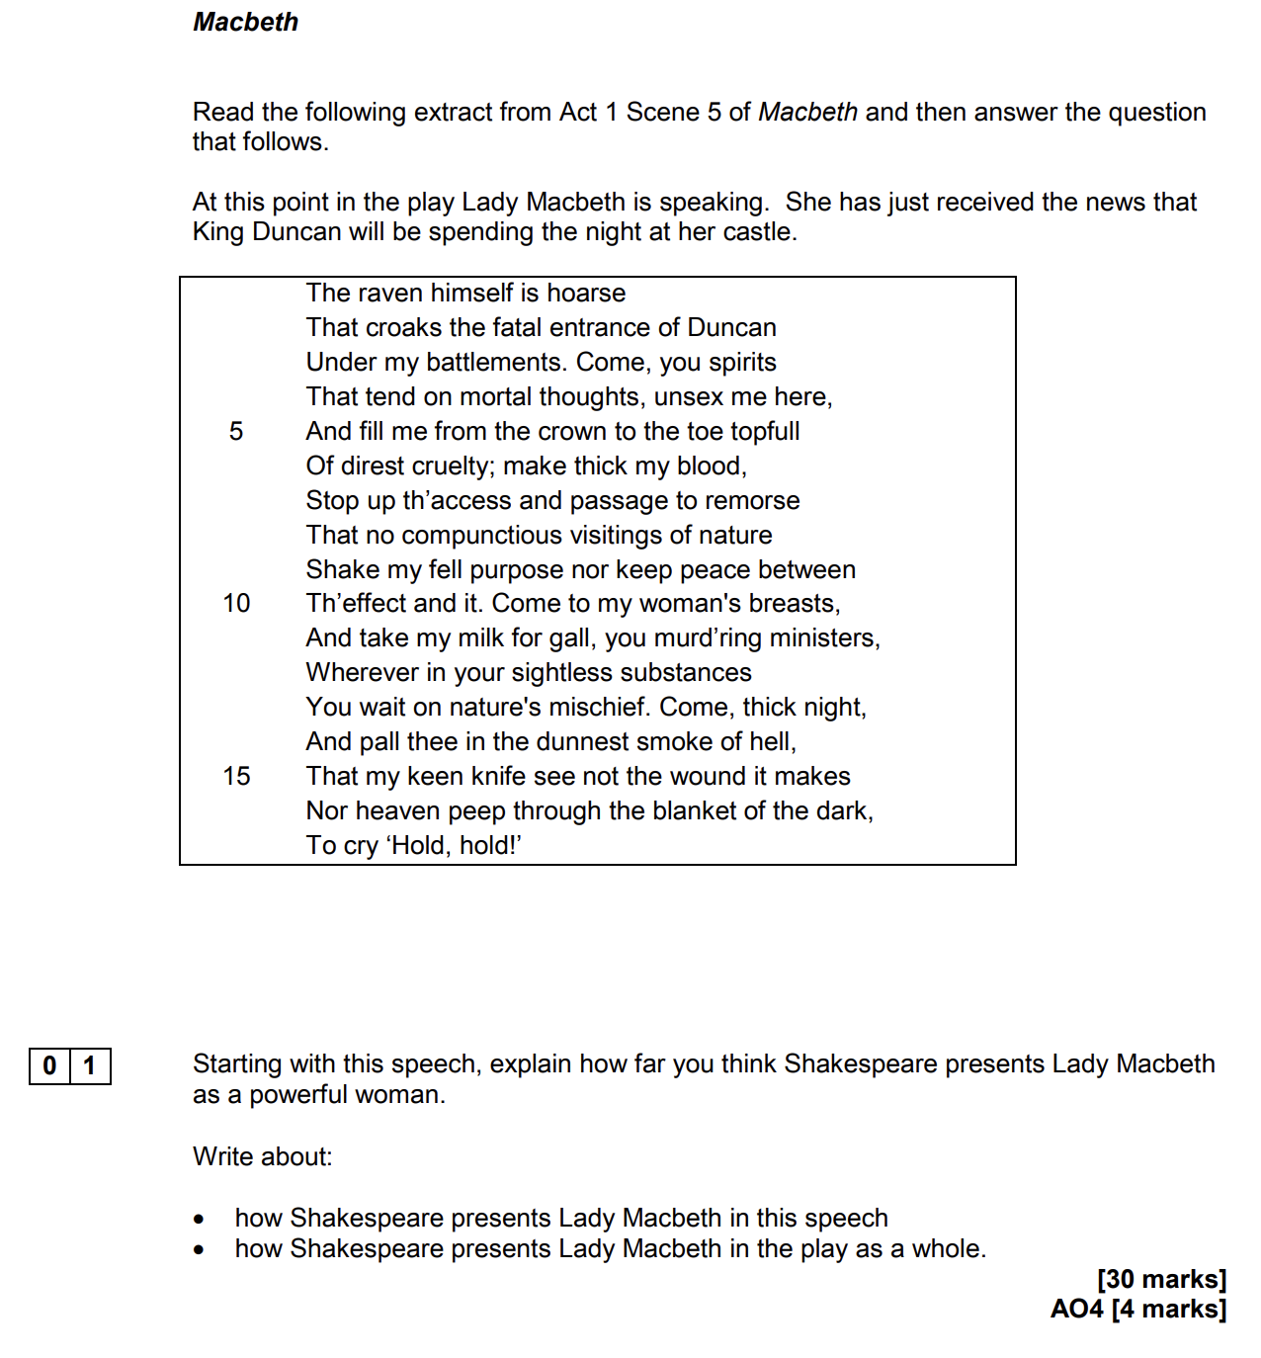 50 mins
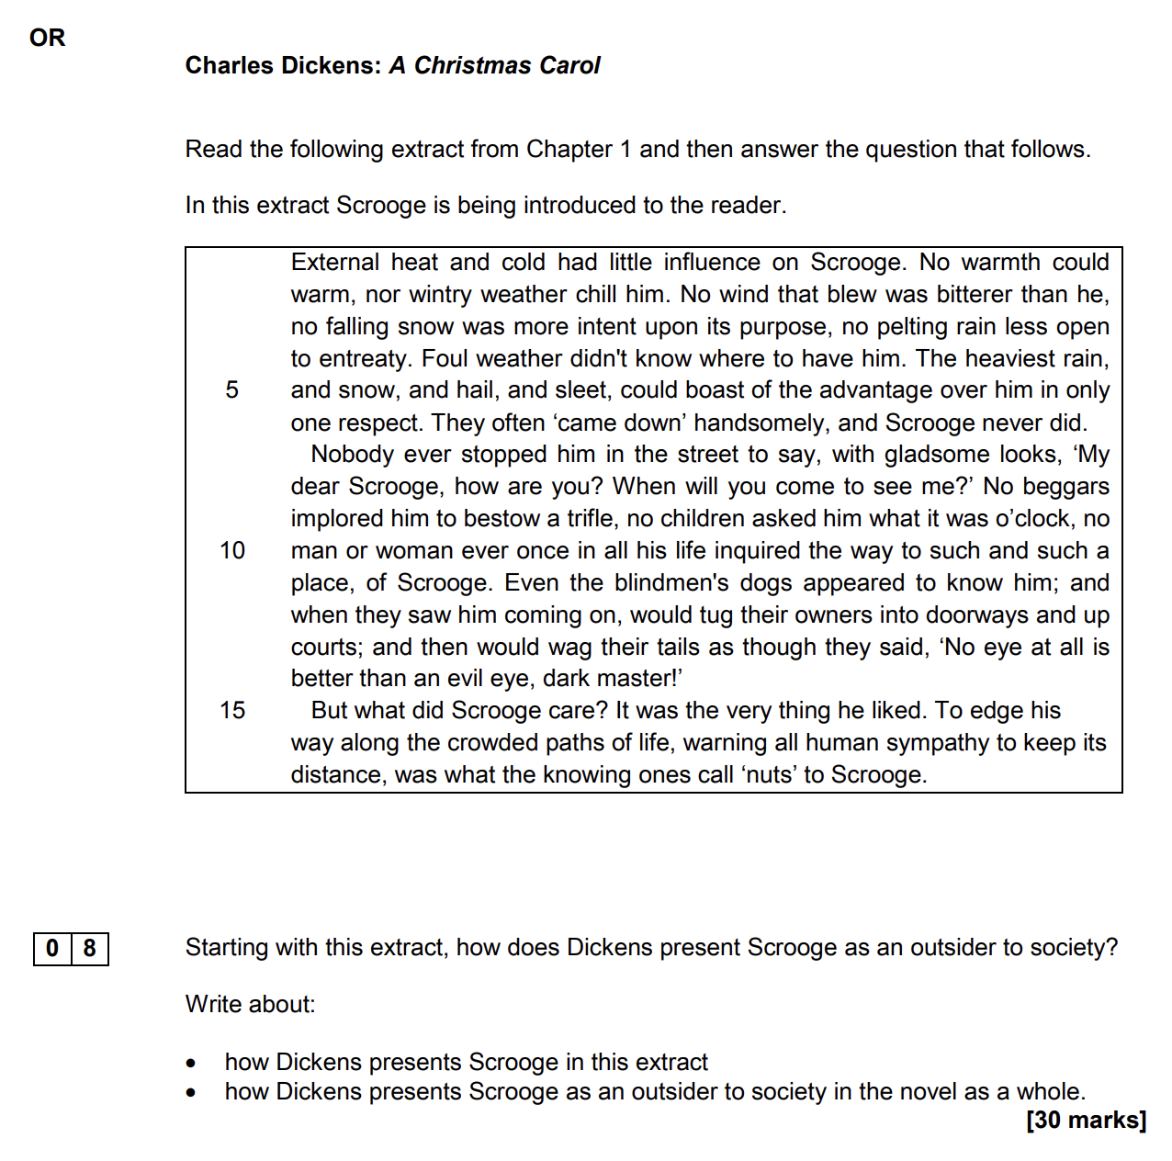 50 mins

