**Proof-Reading**

Fiction Extracts

|  |  |
| --- | --- |
| **2** | *The Road*, by Cormac McCarthy |
| **3** | *Cider with Rosie*, by Laurie Lee |
| **4** | *The Two Towers*, by J. R. R. Tolkien |
| **5** | *The Handmaid’s Tale*, by Margaret Atwood |
| **6** | *Small Island*, by Andrea Levy |
| **7** | *The Company of Wolves*, by Angela Carter |
| **8** | *The Song of Achilles*, by Madeline Miller |
| **9** | *NW*, by Zadie Smith |
| **10** | *All the Pretty Horses*, by Cormac McCarthy |
| **11** | *Wide Sargasso Sea*, by Jean Rhys |

|  |  |  |  |  |
| --- | --- | --- | --- | --- |
| *The Road by Cormac McCarthy* | Image result for cider with rosie | The Two Towers by J.R.R. Tolkien | Image result for the handmaid's tale front cover | Image result for small island front cover |
| Image result for the bloody chamber | Image result for the song of achilles cover |  |  |  |

* *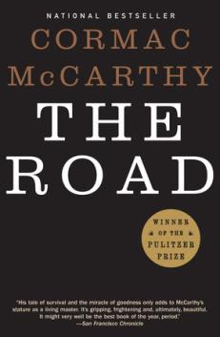****The Road*, by Cormac McCarthy**
* Published in 2007
* Winner of the Pulitzer Prize

A father and his son walk alone through burned America. Nothing moves in the ravaged landscape save the ash on the wind. It is cold enough to crack stones, and when the snow falls it is gray. The sky is dark. Their destination is the coast, although they don’t know what, if anything, awaits them there. They have nothing; just a pistol to defend themselves against the lawless bands that stalk the road.

Source: Penguin Random House website

…………………………………………………………………………………………………………………………………………………………………………

When he woke in the woods in the dark and the cold of the night hed reach out to touch the child sleeping beside him. Night’s dark beyond darkness and the days more gray each one than what had gone before. Like the onset of some cold glaucoma dimming away the world. his hand rose and fell softly with each precious breath. He pushed away the plastic tarpaulin and raised himself in the stinking Robes and blankets and looked toward the east for any light but there was none. In the dream from which he’d wakenned he had wandered in a cave where the child led him by the hand. There light playing over the wet flowstone walls. Like pilgrims in a fable swallowed up and lost among the inward parts of some granitic beast. Deap stone flues where the water dripped and sang. Tolling in the silence the minute’s of the earth and the hours and the days of it and the years without cease. Until they stood in a grate stone room where lay a black and ancient lake. And on the far shore a creature that raised it’s dripping mouth from the rimstone pool and stared into the light with eyes dead white and sightless as the eggs of spiders. It swung it’s head low over the water as if to take the scent of what it could not see. Crouching their pale and naked and translucent, its alabaster bones cast up in shadow on the rocks behind it. It’s bowels, its beating heart. The brain that pulsed in a dull glass bell. It swung it’s head from side to side and then gave out a low moan and turned and lurched away and loped soundlessley into the dark.

With the first gray light he rose and left the boy sleaping and walked out to the road and squatted and studied the country to the South. Barren, silent, godless.

* 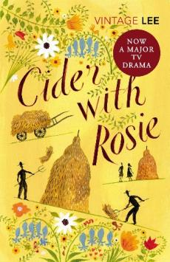***Cider with Rosie*, by Laurie Lee**
* Published in 1959
* Autobiographical novel

*Cider with Rosie* is a wonderfully vivid memoir of childhood in a remote Cotswold village, a village before electricity or cars, a timeless place on the verge of change. Growing up amongst the fields and woods and characters of the place, Laurie Lee depicts a world that is both immediate and real and belongs to a now-distant past. Many of the episodes are richly comic, yet there is also a sense of tragedy.

Source: Penguin Random House website

…………………………………………………………………………………………………………………………………………………………………………

I was set down from the carriers cart at the age of three; and there with a sense of bewilderment and terror my life in the village began. The june grass, amongst which I stood, was taller than I was, and I wept. I had never been so close to grass before. It towered above me and all around me, each blade tatooed with tiger-skins of sunlight. It was knife-edged, dark, and a wicked green, thick as a forest and alive with grass hoppers that chirped and chattered and leapt through the air like monkeys

I was lost and didnt know where to move. A tropic heat oozed up from the ground, rank with sharp odours of roots and nettles. Snow-clouds of elder-blossom banked in the Sky, showering upon me the fumes and flakes of there sweet and giddy suffocation. High overhead ran frenzied larks, screaming, as though the sky were tearing apart. For the first time in my life, i was out of the sight of humans. For the first time in my life, I was alone in a world whose behaviour I could neither predict nor fathom: a world of birds that squeeled, of plants that stank, of insects that sprang about without warning. I was lost and I did not expect too be found again. I put back my head and howled, and the sun hit me smartley on the face, like a bully.

From this daylight nightmare I was awakened, as from many another, by the apearance of my sisters. They came scrambling and calling up the steap rough bank, and parting the long grass found me. Faces of rose, familiar, living; huge shinning faces hung up like shields between me and the sky; faces with grins and white teeth (some broken) to be conjured up like genii with a howl, brushing off teror with their broad scoldings and effection.

* 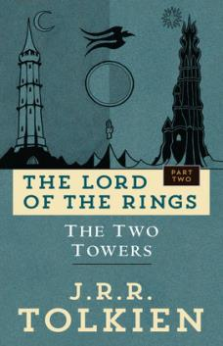***The Two Towers*, by J. R. R. Tolkien**
* Published in 1954
* One of the best selling novels ever written

The Fellowship is scattered. Some are bracing hopelessly for war against the ancient evil of Sauron. Some are contending with the treachery of the wizard Saruman. Only Frodo and Sam are left to take the accursed One Ring, ruler of all the Rings of Power, to be destroyed in Mordor, the dark realm where Sauron is supreme. Their guide is Gollum, a slave to the corruption of the Ring.

Source: Penguin Random House website

…………………………………………………………………………………………………………………………………………………………………………

The night grew ever colder. Aragorn and Gimli slept fitfuly, and whenever they awoke they saw Legolas standing beside them, or walking to and fro, singing softly to himself in his own tongue, and As he sang the white stars opened in the hard black vault above. So the night passed. Together they watched the dawn grow slowley in the sky, now bare and cloudless, until at last the sunrise came. It was pale and clear. The wind was in the East and all the mists had rolled away; wide lands lay bleak about them in the bitter light

Ahead and eastward they saw the windey uplands of the Wold of Rohan that they had already glimpsed many days ago from the Great River. North-westward stalked the dark forrest of Fangorn; still ten leagues away stood its shadowy eaves, and its further slopes faded into the distant blue. Beyond there glimmered far away, as if floating on a grey Cloud, the white head of tall Methedras, the last peak of the Misty Mountains. Out of the forest the Entwash flowed to meat them, its stream now swift and narrow, and its banks deepcloven. The orc-trail turned from the downs towards it

Following with his keen eyes the trail to the river, and then the river back towards the forest, aragorn saw a shadow on the distant grean, a dark swift-moving blur. He cast himself upon the ground and listened again intently. But Legola’s stood beside him, shading his bright elven-eyes with his long slender hand, and he saw not a shadow, nor a blur, but the small figures of horse men, many horsemen, and the glint of morning on the tips of their spears was like the twinkle of minute star’s beyond the edge of mortal sight. Far behind them a dark smoke rose in thin curling threads

* 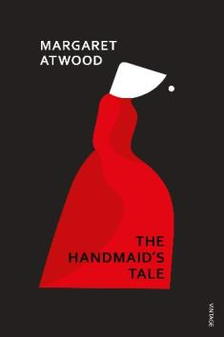***The Handmaid’s Tale*, by Margaret Atwood**
* Published in 2010
* Serialised on channel 4

This dystopian novel portrays the totalitarian society of Gilead, which has replaced the USA, where women’s rights have been eroded. Handmaids exist solely for the purpose of reproduction. They are forbidden to work, vote or read. Handmaids are only allowed to travel outside in pairs and, in this extract, Ofglen and Offred are on a shopping trip.

Source: AQA prose reading booklet

…………………………………………………………………………………………………………………………………………………………………………

A group of people is coming towards us. Their tourists, from Japan it looks like, a trade delegation perhaps, on a tour of the historic landmarks or out for local colour. Theyr’e diminutive and neatly turned out; each has his or her camera, his or her smile. They look around, bright-eyed, cocking there heads to

one side like robins, there very cheerfulness aggressive, and I can’t help staring. It’s been a long time since I’ve seen skirts that short on women. the skirts reach just below the knee and the legs come out from beneath them, nearly naked in their thin stockings, blatant, the high-healed shoes with their straps attached to the feet like delicate instrument’s of torture. The women teeter on their spiked feet as if on stilts, but off balance; their backs arch at the waist, thrusting the buttocks out. There heads are uncovered and their hair to is exposed, in all its darkness and sexuality. They wear lipstick, red, outlining the damp cavities of their mouth’s, like scrawls on a washroom wall, of the time before. I stop walking. Ofglen stops beside me and I know that she to cannot take her eyes off these women. We are fascinated, but also repelled. They seem undressed. It has taken so little time to change our minds about things like this

Then I think: I used to dress like that. That was freadom.

westernised, they used to call it.

The japanese tourists come towards us, twittering, and we turn our heads away too late: our faces have bean seen.

* 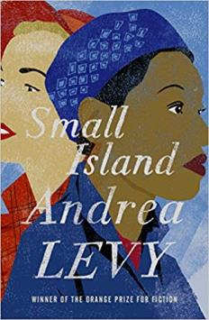***Small Island*, by Andrea Levy**
* Published in 2004
* Winner of the Orange Best of the Best Prize

Levy’s 2004 novel interweaves the stories of Jamaican migrants Gilbert and Hortense, their white English landlady, Queenie, and her husband Bernard. Told from these four different perspectives, the novel explores their hopes and expectations of life in post-war London and the complications that arise between them as their worlds change.

Source: British Library website

…………………………………………………………………………………………………………………………………………………………………………

I was christened Victoria buxton. My mother had wanted me to be christened Queenie but the vicar had said, ‘No, Mrs Buxton, Im afraid Queenie is a common name.’

‘Common!’ my mother had replied. ‘How can it be common. It’s a queen’s name.’ The vicar had then given an impromptu sermon which my mother, father and their gathered gests had to listen to as they stood round the stone font in our bleak local church. the vicar went on at length about monarchs having proper names like Edward, George, elizabeth while everyone, dressed in their pinching church-best shoes began to shift from foot to foot and stifle yawns behind their scrubbed hands. ‘Take our late queen,’ the vicar finaly explained, ‘her name, Mrs Buxton, was not quean but Victoria.’

So that was how – one thundery august day in a church near Mansfield, dressed in a handed down white-starched christening gown that wouldnt do up at the neck – I, the first born child of Wilfred and Lillie Buxton, came to be christened Victoria yet called forever Queenie

my mother, Lillie, was an English rose. Flaxen hair, a complexion like milk with a faint pink flush at her cheeks and a nose that tipped up at the end to present the two perfect triangles of her nostrils. She was a farmers daughter and had hands that could clasp like a vice, arms as strong as a bears and hips that widened every year until even the old men on the village green agreed they were childbearing

* 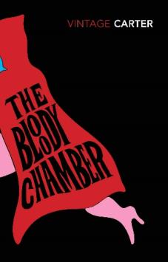***The Company of Wolves*, by Angela Carter**
* Published in 1979
* Winner of the Cheltnham Festival Literary Prize

Wolves are described with seductive, mesmerisingly shifting descriptions that borrow from theatre and amateur dramatics: their eyes are yellowish, reddish, unnatural green, likened to ‘candle flames’ and ‘sequins’. Their howling is, again taking from stage and performance, an ‘aria of fear’, entertaining and beautiful even when expressing dread.

Source: British Library website

…………………………………………………………………………………………………………………………………………………………………………

The wolf is carnivore incarnate and he’s as cunning as he is ferocious; once hes had a taste of flesh then nothing else will do

At night, the eyes of wolfs shine like candle flames, yellowish, reddish, but that is because the pupils of their eyes fatten on darkness and catch the light from your lantern to flash it back to you – Red for danger; if a wolfs eyes reflect only moonlight, then they gleam a cold and unnatural green, a mineral, a piercing colour. If the benighted traveler spies those luminous, terrible sequins stitched suddenly on the black thickets, then he knows he must run, if fear has not struck him stock-still

but those eyes are all you will be able to glimpse of the forest assassins as they cluster invisibly round your smell of meet as you go through the wood unwisely late. They will be like shadows, they will be like wraiths, grey members of a congregation of nightmare. Hark! His long, wavering howl... An aria of feer made audible

The wolf song is the Sound of the rending you will suffer, in itself a murdering

It is winter and cold weather. In this region of mountain and forrest, there is now nothing for the wolves to eat. Goats and sheeps are locked up in the byre, the deer departed for the remaining pasturage on the southern slope – wolves grow lean and famished. Their is so little flesh on them that you could count the starveling ribs through there pelts, if they gave you time before they pounced.

* 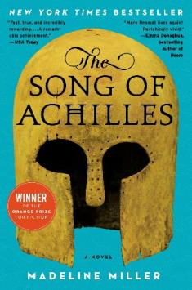***The Song of Achilles*, by Madeline Miller**
* Published in 2012
* Winner of the Orange Prize for Fiction

Greece in the age of heroes. Patroclus, an awkward young prince, has been exiled to the court of King Peleus and his perfect son Achilles. Despite their differences, the boys develop a tender friendship, a bond which blossoms into something deeper as they grow into young men. But when Helen of Sparta is kidnapped, Achilles is dispatched to distant Troy to fulfil his destiny.

Source: Bloomsbury website

…………………………………………………………………………………………………………………………………………………………………………

My father was a king and the sun of kings. He was a short man, as most of us were, and built like a bull, all shoulder’s. He married my mother when she was fourteen and sworn by the priestess to be fruitful. It was a good match: she was an only child, and her father’s fortune would go to her husband

He did not find out until the wedding that she was simple. her father had been scrupulous about keeping her veiled until the ceremony, and my farther had humoured him. If she were ugly, there were always slave girls and serving boys. When at last they pulled off the veil, they say my mother smiled. that is how they knew she was quiet stupid. Brides did not smile.

when I was delivered, a boy, he plucked me from her arms, and handed me to a nurse. In pity, the midwife gave my mother a pilow to hold instead of me. My mother hugged it. She did not seem to notice a change had bean made.

Quickly, I became a dissapointment: small, slight. I was not fast. I was not strong. I could not sing. The best that could be said of me was that I was not sickley. The colds and cramps that seized my peers left me untouched. This only made my father suspisious. Was I a changeling, inhuman? He scowled at me, watching. My hand shook, feeling his gaze. And their was my mother, dribbling wine on herself.

I am five when it is my fathers turn to host the games. Men gather from as far as Thessaly and Sparta, and our store-houses grow rich with there gold.

* 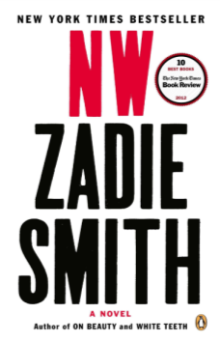***NW*, by Zadie Smith**
* Published in 2012
* Adapted into a film for television in 2016

NW follows the paths of two young women from the same council estate – half-Irish Leah, and Caribbean Keisha – through a time and place ‘crazy busy with self-invention’. Two men shadow their trajectories: Nathan, who sinks back into the street-life hustling of drugs and crime, and Felix, whose intermittent toehold on a ‘creative’ career is dislodged by the demons of addiction.

Source: Independent newspaper

…………………………………………………………………………………………………………………………………………………………………………

On the way bak from the chain supermarket where they shop, though it closed down the local grocer and pays slave wages, with new bags though they should take old bags, leeving with broccoli from Kenya and tomatoes from Chile and unfair coffee and sugary crap and the wrong news paper.

They are not good people. They do not even have the integrity to be the sort of people who dont worry about being good peeple. They worry all the time. They are stuck in the middle again. They buy always Pinot Grigio or Chardonnay because these are the only words they know that relate to wine They are attending a diner party and for this you need to bring a bottle of wine. This much they have learned. They do not purchase ethical things because they cant afford them Michel claims and Leah says, no, it’s because you cant be bothered. Privately she thinks: you want to be rich like them but you can’t be bothered with their morals, whereas I am more interested in their morales than their money, and this thought, this opposition, makes her feel good. Mariage as the art of invidious comparison. And shit that’s him in the phone box and if she had thought about it for more than a split second she wud never have said:

— Shit thats him in the phone box.

— Thats him?

— Yes, but — no, I dont know. No. I thought. Doesn’t matter. Forget it.

— Leah, you just said it was him. Is it or isnt it?

* 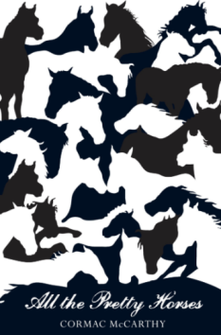***All the Pretty Horses*, by Cormac McCarthy**
* Published in 1992
* Winner of the US National Book Award

All the Pretty Horses is the story of John Grady Cole, the last of a long line of west Texas ranchers. Upon his grandfather’s death and his parents’ divorce, the sixteen-year-old Cole finds himself landless, penniless, and possessed of skills that mean nothing in a country transformed by highways and a world war, where cowboys are as doomed and marginal as the Indians they once displaced.

Source: Penguin Random House website

…………………………………………………………………………………………………………………………………………………………………………

He rode with the sun coppering his face and the red wind blowing out of the west. he turned south along the old war trail and he rode out to the crest of a low rise and dis mounted and dropped the reins and walked out and stood like a man come to the End of something.

Their was an old horse skull in the brush and he squatted and picked it up and turned it in his hands. Frail and brittle. Bleached paper white. He squatted in the long light holding it, the comic book teeth lose in their sockets. The joint’s in the cranium like a ragged welding of the bone plates. The muted run of sand in the brainbox when he turned it

What he loved in horse’s was what he loved in men, the blood and the heat of the blood that ran them. All his reverence and all his fondness and all the leaning’s of his life were for the ardent hearted and they would always be so and never be other wise.

He rode back in the dark. The horse quickened it’s step. The last of the day’s light fanned slowly upon the plane behind him and withdrew again down the edges of the world in a cooling blue of shadow and dusk and chill and a few last chitterings of birds sequestered in the dark and wiry brush. He crosed the old trace again and he must turn the pony up onto the plane and homeward but the warriors would ride on in that darkness theyd become, rattling past with their stone-age tools of war in default of all substance and singing softly in blood and longing south across the plains to mexico.

* 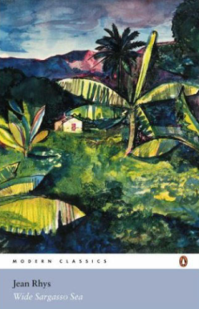***Wide Sargasso Sea*, by Jean Rhys**
* Published in 1966
* Named by Time Magazine as one of the 100 best English-language novels since 1923

*Wide Sargasso Sea* is both a response and a prequel to Charlotte Brontë’s Jane Eyre, set in the West Indies and imagining the lives of Bertha Mason and her family. The novel is a valuable historical work, written in the 1960s but set in the early 1800s, which explores Victorian paternalism, racism and the complex social and political history of the West Indies.

Source: British Library website

…………………………………………………………………………………………………………………………………………………………………………

There is one window high up – you canot see out of it. My bed had doors but they have been taken away. There is not much else in the room. Her bed, a black press, the table in the middle and to black chairs carved with fruit and flowers. They have high back’s and no arms. The dressing-room is very small, the room next to this one is hung with a tapestry. looking at the tapestry one day, I recognised my mother dressed in an evening gown but with bear feet. She looked away from me, over my head just as she used to do. I wouldn’t tell Grace this. Her name oughtn’t to be grace. Names matter, like when he wouldn’t call me Antoinette, and I saw Antoinette drifting out of the window with her scents, her pretty cloths and her looking-glass.

There is no looking-glass here and I dont know what I am like now. I remember watching myself brush my hare and how my eyes looked back at me. The girl I saw was myself, yet not quite myself. Long ago when I was a child and very lonley, I tried to kiss her. But the glass was between us – hard, cold and misted over with my breath. Now they have taken everything away. What am I doing in this place and who am I.

The door of the tapestry room is kept locked. It leeds, I know, into a passage. That is where Grace stands and talks to another woman whom I have never seen. Her name is leah. I listen but I cannot understand what they say.

So, there is still the sound of whisperings that I have heard all my life, but these are diferent voices.