Overview

Task 1

- 24 marks
- Analyse the poem in detail
- Focus on methods (language, structure, form) and their effects
- Spend roughly 30 minutes on the task

Task 2

- 8 marks
- Compare the two poems
- Focus on similarities and/or differences in methods and ideas
- Spend roughly 15 minutes on the task

Assessment Objectives

- Clear, sustained response to the tasks
- Understanding of explicit and implicit meanings
- Use of textual references (quotations)
- Analysis of poet’s methods (language, structure, form)
- Use of subject terminology
- Explanation of effects on the reader

Past Exam Question

Task 1

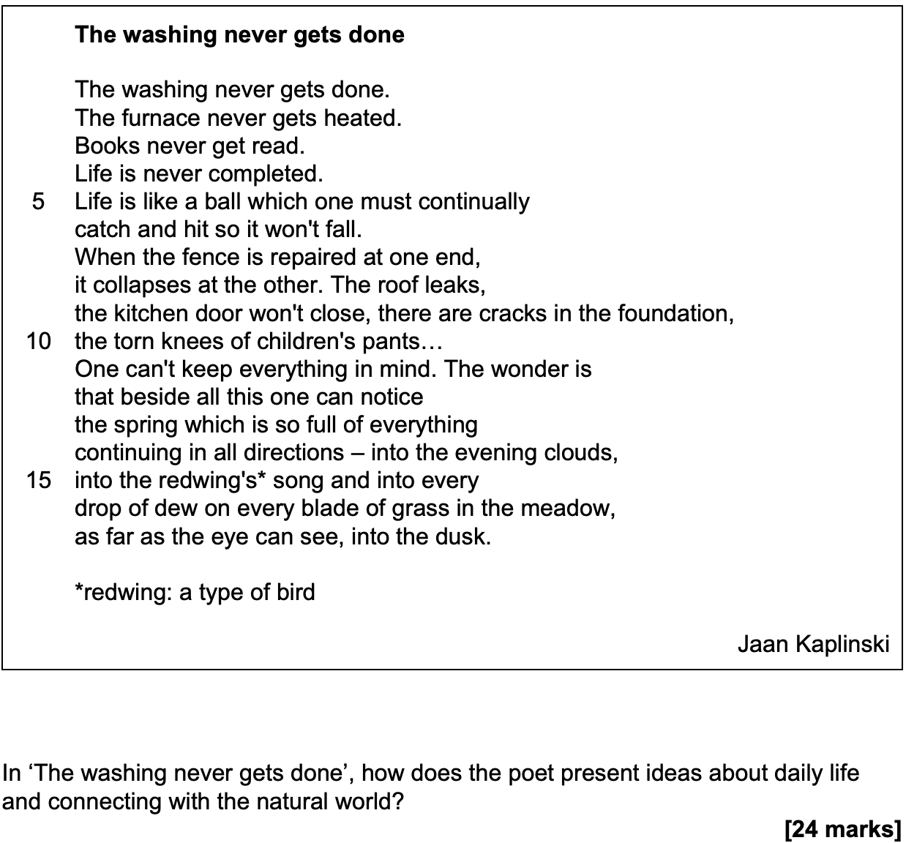

Task 2

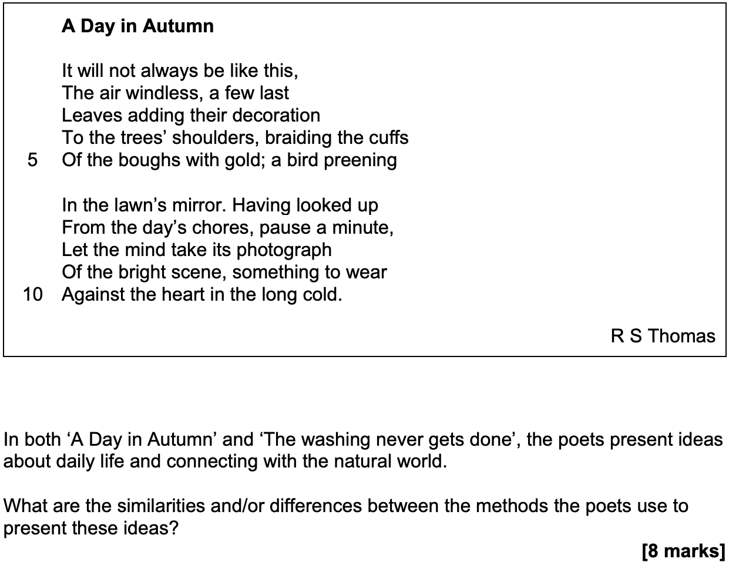
Approaching Task 1

Introduction

- Give some brief context (who’s speaking, what’s happening)
- Put forward your overall viewpoint
- Provide a preview of methods

Main Paragraphs

- Start with a clear point about the poet’s methods
- Provide embedded quotations as evidence
- Analyse the specific methods used
- Explain the effects on the reader
- Link back to the question

Conclusion

- Summarise your main argument
- Offer a final insight

………………………………………………………………………………………………………………………………………….

Stems for Language Analysis

- The poet’s use of [technique] in ‘[quote]’ emphasises [effect/idea]
- The poet employs [technique] to convey [idea], as seen in ‘[quote]’
- Through [technique], the poet creates a sense of [feeling/atmosphere]
- The repetition of [word/phrase] throughout the poem reinforces [idea]
- The word ‘[word]’ carries connotations of [associations], which suggests [meaning]
- ‘The juxtaposition of ‘[word 1]’ and ‘[word 2]’ highlights the contrast between [analysis]

Stems for Structure Analysis
- ‘The poem’s structure shifts at [point], marking a change from [x] to [y]
- ‘The use of [enjambment/caesura] creates [effect]
- ‘The [regular/irregular] rhythm of the poem mirrors [idea]
- ‘Structurally, the poem moves from [beginning] to [end], suggesting [development]

Approaching Task 2

Introduction

- Give some brief context (who’s speaking, what’s happening)
- Write a short overview of how the poems compare

Main Paragraphs

- Identify a similarity/difference in methods (e.g. language and structure)
- Provide evidence from both poems
- Explain the effect in both poems
- Make the comparison explicit

Conclusion

- Summarise your main argument
- Offer a final insight

………………………………………………………………………………………………………………………………………….

Stems for Similarities

- Both poets use [technique] to convey [idea]
- In [Poem 1], ‘[quote]’ suggests [meaning], while [Poem 2]’s ‘[quote]’ similarly [meaning]
- Like [Poem 1], [Poem 2] employs [technique], as seen in ‘[quote 1]’ and ‘[quote 2]
- The use of [technique] is central to both poems because [analysis]
- Both poems share [quality], creating [similar effect] through [method]

Stems for Differences

- While [Poem 1] uses [technique], [Poem 2] employs [technique] to achieve [effect]
- In contrast to [Poem 1]’s [quality], [Poem 2] is characterised by [different quality]
- Unlike [Poem 1], which [does x], [Poem 2] [does y] to create a contrasting effect
- The tone of [Poem 1] is achieved through [method], whilst [Poem 2]’s tone is created by [method]

